**MINISTRY OF EDUCATION AND TRAINING**

**FPT UNIVERSITY**

Capstone Project Document

**Computer Product Suggestion**

|  |  |
| --- | --- |
| **Group 13** | |
| **Group member** | Pham Hong Sang – Team Leader – SE60601  Huynh Thanh Viet – Team Member - SE60666  Tran Tan Len – Team Member - SE60623  Ha Chi Danh – Team Member – 60431 (Dropped out) |
| **Supervisor** | Mr. Kieu Trong Khanh |
| **Ext. Supervisor** | N/A |
| **Capstone Project code** | CPS |

-Ho Chi Minh City, 05/2014-

*This page is intentionally left blank*

***ACKNOWLEDGEMENTS***

We wish to thank various people for their contribution to this project: Our teachers for their advice and participation in the final review, our friends for their valuable technical support.

Special thanks should be given to Mr. Kieu Trong Khanh, our research supervisor for his professional guidance and the useful, constructive recommendations throughout the course of this project.

# Table of Contents

Table of Contents 4

List of Tables 7

List of Figures 9

Definitions, Acronyms, and Abbreviations 12

A. Introduction 13

1. Project Information 13

2. Introduction 13

3. Current Comparison websites in Vietnam 13

4. Problem Definition 13

5. Proposed Solution 14

5.1 Feature functions 14

5.2 Advantage and disadvantage 14

6. Functional Requirement 14

6.1 Data Management 14

6.2 Suggestion 14

6.3 System Management 15

6.4 User Management 15

6.5 Training machine 15

7. Role and Responsibility 15

B. Software Project Management Plan 16

1. Problem Definition 16

1.1 Name of this Capstone Project 16

1.2 Problem Abstract 16

1.3 Project Overview 16

2. Project organization 17

2.1 Software Process Model 17

2.2 Roles and responsibilities 18

2.3 Tools and Techniques 19

3. Project Management Plan 20

3.1 Iteration 20

3.2 Iteration Detail 21

3.3 All Meeting Minutes 23

4. Coding Convention 23

C. Software Requirement Specification 24

1. User Requirement Specification 24

1.1 Guest Requirement 24

1.2 Member Requirement 24

1.3 Staff Requirement 24

1.4 Admin Requirement 24

1.5 System Requirement 24

2. System Requirement Specification 24

2.1 External Interface Requirement 24

2.2 System Overview Use Case 25

2.3 List of Use Case 25

3. Software System Attribute 100

3.1 Usability 100

3.2 Reliability 101

3.3 Availability 101

3.4 Security 101

3.5 Maintainability 101

3.6 Portability 101

3.7 Performance 101

4. Conceptual Diagram 102

Data Dictionary 102

D. Software Design Description 102

1. Design Overview 102

2. System Architectural Design 104

2.1 Web Architecture 104

3. Component Diagram 104

4. Detailed Description of Components 106

4.1 Class Diagram 106

4.2 Class Diagram Explanation 106

4.3 Sequence Diagram 112

5. User Interface Design 119

5.1 Guest, Member Interface Design 119

5.2 Admin Interface Design 127

5.3 Staff Interface Design 131

6. Database Design 157

6.1 Web Application 157

7. Algorithms 161

7.1 Calculating Product’s Score 161

7.2 String Comparison 163

E. System Implementation & Test 164

1. Introduction 164

1.1 System Overview 164

1.2 Test Approach 164

2. Database Relationship Diagram 164

2.1 Diagram 164

2.2 Data Dictionary 166

3. Performance Measures 170

3.1 Parser Performance 170

3.2 Suggestion Algorithm Performance 170

4. Test Plan 171

4.1 Features to be tested 171

4.2 Features not to be tested 171

5. System Testing Test Case 172

5.1 Guest Test Case 175

5.2 Member Test Case 179

5.3 Staff Test Case 180

F. Software User’s Manual 184

1. Installation Guide 184

1.1 Setting up environment at server side 184

1.2 Deployment at server side 184

1.3 Setting up the environment at client side 189

2. User Guide 189

2.1 Guest/Member Guide 189

2.2 Staff Guide 192

G. Appendix 200

# List of Tables

Table 1: Roles and Responsibility 15

Table 2: Hardware Requirement for Server 17

Table 3: Roles and Responsibility Details 19

Table 4: Iteration 21

Table 5: Phase 1: Preliminary Investigation or Analysis 21

Table 6: Phase 2: Data Management 22

Table 7: Phase 3: Main User’s Functions 22

Table 8: Phase 4: Suggestion Algorithm 23

Table 9: Phase 5: Account Management 23

Table 10: <Admin> Create User 28

Table 11: <Admin> Update User 30

Table 12: <Admin> Activate User 31

Table 13: <Admin> Deactivate User 32

Table 14: <Staff> Create Parser 36

Table 15: <Staff> Update Parser 40

Table 16: <Staff> Deactivate Parser 41

Table 17: <Staff> Activate Parser 43

Table 18: Staff> Configure System 45

Table 19: <Staff> Force parses data 48

Table 20: < Staff> Create Product 49

Table 21: <Staff> Update Product 51

Table 22: <Staff> Deactivate Product 53

Table 23: <Staff> Import File 56

Table 24: <Staff> Process error product 59

Table 25: <Staff> Process duplicate product 62

Table 26: <Staff> save correct product 66

Table 27: <Staff> Write log file 67

Table 28: <Staff> Import hardware File 71

Table 29: <Staff> Process error hardware 73

Table 30: <Staff> Process duplicate hardware 75

Table 31: <Staff> save correct hardware 77

Table 32: <Staff> Write log file 79

Table 33: <Staff> Confirm new product. 81

Table 34: <Staff> Confirm new hardware. 82

Table 35: <Staff> Confirm new product. 84

Table 36: <Member> Recommend 87

Table 37: <Member> Rating 89

Table 38: <Member> Add to cart 91

Table 39: <Member> See Suggestion 92

Table 40: < Authorized > Log out 94

Table 41: <Authorized user> Change Password 95

Table 42: <Guest> Register 97

Table 43: <Guest> Login 99

Table 44: <Guest> View Detail 100

Table 45: Entity Data dictionary - Describe content of all entities 102

Table 46: Entity Data Dictionary 158

Table 47: Attribute Data Dictionary 161

Table 48: Data Dictionary 166

Table 49: Attribute Data Dictionary 170

Table 50: Search Product by name Test Case 175

Table 51: Search Product by price Test Case 176

Table 52: View Detail Test Case 176

Table 53: Add To Cart Test Case 178

Table 54: View Compare Test Case 178

Table 55: View hight light product Test Case 178

Table 56: Compare detail Test Case 179

Table 57: History compares Test Case 179

Table 58: Manage Parser Test Case 180

Table 59: Manage Import Data Test Case 182

Table 60: Train Machine Test Case 183

Table 61: Fill Weight Hardware Test Case 184

Table 62: Login Steps 189

Table 63: Search Product Steps 190

Table 64: Recommend Product 190

Table 65: Suggest Route Steps 191

Table 66: View Compare 192

Table 67: View History Steps 192

Table 68: Staff Login Steps 193

Table 69: Save Imported Data Steps 194

Table 70: Handle Name Conflict Steps 195

Table 71: Create Parser Steps – 1 195

Table 72: Create Parser Steps - 2 198

Table 73: Manage new laptop 199

# List of Figures

Figure 1: Agile Development Model 19

Figure 2: System Overview Use Case 26

Figure 3: <Admin> Overview Use Case 27

Figure 4: <Admin> Create User 27

Figure 5: <Admin> Update User 29

Figure 6: <Admin> Activate User 31

Figure 7: <Admin> Deactivate User 32

Figure 8: <Staff> Overview Use Case 34

Figure 9: <Staff> Create Parser 34

Figure 10: <Staff> Update Parser 38

Figure 11: <Staff> Deactivate Parser 41

Figure 12: <Staff> Activate Parser 43

Figure 13: <Staff> Configure System 44

Figure 14: <Staff> Force parses data 46

Figure 15: <Staff> Create Product 49

Figure 16: <Staff> Update Product 50

Figure 17: <Staff> Deactivate Product 52

Figure 18: <Staff> Import file 54

Figure 19: <Staff> Process error product 58

Figure 20: <Staff> Process duplicate product 61

Figure 21: <Staff>save correct product 63

Figure 22: <Staff> Write log file 67

Figure 23: <Staff> Import hardware file 69

Figure 24: <Staff> Process error hardware 72

Figure 25: <Staff> Process duplicate hardware 74

Figure 26: <Staff>save correct hardware 76

Figure 27: <Staff> Write log file 79

Figure 28: <Staff> Confirm new product. 80

Figure 29: <Staff> Confirm new hardware. 82

Figure 30: <Staff> Confirm new hardware. 84

Figure 31: <Member> Overview Use Case 85

Figure 32: <Member> Recommend 86

Figure 33: <Member> Rating 89

Figure 34: <Member> Add to cart 90

Figure 35: <Member> See suggestion 92

Figure 36: < Authorized > Log out 94

Figure 37: <Authorized user> Change Password 95

Figure 38: <Guest> Overview Use Case 97

Figure 39: <Guest> Register 97

Figure 40: <Guest> Login 99

Figure 41: <Guest> View Detail 100

Figure 42: Conceptual Diagram 103

Figure 43: MVC Architecture 105

Figure 44: Component Diagram 106

Figure 45: Class Diagram 107

Figure 46: Force Parse Data Sequence Diagram 114

Figure 47: Import Product Sequence Diagram 114

Figure 48: Process Error Products Sequence Diagram 115

Figure 49: Process Duplicated Products Sequence Diagram 115

Figure 50: Save Correct Products Sequence Diagram 116

Figure 51: Log File Sequence Diagram 116

Figure 52: Recommend Sequence Diagram 117

Figure 53: View History Sequence Diagram 117

Figure 54: Search Product Sequence Diagram 118

Figure 55: Configure System Sequence Diagram 118

Figure 56: Confim New Product 119

Figure 57: Training Machine 120

Figure 58: Guest Home Page 121

Figure 59: Login 121

Figure 60: Register Page 122

Figure 61: Member Home Page 123

Figure 62: Search Page 124

Figure 63: Recommend 125

Figure 64: Highlight 126

Figure 65: View Compare 127

Figure 66: History Details 128

Figure 67: Admin/Staff Login Page 129

Figure 68: User List Page 130

Figure 69: Create New User Page 131

Figure 70: Train Machine Page 132

Figure 71: Import Excel – Correct Data List 134

Figure 72: Import Excel – Error Data List 135

Figure 73: Import Excel - Name Conflict 137

Figure 74: Manage Recommend Product 138

Figure 75: Configure System 139

Figure 76: Manage Product 140

Figure 77: Create New Product 141

Figure 78: Edit product 142

Figure 79: Create Alias Name 144

Figure 80: Edit Alias Product 145

Figure 81: Manage Parser 147

Figure 82: Create Parser - Step 1 148

Figure 83: Create Parser - Step 2 149

Figure 84: Create Parser - Step 3 149

Figure 85: Create Parser - Step 4 150

Figure 86: Create Parser - Step 5 150

Figure 87: Create Parser - Step 6 150

Figure 88: Create Parser - Step 7 151

Figure 89: Create Parser - Step 8 151

Figure 90: Create Parser - Step 9 151

Figure 91: Create Parser - Step 10 152

Figure 92: Manage Log File 153

Figure 93: Manage new Laptop 154

Figure 94: Confirm new Laptop 155

Figure 95: Manage new Hardware 156

Figure 96: Confirm new Hardware 157

Figure 97: Entity Relationship Diagram 158

Figure 98: Database Relationship Diagram 166

Figure 99: Guest Core Flow 173

Figure 100: Member core flow 174

Figure 101: Staff, System Core Flow 176

Figure 102: Prepare deployment package 186

Figure 103: Deploy database – 1 186

Figure 104: Deploy database - 2 187

Figure 105: Configure Server before deploy – 1 187

Figure 106: Deploy web application on server – 1 188

Figure 107: Deploy web application on server – 2 188

Figure 108: Deploy web application on server – 3 189

Figure 109: Deploy web application on server – 4 189

Figure 110: Login Page 190

Figure 111: Search Product Page 191

Figure 112: Recommend Product 191

Figure 113: Suggest Route Page 192

Figure 114: View Compare 192

Figure 115: View compares result 193

Figure 116: Staff Login 194

Figure 117: Imported Data Page 195

Figure 118: Handle Name Conflict Page 195

Figure 119: Create Parser Page&Step - 1 196

Figure 120: Create Parser Page – 2 196

Figure 121: Create Parser Page – 3 197

Figure 122: Create Parser Page – 4 197

Figure 123: Create Parser Page – 5 197

Figure 124: Create Parser Page – 6 197

Figure 125: Create Parser Page – 7 198

Figure 126: Create Parser Page – 8 198

Figure 127: Create Parser Page – 9 198

Figure 128: Create Parser Page – 10 198

Figure 129: Preview parses data 199

Figure 130: Preview parses data 199

Figure 131: Manage new laptop 200

Figure 132: Confirm new laptop 200

# Definitions, Acronyms, and Abbreviations

|  |  |  |
| --- | --- | --- |
| **No.** | **Abbreviation & Acronym** | **Definition** |
| 1 | CPS | Computer Product Suggestion |
| 2 | OS | Operation System |
| 3 | Admin | Administrator |
| 4 | API | Application Programming Interface |
| 5 | HTTP | Hyper Text Transfer Protocol |

# Introduction

## Project Information

* Project name: **Computer Product Suggestion**
* Project Code: **CPS**
* Product Type: **Website**
* Start Date: **May 13th, 2014**
* End Date:**September 4th, 2014**

## Introduction

Nowadays Online shopping is become the most popular trends in the world.

E-commerce websites are become more and more popular; however, they just only show the details of products and don’t have any effective search and compare function that can recommend for customer about their choices. But, how can we know a computer is better than the other ones? Or which one is fixed their budget? Our system will do that thing, it helps users find computer online, compares them and system will suggest products what is suitable for users, etc…

## Current Comparison websites in Vietnam

Below are some comparison sites:

* Normal E-commerce websites (thegioididong.com, vienthonga.com, dienmay.com, etc…): They have some functions that let people search and see details of each product. But all that products are had in their website and we can’t compare them with another website. They show all text details, it is too difficult for users to choose what they want and it spends too much time.
* Especial compare websites (compare.vn, websosanh.vn, sosanh.vn, etc…): They provide functions that let users add 2 or more in order to make them see details of products easily. They collect data from another website, so that make users see more details of product then a normal e-commerce websites. But they still have no any especial search and compare functions.

## Problem Definition

Below are the advantages and disadvantages of current comparison website in Vietnam:

- Advantages:

+ All products in 1 website (normal e-commerce websites), it makes users easy to search or get information about the products.

+ It save your time and cost of travelling to see products in real or other website.

+ You don’t need to leave your home and go to store for consultant or specialist about advises.

- Disadvantages:

+ It doesn’t show you that product will suitable for you, it has just showed details of products.

+ It takes a lot of your time to spend to compare or research details of product that you care about.

+ You will be confused about the price because it collects data from another website. So that you don’t know what price is suitable for you (especial compare websites)?

+ Finally, It is so difficult for you to make decide what products that you would buy because it is all text and don’t have any special compare functions.

According to the description above, we can realize that user couldn’t know what product is better than the other ones. Is that product is under your budget? Our system will help you with those problems.

## Proposed Solution

The system is supported for users to make decisions about set of computer products that they want to buy. The system must to manage products, users, etc… In detail, the system will enable following function:

### **Feature functions**

* Admins can manage the system, manage accounts, and configure system.
* System can evaluate the inputted product to give suggestion or proposal, beside that it will parse the web to get the useful information.
* Staff will define or configure the weight of criteria and collect data from web to mine.
* Users can request to search and get the suggestion with set of selected products and recommend and rating for each product.
* Trainings module will help system recognize products are already existed in database.

### Advantage and disadvantage

The advantages and disadvantages of the proposed solution:

* Advantages: Provide full of details suggest about specified product that you want to know and see what product is better than the other ones. It saves your time, because it takes a few minutes instead of several hours to compare the details (all text) and still don’t know which one is under your budget and better. You will never miss out a special, coupon or rebate. Finally, you can get real life reviews, recommend and rating from the other users.
* Disadvantages: Users must have laptop/computer for using system and Internet Connection is required.

## Functional Requirement

Function requirement of the system are listed as below:

### Data Management

* System will parse data from many websites automatically at specific times.
* Staff can force the system to parse data any time.
* Staff can input data manually.
* Staff can define or configure weight criteria manually or train to the machine.

### Suggestion

* System can suggest the suitable solution to buy a product or a list of products to the user which is under their budget.

### System Management

* System evaluates the inputted product to give suggestion and proposal.
* System can parse the website to get useful information.

### User Management

* Admins can manage users.

### Training machine

* System can auto check product is existed or not, after that system will notify for staff if it wouldn’t exist. Then, staff will train.

## Role and Responsibility

|  |  |  |  |  |
| --- | --- | --- | --- | --- |
| No | Full Name | Role | Position | Contact |
| 1 | Kieu Trong Khanh | Project Manager | Instructor | khanhkt@fpt.edu.vn |
| 2 | Pham Hong Sang | Developer | Leader | iv250509@gmail.com |
| 3 | Huynh Thanh Viet | Developer | Member | viethtse60666@fpt.edu.vn |
| 4 | Tran Tan Len | Developer | Member | lenttse60623@fpt.edu.vn |
| 5 | Ha Chi Danh | Developer | Member | danhhc60431@fpt.edu.vn |

Table 1: Roles and Responsibility

# Software Project Management Plan

## Problem Definition

### Name of this Capstone Project

Computer Product Suggestion (CPS).

### Problem Abstract

Nowadays Online shopping is become the most popular trends in the world.E-commerce websites are become more and more popular; however, they just only show the details of products and don’t have any effective search and compare function that can recommend for customer about their choices. But, how can we know a computer is better than the other ones? Or which one is fixed their budget? Our system will do that thing, it helps users find computer online, compares them and system will suggest products what is suitable for users, etc…

### Project Overview

#### Current Comparison websites in Vietnam

Below are some comparison sites:

* Normal E-commerce websites (thegioididong.com, vienthonga.com, dienmay.com, etc…): They have some functions that let people search and see details of each product. But all that products are had in their website and we can’t compare them with another website. They show all text details, it is too difficult for users to choose what they want and it spends too much time.
* Especial compare websites (compare.vn, websosanh.vn, sosanh.vn, etc…): They provide functions that let users add 2 or more in order to make them see details of products easily. They collect data from another website, so that make users see more details of product then a normal e-commerce websites. But they still have no any especial search and compare functions.

#### The Proposed System

The system is intended for users to make decisions about set of computer products that they want to buy. The system must to manage products, users, etc… In detail, the system will enable following function:

* Admins can manage the system, manage accounts, and configure system.
* System can evaluate the inputted product to give suggestion or proposal, beside that it will parse the web to get the useful information.
* Staff will define or configure the weight of criteria and collect data from web to mine.
* Users can request to search and get the suggestion with set of selected products and recommend and rating for each product.
* Trainings module will help system recognize products are already exist in database or not. If not, system will be trained about products.

#### Boundaries of the System

* The system can be used by every people with a laptop/computer with Internet connection.
* The system is **not intended** for managing these aspects:

+ Managing product quality.

+ Managing your expense.

* The language of the system is English.
* The complete product includes:

+ The website, for staff and user.

+ All the process document involved.

#### Development Environment

##### Hardware requirements

**For Server**

|  |  |  |
| --- | --- | --- |
| Windows | Minimum Requirements | Recommended |
| Internet Connection | Cable, Wifi (4 Mbps) | Cable, Wifi (8 Mbps) |
| Operating System | XP, Vista, 7, 8 | XP, Vista, 7, 8 |
| Computer Processor | Intel® Core 2 Duo | Intel® Core(TM) i5 CPU , M 460 @ 2.53GHz |
| Computer Memory | 1GB RAM | 3GB or more |

Table 2: Hardware Requirement for Server

**For Mobile Application**

##### Software requirements

* Microsoft Windows 7 Ultimate: operating system and platform for development.
* SQL Server 2008 Enterprise R2: used to create and manage the database for system.
* StarUML: used to create models and diagrams.
* Skype: used for communication and meeting.
* Visual Studio 2012: used to implement website.
* Google Code & TortoiseSVN: used for source control.

## Project organization

### Software Process Model

Project is developed under agile model.



Figure 1: Agile Development Model

For more information: <http://www.indicthreads.com/1439/quick-introduction-to-agile-software-development/>

(Owner: IndicThreads.com. Online Software Developer Magazine and Conferences)

### Roles and responsibilities

|  |  |  |  |
| --- | --- | --- | --- |
| **No** | **Full name** | **Role in Group** | **Responsibilities** |
| **1** | Kieu Trong Khanh | Project manager | * Specify user requirement * Control the development process * Give out technique and business analysis support |
| **2** | Pham Hong Sang | Team Leader, BA, DEV, Tester | * Managing process * Designing database * Clarifying requirements * Prepare documents * GUI Design * Create test plan * Coding * Testing |
| **3** | Huynh Thanh Viet | Team Member, BA, DEV, Tester | * Designing database * Clarifying requirements * Prepare documents * GUI Design * Create test plan * Coding * Testing |
| **4** | Tran Tan Len | Team Member, BA, DEV, Tester | * Designing database * Clarifying requirements * Prepare documents * GUI Design * Create test plan * Coding * Testing |
| **5** | Ha Chi Danh | Team Member, BA, DEV, Tester | * Designing database * Clarifying requirements * Prepare documents * GUI Design * Create test plan * Coding * Testing |

Table 3: Roles and Responsibility Details

### Tools and Techniques

- Front-end technologies: HTML5, CSS3, JavaScript, jQuery, AJAX.

- Back-end:

* Website: ASP.NET MVC4 + Entity Framework 5.
* Scheduler: Quartz.
* Parse data from Excel file: Linq to excel.

- Web Server: Microsoft IIS.

- Database Management System: MS SQL Server 2008 Enterprise R2.

## Project Management Plan

### Iteration

|  |  |  |  |  |  |
| --- | --- | --- | --- | --- | --- |
| **Phase**  **/Iteration** | **Description** | **Deliverables** | **Resource needed** | **Dependencies and Constrains** | **Risks** |
| **Preliminary Investigation or Analysis** | - Study similar existing systems.  -Identify and clarify requirements for the system in general. | -Introduction of proposed system.  -Main functions.  -Project Iteration Plan. | 30 man-days | N/A | Project may  not be feasible  for developing  because lack of technologies  And/or data. |
| **Data management** | - Collect data from websites.  - Input data manually. | - Data management service. | 30 man-days | N/A | Lack of experience.  The implemented parsers are not the best.  Lack of test data. |
| **Main user’s functions** | - Let user see details of each product.  - User can search a product.  -User can see suggestion if he is a member. | - Main user’s functions on web. | 30 man-days | Depend on “Data management”. | Lack of experience.  Not have a clear understanding about business process. |
| **Suggestion algorithm** | - Build algorithm to calculate the best way to suggest for user a suitable product. | - Suggestion service.  - User now can ask for the best suggest a suitable product. | 20 man-days | Depends on “Data management”. | The implemented algorithm is not the best.  Lack of test data. Lack of experience on defining weight criteria. |
| **User Account**  **management** | - Manage user accounts in the system | - User management system. | 7 man-days | N/A | Lack of experience.  Not have a clear understanding about business process. |
| **Training Machine** | -Teach the system about learning a new product. | N/A | 8 man-days | Depends on “Data management”. | Not have a clear understanding about business process. |

Table 4: Iteration

### Iteration Detail

#### Phase 1: Preliminary Investigation or Analysis

|  |  |  |
| --- | --- | --- |
| **Task** | **Description** | **Author** |
| **1. Identifying and studying existing systems** | Find which systems currently provide similar service, their strengths and weakness. | SangPH, VietHT, LenTT, DanhHC |
| **2. Identifying and clarifying main functions.** | Define which main functions system should provide. | SangPH |
| **3. Introduction.** | Complete Introduction Report. | SangPH |
| **4. Project Management**  **Plan.** | Prepare Project  Management Plan. | SangPH |
| **5. Website Prototype.** | Build a prototype of proposed system. | SangPH, DanhHC,LenTT |
| **6. Design ER diagram.** | Design ER diagram. | SangPH , VietHT, DanhHC, LenTT |

Table 5: Phase 1: Preliminary Investigation or Analysis

#### Phase 2: Data Management

|  |  |  |
| --- | --- | --- |
| **Task** | **Description** | **Author** |
| **1. Identifying Requirement and Planning** | Which feature this function should have and how to implement. | SangPH |
| **2. Create parsers** | Create appropriate parsers to parse data from many websites. | SangPH |
| **3. Input data** | Build a function which lets user input data by manually input. | DanhHC |
| **4. Implement GUI** | Create the interface for user. | DanhHC, LenTT |
| **5. Testing** | Test system behavior and  performance  Test user behavior and  performance | SangPH, VietHT, LenTT, DanhHC |
| **6. Document** | Adding SRS, SDD,  Installation Guide, Manual  Guide | SangPH, VietHT, LenTT, DanhHC |

Table 6: Phase 2: Data Management

#### Phase 3: Main User’s Functions

|  |  |  |
| --- | --- | --- |
| **Task** | **Description** | **Author** |
| **1. Identifying Requirement and Planning** | Which feature this function should have and how to implement. | SangPH, VietHT, LenTT, DanhHC |
| **2. Manage User** | Allow staff to manage user accounts. | DanhHC |
| **3. View Product ‘s Details** | Allow user view details of the product. | LenTT |
| **4. Search Product** | Allow user to search product | SangPH, VietHT |
| **5. Testing** | Test system behavior and  performance  Test user behavior and  performance | SangPH, VietHT, LenTT, DanhHC |
| **6. Document** | Adding SRS, SDD,  Installation Guide, Manual  Guide | SangPH, VietHT, LenTT, DanhHC |

Table 7: Phase 3: Main User’s Functions

#### Phase 4: Suggestion Algorithm

|  |  |  |
| --- | --- | --- |
| **Task** | **Description** | **Author** |
| **1. Identifying Requirement and Planning** | Which feature this function should have and how to implement. | SangPH |
| **2. Choose algorithm** | Compare many algorithms and choose the best one. | SangPH |
| **3. Implement algorithm** | Implement the chosen algorithm. | SangPH,VietHT |
| **4. System suggestion function** | User now can ask for system suggestion. | SangPH,VietHT |
| **5. Testing** | Test system behavior and performance. | SangPH, VietHT, LenTT, DanhHC |
| **6. Document** | Adding SRS, SDD,  Installation Guide, Manual  Guide | SangPH |

Table 8: Phase 4: Suggestion Algorithm

#### Phase 5: Account Management

|  |  |  |
| --- | --- | --- |
| **Task** | **Description** | **Author** |
| **1. Identifying Requirement and Planning** | Which feature this function should have and how to implement. | SangPH, VietHT, LenTT, DanhHC |
| **2. Manage account** | Staff can manage accounts in the system. | LenTT |
| **3. Testing** | Test system behavior and  performance  Test user behavior and  performance | SangPH, VietHT, LenTT, DanhHC |
| **4. Document** | Adding SRS, SDD,  Installation Guide, Manual  Guide | SangPH, VietHT, LenTT, DanhHC |

Table 9: Phase 5: Account Management

### All Meeting Minutes

Refer to Meeting Minutes folder.

## Coding Convention

C#: Using to develop website.

Summary:

* Naming Convention:
  + For variable’s name, use camel case. Eg: minValue, maxValue…
  + For function name, class name, use pascal case. Eg: SearchProduct, GetRecommendProduct…
* Layout Convention:
  + Write only one statement/declaration per line.
  + Indent continuation one tab stop (four spaces).
  + Add at least one blank line between method definitions and property definitions.
  + Use parentheses to make clauses in an expression apparent.
* Commenting Convention:
  + Place the comment on a separate line, not at the end of a line of code.
  + Begin comment text with an uppercase letter.
  + End comment text with a period.
  + Insert one space between the comment delimiter (//) and the comment text.
  + Do not create formatted blocks of asterisks around comments.
* Language Guidelines:

Using C# Code Convention From:

<http://msdn.microsoft.com/en-us/library/vstudio/ff926074.aspx>

# Software Requirement Specification

## User Requirement Specification

### Guest Requirement

Guest is a person who doesn’t have access to the system. Guest can use some functions in the system. To use all functions, guest must login. These are some functions guest can use:

* Register.
* Ask for system suggestion.
* Search product.
* Add product to cart.
* Compare product

### Member Requirement

Member is guest who uses his account to login to the system. Member can use additional functions, such as:

* Rating products
* View product history.
* View compares.
* Compare detail.

### Staff Requirement

Staffs are the person who manages hardwares and products. Staff can use these functions:

* Manage products.
* Manage parsers.
* Configure system.

### Admin Requirement

Admin is the person who manages the system. Admin can use these functions:

* Manage user.

### System Requirement

System is also an actor, run in the background to keep the system working. System can do functions:

* Parse data.
* Update price.

## System Requirement Specification

### External Interface Requirement

#### User Interface

* The interface of website is clear, do not annoy customer.
* The error, warning messages must be make clear, easy to understand. Error warning does not disturb customer.

#### Hardware Interface

* The system will use the standard hardware and data communications resources of a standard computer.

#### Software Interface

* Firefox Browser, Chromes with Resolution (1024*768) or bigger and support JavaScript and HTML5

#### Communication Protocol

* Website using HTTP protocol for communication between the web browser and the web server.
* Mobile app using HTTP protocol for communicating between app and web service.

### System Overview Use Case

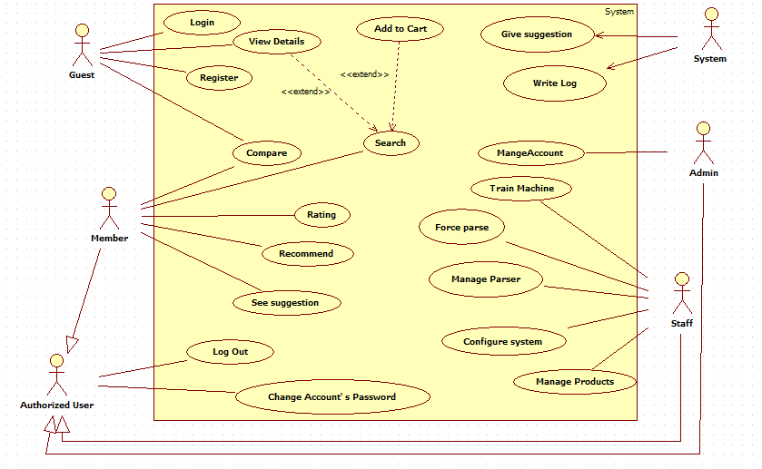

Figure 2: System Overview Use Case

### List of Use Case

#### <Admin>Overview Use Case

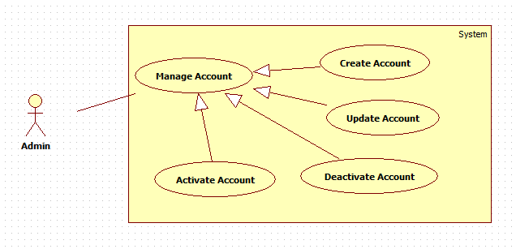

Figure 3: <Admin> Overview Use Case

##### <Admin> Create User

Use Case Diagram



Figure 4: <Admin> Create User

Use Case Specification

|  |  |  |  |
| --- | --- | --- | --- |
| **USE CASE – CPS001** | | | |
| **Use Case No.** | CPS001 | **Use Case Version** | 1.0 |
| **Use Case Name** | Create account | | |
| **Author** | Tran Tan Len | | |
| **Date** | 28/05/2014 | **Priority** | Normal |
| **Actor:**   * Admin   **Summary:**   * This use case allows admin to create new account in the system.   **Goal:**   * New account will be added to the system.   **Triggers:**   * Admin wants to create new account. * From the sidebar:   + Choose “Quản lý tài khoản” menu.   + Choose “Tạo tại khoản mới” button.   **Preconditions:**   * User must login the system with admin role.   **Post Conditions:**   * **Success:** New account will be added to the database. * **Fail:** Show error message on the current page.   **Main Success Scenario:**   |  |  |  | | --- | --- | --- | | Step | Actor Action | System Respone | | 1 | Click menu item “Quản lý tài khoản”. | Navigate to “Quản lý tài khoản” page which contains:   * “Tạo tài khoản mới” button. * A table with 5 columns:   + Tên Tài Khoản.   + Email.   + Vai trò.   + Kích Hoạt.   + Sửa. * “Tên Tài Khoản”: label. * “Địa chỉ Email”: label. * “Vai trò”: label. * “Hoạt Động”: button or “Ngưng Hoạt Động”: button * “Sửa”: button. | | 2 | Admin clicks “Tạo tài khoản mới” button. | Navigate to “Tạo tài khoản mới” popup which contains:   * Tên tài khoản: textbox, min length: 5, max length: 100, required. * Mật khẩu: textbox, min length: 5, max length: 100, required. * Xác nhận mật khẩu: textbox, min length: 5, max length: 100, required. * Địa chỉ Email:regular expression: /^[_a-z0-9-]+(\.[_a-z0-9-]+)*@@[a-z0-9-]+(\.[a-z0-9-]+)*(\.[a-z]{2,4})$/ required. * Vai trò: drop down list, “admin" default. * “Tạo tài khoản”: button. * “Xóa Trắng”: button. | | 3 | Admin fills data to the form.  Admin clicks “Tạo tài khoản” button.  [Alternative 1] | Insert new account to the database and close popup  [Exception 1, 2, 3,4,5] |   **Alternative Scenario:**   |  |  |  | | --- | --- | --- | | No | ctor Action | System Response | | 1 | Admin clicks “Xóa Trắng” button”. | Clear all input data. |   **Exceptions:**   |  |  |  | | --- | --- | --- | | No | Actor Action | System Response | | 1 | “Tên Tài Khoản”is not in range [5-100]. | “Tên Tài Khoản” textbox border color is red. | | 2 | “Mật Khẩu” is not in range  [5-100]. | “Mật Khẩu” textbox border color is red. | | 3 | “Tên Tài Khoản” has already existed. | Show message: “Tài khoản đã tồn tại!” and “Tên Tài Khoản” textbox border color is red. | | 4 | “Xác nhận mật khẩu” not similer “Mật Khẩu” | “Mật Khẩu” textbox border color is red.  “Xác Nhận Mật Khẩu” textbox border color is red. | | 5 | Invalid email format. | “Email” textbox border color is red. |   **Relationships:** N/A  **Business Rules:**   * Each created account must be in active state when insert to database. | | | |

Table 10: <Admin> Create User

##### <Admin> Update User

Use Case Diagram



Figure 5: <Admin> Update User

Use Case Specification

|  |  |  |  |
| --- | --- | --- | --- |
| **USE CASE – CPS002** | | | |
| **Use Case No.** | CPS002 | **Use Case Version** | 1.0 |
| **Use Case Name** | Update account | | |
| **Author** | Tran Tan Len | | |
| **Date** | 28/05/2014 | **Priority** | Normal |
| **Actor:**   * Admin   **Summary:**   * This use case allows admin to update information for user accounts.   **Goal:**   * New information will be updated to the database.   **Triggers:**   * Admin wants to change some information.   **Preconditions:**   * User must log in system with admin role.   **Post Conditions:**   * **Success:** New information will be updated to the database. * **Fail:** Show error message.   **Main Success Scenario:**   |  |  |  | | --- | --- | --- | | Step | Actor Action | System Response | | 1 | Click menu item “Quản lý tài khoản”. | Navigate to “Quản lý tài khoản” page which contains:   * “Tạo tài khoản mới” button. * A table with 5 columns:   + Tên Tài Khoản.   + Email.   + Vai trò.   + Kích Hoạt.   + Sửa. * “Tên Tài Khoản”: label. * “Địa chỉ Email”: label. * “Vai trò”: label. * “Hoạt động”: button or “Ngưng hoạt động”: button. * “Sửa”: button | | 2 | Click “Sửa” button. | Navigate to “Cập nhập tài khoản” popup, which contains:   * Tên Tài Khoản: textbox, disabled. * Mật khẩu: textbox, min length: 5, max length: 100. * Xác nhận mật khẩu: textbox, min length: 5, max length: 100. * Địa Chỉ Email: regular expression: /^[_a-z0-9-]+(\.[_a-z0-9-]+)*@@[a-z0-9-]+(\.[a-z0-9-]+)*(\.[a-z]{2,4})$/ required. * Vai trò: drop down list, “user" default. * “Lưu”: button. | | 3 | Admin updates “Mật Khẩu”,”Email”,”Vai trò”.  Click “Lưu” button. | New information will be updated to the database and close the popup.  [Exception1,2,3] |   **Alternative Scenario:** N/A  **Exceptions:**   |  |  |  | | --- | --- | --- | | No | Actor Action | System Response | | 1 | “Mật khẩu” is not in range  [5,100]. | “Mật Khẩu” textbox border color is red. | | 2 | Invalid email formt. | Show error message: “Địa Chỉ Email phải đúng định dạng!” | | 3 | “Xác Nhận Mật khẩu” is not similar “Mật Khẩu” | “Mật Khẩu” textbox border color is red.  “Xác Nhận Mật Khẩu” textbox border color is red. |   **Relationships:** N/A  **Business Rules:**   * Can’t edit “Tên Tài khoản”. | | | |

Table 11: <Admin> Update User

##### <Admin> Activate User

Use Case Diagram

Figure 6: <Admin> Activate User

Use Case Specification

|  |  |  |  |
| --- | --- | --- | --- |
| **USE CASE – CPS003** | | | |
| **Use Case No.** | CPS003 | **Use Case Version** | 1.0 |
| **Use Case Name** | Activate Account | | |
| **Author** | Tran Tan Len | | |
| **Date** | 28/05/2014 | **Priority** | Normal |
| **Actor:**   * Admin   **Summary:**   * This user case allows admin to activate a user account.   **Goal:**   * Deactivated accounts will be activated.   **Triggers:**   * Admin wants to activate an account in order to login into the system.   **Preconditions:**   * User must log in the system with admin role.   **Post Conditions:**   * **Success:** The selected account will be activated. * **Fail:** Database connection is not available. Show error message   **Main Success Scenario:**   |  |  |  | | --- | --- | --- | | Step | Actor Action | System Response | | 1 | Click menu itm “Quản lý tài khoản”. | Navigate to “Quản lý tài khoản” page which contains:   * “Tạo tài khoản mới” button. * A table with 5 columns:   + Tên Tài Khoản.   + Email.   + Vai trò.   + Kích Hoạt.   + Sửa. * “Tên Tài Khoản”: label. * “Địa chỉ Email”: label. * “Vai trò”: label. * “Ngừng Hoạt động”: button.   “Sửa”: button | | 2 | Click “Ngừng Hoạt động” button. | The account will be activating and button name change to “Hoạt động”  [Exception1] |   **Alternative Scenario:** N/A  **Exceptions:**   |  |  |  | | --- | --- | --- | | No | Actor Action | System Response | | 1 | Cannot activate the accoun Due to daabase connection. | Show error message: “Không thể kích hoạt! Vui lòng thử lại sau.” |   **Relationships:** N/A  **Business Rules:**   * Admins can’t activate/deactivate account of themselves or other admins. | | | |

Table 12: <Admin> Activate User

##### <Admin> Deactivate User

Use Case Diagram



Figure 7: <Admin> Deactivate User

Use Case Specification

|  |  |  |  |
| --- | --- | --- | --- |
| **USE CASE – CPS004** | | | |
| **Use Case No.** | CPS004 | **Use Case Version** | 1.0 |
| **Use Case Name** | Deactivate Account | | |
| **Author** | Tran Tan Len | | |
| **Date** | 28/05/2014 | **Priority** | Normal |
| **Actor:**   * Admin   **Summary:**   * This user case allows admin to deactivate an account.   **Goal:**   * An active account will be deactivated.   **Triggers:**   * Admin don’t want the user to login in system. * Admin will deactivate an account.   **Preconditions:**   * User must log in the system with admin role.   **Post Conditions:**   * **Success:** The selected account will be deactivated. * **Fail:** Database connection is not available. Show error message.   **Main Success Scenario:**   |  |  |  | | --- | --- | --- | | Step | Actor Action | System Response | | 1 | Click menu item “Quản lý tài khoản”. | Navigate to “Quản lý tài khoản” page which contains:   * “Tạo tài khoản mới” button. * A table with 5 columns:   + Tên Tài Khoản.   + Email.   + Vai trò.   + Kích Hoạt.   + Sửa. * “Tên Tài Khoản”: label. * “Địa chỉ Email”: label. * “Vai trò”: label. * “Hoạt động”: button.   “Sửa”: button | | 2 | Click “Hoạt động” button. | The account will be deactivating and button name change to “Ngừng Hoạt động”  [Exception1] |   **Alternative Scenario:** N/A  **Exceptions:**   |  |  |  | | --- | --- | --- | | No | Actor Action | System Response | | 1 | Cannot activate the accout due to database connection. | Show error message: “Không thể kích hoạt! Vui lòng thử lại sau.” |   **Relationships:** Manage Account  **Business Rules:**   * Admins can’t activate/deactivate account of themselves or other admins. | | | |

Table 13: <Admin> Deactivate User

#### <Staff >Overview Use Case



Figure 8: <Staff> Overview Use Case

##### <Staff> Create parser

Use Case Diagram

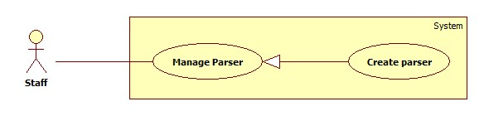

Figure 9: <Staff> Create Parser

Use Case Specification

|  |  |  |  |
| --- | --- | --- | --- |
| **USE CASE – CPS005** | | | |
| **Use Case No.** | CPS005 | **Use Case Version** | 1.0 |
| **Use Case Name** | Create Parser | | |
| **Author** | Pham Hong Sang | | |
| **Date** | 02/06/2014 | **Priority** | High |
| **Actor:**   * Staff.   **Summary:**   * This use case allows staff to create new parser.   **Goal:**   * New parser will be created.   **Triggers:**   * Staffs want to create a new parser to get data from a website. * Staff clicks “Tạo parser” sub menu.   **Preconditions:**   * User has logged in with staff role.   **Post Conditions:**   * **Success**: New parser is added to the system. Show success message. * **Fail:** Show error message.   **Main Success Scenario:**   |  |  |  | | --- | --- | --- | | Step | Actor Action | Sstem Response | | 1 | Staff clicks “Quản lí parser” in menubar. | Show sub menu which includes:   * Tạo parser: submenu. * Danh sách parser: submenu. | | 2 | Staff clicks “Tạo parser” sub menu. | Show “Tạo Parser” page which includes:   * Link cần lấy: text box, min length: 1, max length: 300, required. * Xem: button | | 3 | Staff enters a link and click “Xem” button. | Show “Tạo Parser” page which includes:   * Link cần lấy: display entered value. * Xem: button. * Wizard to create parser. * A frame to show staff’s selected page.   [Alternatvie 1]  [Exception 1] | | 4 | At parse data page, staff input an URL of product into textbox in “Đường dẫn sản phẩm” panel, then click “Xem trước” button. | * Show “Các bước parse dữ liệu” panel includes a wizard to create a parser with 8 steps. * Show “Xem trước” panel include a frame preview the page of the URL which staff inputted. [Exception 1] | | 5 | At steps 1: “Tên sản phẩm”, staff clicks the mouse at the area which include product’s name in “Xem trước” panel, then click “Tiếp theo” button. | * Textbox “Xpath tới tên sản phẩm” filled with the xpath string, required. * Show step 2 of the wizard: “Giá” includes “Xpath tới Giá” textbox. * Show “Xem trước” panel includes a frame preview the page of the URL which staff inputted. * [Exception 2] | | 5 | At steps 2: “Giá sản phẩm”, staff clicks the mouse at the area which include product’s price in “Xem trước” panel, then click “Tiếp theo” button. | * Textbox “Xpath tới giá sản phẩm” filled with the xpath string, required. * Show step 3 of the wizard: “Ảnh” includes “Xpath tới Ảnh” textbox. * Show “Xem trước” panel includes a frame preview the page of the URL which staff inputted. * [Exception 3] | | 6 | At step 3: “Ảnh”, staff clicks the mouse at the area which include image information in “Xem trước” panel, then click “Tiếp theo” button. | * Textbox “Xpath tới ảnh sản phẩm” filled with the xpath string, required. * Show step 4 of the wizard: “CPU” includes “Xpath tới CPU” textbox. * Show “Xem trước” panel includes a frame preview the page of the URL which staff inputted. * [Exception 4] | | 8 | At step 4:”CPU”, staff click the mouse at the area which includes CPU information in “Xem trước” panel, then click “Tiếp theo” button. | * Textbox “Xpath tới CPU” filled with the xpath string, required. * Show step 5 of the wizard: “VGA” includes “Xpath tới độ phân giải màn hình” textbox. * Show “Xem trước” panel includes a frame preview the page of the URL which staff inputted. * [Exception 5] | | 8 | At step 5:”Card màn hình”, staff click the mouse at the area which include VGA information in “Xem trước” panel, then click “Tiếp theo” button. | * Textbox “Xpath tới HDD” filled with the xpath string, required. * Show step 6 of the wizard: “HDD” includes “Xpath tới HDD” textbox. * Show “Xem trước” panel includes a frame preview the page of the URL which staff inputted. * [Exception 6] | | 9 | At step 6: “HDD hình”, staff click the mouse at the area which include HDD information in “Xem trước” panel, then click “Tiếp theo” button. | * Textbox “Xpath tới HDD” filled with the xpath string, required. * Show step 7 of the wizard: “Ram” includes “Xpath tới Ram sản phẩm” textbox. * Show “Xem trước” panel includes a frame preview the page of the URL which staff inputted. * [Exception 7] | | 10 | At step 7:”Display sản phẩm”, staff click the mouse at the area which include product’s screen solution information in “Xem trước” panel, then click “Tiếp theo” button. [Alternative 2] | * Textbox “Xpath tới độ rộng màn hình” filled with the xpath string, required. * Show “Hoàn thành” button. * Show “Xem trước” panel includes a frame preview the page of the URL which staff inputted. * [Exception 8] | | 11 | Staff click “Hoàn thành” button. | * Send request to the parsed link. * Fetch data from the response based on the inputted XPaths. * Validate data [Exception 8]. * If data is valid, insert to database [Alternative 3]. |   **Alternative Scenario:**   |  |  |  | | --- | --- | --- | | Step | Actor Action | System Response | | 1 | Staff inputted value then did not click on “Tạo” button. | * Do nothing. | | 2 | At step 8: “Display sản phẩm”, staff click “Tiếp theo” button. [Alternative 3] | * Show “Hoàn thành” button. * Show “Xem trước” panel includes a frame preview the page of the URL which staff inputted. | | 3 | Staffs follow the wizard to complete the process, then click “Hoàn thành” button. | * If data is valid, insert to database. |   **Exceptions:**   |  |  |  | | --- | --- | --- | | Step | Actor Action | System Response | | 1 | “Link cần lấy” is a blank. | * Show message error:”Vui long nhập thông tin vào ô Link cần lấy”. | | 2 | “Xpath tới tên sản phẩm” is a blank. | * Show message error:”Vui long nhập thông tin vào ô Xpath tới tên sản phẩm”. | | 3 | “Xpath tới tên sản phẩm” is a blank. | * Show message error:”Vui long nhập thông tin vào ô Xpath tới tên sản phẩm”. | | 4 | “Xpath tới ảnh sản phẩm” is a blank. | * Show message error:”Vui long nhập thông tin vào ô Xpath tới ảnh sản phẩm”. | | 5 | “Xpath tới CPU” is a blank | * Show message error:”Vui long nhập thông tin vào ô Xpath tới CPU”. | | 6 | “Xpath tới card màn hình” is a blank. | * Show message error:”Vui long nhập thông tin vào ô Xpath tới card màn hình”. | | 7 | “Xpath tới RAM” is a blank | * Show message error:”Vui long nhập thông tin vào ô Xpath tới RAM”. | | 8 | “Xpath tới độ phân giải màn hình” is a blank. | * Show message error:”Vui long nhập thông tin vào ô Xpath tới độ phân giải màn hình”. | | 9 | Data is not valid. | * Don’t insert to database. |   **Relationships:** N/A  **Business Rules:**   * The data display structure of that page should be for a specified product. * If the value of RAM, product’s price is negative or not a number, consider invalid. | | | |

Table 14: <Staff> Create Parser

##### <Staff> Update Parser

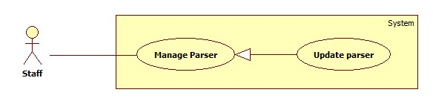

Figure 10: <Staff> Update Parser

|  |  |  |  |
| --- | --- | --- | --- |
| **USE CASE – CPS006** | | | |
| **Use Case No.** | CPS006 | **Use Case Version** | 1.0 |
| **Use Case Name** | Update Parser | | |
| **Author** | Pham Hong Sang | | |
| **Date** | 02/06/2014 | **Priority** | High |
| **Actor:**   * Staff.   **Summary:**   * This use case allows staff to update a parser   **Goal:**   * Selected parser will be updated.   **Triggers:**   * Staff wants to update a parser in the system. * Staff clicks “Chỉnh sửa” link.   **Preconditions:**   * User has logged in with staff role. * There is at least 1 parser which is created before.   **Post Conditions:**   * **Success**: Selected parser will be updated. Show success message. * **Fail:** Show error message.   **Main Success Scenario:**   |  |  |  | | --- | --- | --- | | Step | Actor Action | System Response | | 1 | Staff clicks “Quản lí parser” in menubar. | Show sub menu which includes:   * Tạo parser: submenu. * Danh sách parser: submenu. | | 2 | Staff clicks “Danh sách parser” sub menu. | Show “Danh sách parser” page which includes:   * A table with 4 columns:   + STT  + Link cần lấy  + Trạng thái  + Hành động | | 3 | Staff clicks “Chỉnh sửa” link. | Show “Sửa Parser” page which includes:   * Link cần lấy: display entered value. * Xem: button. * Wizard to create parser. * A frame to show staff’s selected page.   [Exception 1] | | 4 | At parse data page, staff input an URL of product into textbox in “Đường dẫn sản phẩm” panel, then click “Xem trước” button. | * Show “Các bước parse dữ liệu” panel includes a wizard to create a parser with 8 steps. * Show “Xem trước” panel include a frame preview the page of the URL which staff inputted. | | 5 | At steps 1: “Tên sản phẩm”, staff clicks the mouse at the area which include product’s name in “Xem trước” panel, then click “Tiếp theo” button. | * Textbox “Xpath tới tên sản phẩm” filled with the xpath string, required. * Show step 2 of the wizard: “Giá” includes “Xpath tới Giá” textbox. * Show “Xem trước” panel includes a frame preview the page of the URL which staff inputted. * [Exception 2] | | 6 | At steps 2: “Giá sản phẩm”, staff clicks the mouse at the area which include product’s price in “Xem trước” panel, then click “Tiếp theo” button. | * Textbox “Xpath tới giá sản phẩm” filled with the xpath string, required. * Show step 3 of the wizard: “Ảnh” includes “Xpath tới Ảnh” textbox. * Show “Xem trước” panel includes a frame preview the page of the URL which staff inputted. * [Exception 3] | | 7 | At step 3: “Ảnh”, staff clicks the mouse at the area which include image information in “Xem trước” panel, then click “Tiếp theo” button. | * Textbox “Xpath tới ảnh sản phẩm” filled with the xpath string, required. * Show step 4 of the wizard: “CPU” includes “Xpath tới CPU” textbox. * Show “Xem trước” panel includes a frame preview the page of the URL which staff inputted. * [Exception 4] | | 8 | At step 4:”CPU”, staff click the mouse at the area which includes CPU information in “Xem trước” panel, then click “Tiếp theo” button. | * Textbox “Xpath tới CPU” filled with the xpath string, required. * Show step 5 of the wizard: “VGA” includes “Xpath tới độ phân giải màn hình” textbox. * Show “Xem trước” panel includes a frame preview the page of the URL which staff inputted. * [Exception 5] | | 9 | At step 5:”Card màn hình”, staff click the mouse at the area which include VGA information in “Xem trước” panel, then click “Tiếp theo” button. | * Textbox “Xpath tới HDD” filled with the xpath string, required. * Show step 6 of the wizard: “HDD” includes “Xpath tới HDD” textbox. * Show “Xem trước” panel includes a frame preview the page of the URL which staff inputted. * [Exception 6] | | 10 | At step 6: “HDD hình”, staff click the mouse at the area which include HDD information in “Xem trước” panel, then click “Tiếp theo” button. | * Textbox “Xpath tới HDD” filled with the xpath string, required. * Show step 7 of the wizard: “Ram” includes “Xpath tới Ram sản phẩm” textbox. * Show “Xem trước” panel includes a frame preview the page of the URL which staff inputted. * [Exception 7] | | 11 | At step 7:”Display sản phẩm”, staff click the mouse at the area which include product’s screen solution information in “Xem trước” panel, then click “Tiếp theo” button. [Alternative 2] | * Textbox “Xpath tới độ rộng màn hình” filled with the xpath string, required. * Show “Hoàn thành” button. * Show “Xem trước” panel includes a frame preview the page of the URL which staff inputted. * [Exception 8] | | 12 | Staff cick “Hoàn thành” button. | * Send request to the parsed link. * Fetch data from the response based on the inputted XPaths. * Validate data [Exception 8]. * If data is valid, insert to database [Alternative 3]. |   **Alternative Scenario:**   |  |  |  | | --- | --- | --- | | Step | Actor Action | System Response | | 1 | Staff inputted value then did not click on “Tạo” button. | * Do nothing. | | 2 | At step 8: “Giá sản phẩm”, staff click “Tiếp theo” button. [Alternative 3] | * Show “Hoàn thành” button. * Show “Xem trước” panel includes a frame preview the page of the URL which staff inputted. | | 3 | Staffs follow the wizard to complete the process, then click “Hoàn thành” button. | * If data is valid, insert to database. |   **Exceptions:**   |  |  |  | | --- | --- | --- | | Step | Actor Action | System Response | | 1 | “Link cần lấy” is a blank. | * Show message error:”Vui long nhập thông tin vào ô Link cần lấy”. | | 2 | “Xpath tới tên sản phẩm” is a blank. | * Show message error:”Vui long nhập thông tin vào ô Xpath tới tên sản phẩm”. | | 3 | “Xpath tới tên sản phẩm” is a blank. | * Show message error:”Vui long nhập thông tin vào ô Xpath tới tên sản phẩm”. | | 4 | “Xpath tới ảnh sản phẩm” is a blank. | * Show message error:”Vui long nhập thông tin vào ô Xpath tới ảnh sản phẩm”. | | 5 | “Xpath tới CPU” is a blank | * Show message error:”Vui long nhập thông tin vào ô Xpath tới CPU”. | | 6 | “Xpath tới card màn hình” is a blank. | * Show message error:”Vui long nhập thông tin vào ô Xpath tới card màn hình”. | | 7 | “Xpath tới RAM” is a blank | * Show message error:”Vui long nhập thông tin vào ô Xpath tới RAM”. | | 8 | “Xpath tới độ phân giải màn hình” is a blank. | * Show message error:”Vui long nhập thông tin vào ô Xpath tới độ phân giải màn hình”. |   **Relationships:** N/A  **Business Rules:**   * The data display structure of that page should be for a specified product. * If the value of RAM, product’s price is negative or not a number, consider invalid. * There is at least 1 created parser in database. * Selected parser will be updated new information and insert into database. | | | |

Table 15: <Staff> Update Parser

##### <Staff> Deactivate Parser

Use Case Diagram

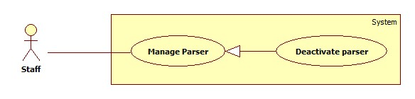

Figure 11: <Staff> Deactivate Parser

Use Case Specification

|  |  |  |  |
| --- | --- | --- | --- |
| **USE CASE – CPS007** | | | |
| **Use Case No.** | CPS007 | **Use Case Version** | 1.0 |
| **Use Case Name** | Deactivate Parser | | |
| **Author** | Pham Hong Sang | | |
| **Date** | 30/05/2014 | **Priority** | High |
| **Actor:**   * Staff.   **Summary:**   * This use case allows staff to deactivate a parser   **Goal:**   * Selected parser will be deactivated.   **Triggers:**   * Staff wants to deactivate a parser in the system. * Staff clicks “Quản lý parser” menu, clicks “Danh sách parser” then clicks “Hoạt động” button.   **Preconditions:**   * User has logged in with staff role.   **Post Conditions:**   * **Success**: Selected parser is deactivated. Show success message. * **Fail:** Show error message.   **Main Success Scenario:**   |  |  |  | | --- | --- | --- | | Step | Actor Action | System Response | | 1 | Staff clicks “Danh sách parser” sub menu. | Show “Danh sách parser” page which includes:   * A table with 4 columns:   + STT   + Link cần lấy   + Trạng thái   + Hành động | | 2 | Staff clicks “Hoạt động” button.  [Alternative 1]  [Exception 1] | That parser is deactivated. The button text is changed into “Không hoạt động”. Show success message. |   **Alternative Scenario:**   |  |  |  | | --- | --- | --- | | Step | Actor Action | System Rsponse | | 1 | Staff clicks on “Chỉnh sửa”button | * System will redirect to “Chinh sửa” page. |   **Exceptions:**   |  |  |  | | --- | --- | --- | | Step | Actor Action | System Response | | 1 | Error while deactivating parser. | Show error message. |   **Relationships:** N/A  **Business Rules:** Only parsers which have “Hoạt động” status will be deactivated. | | | |

Table 16: <Staff> Deactivate Parser

##### <Staff> Activate Parser

Use Case Diagram

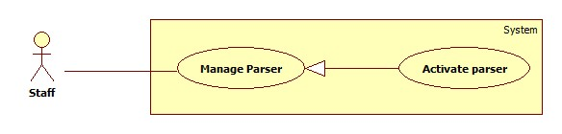

Figure 12: <Staff> Activate Parser

Use Case Specification

|  |  |  |  |
| --- | --- | --- | --- |
| **USE CASE – CPS008** | | | |
| **Use Case No.** | CPS008 | **Use Case Version** | 1.0 |
| **Use Case Name** | Activate Parser | | |
| **Author** | Pham Hong Sang | | |
| **Date** | 02/06/2014 | **Priority** | High |
| **Actor:**   * Staff.   **Summary:**   * This use case allows staff to activate a parser   **Goal:**   * Selected parser will be activated.   **Triggers:**   * Staff wants to activate a parser in the system. * Staff clicks “Quản lý parser” menu, clicks “Danh sách parser” then clicks “Không hoạt động” button.   **Preconditions:**   * User has logged in with staff role.   **Post Conditions:**   * **Success**: Selected parser is activated. Show success message. * **Fail:** Show error message.   **Main Success Scenario:**   |  |  |  | | --- | --- | --- | | Step | Actor Action | System Response | | 1 | Staff clicks “Danh sách parser” menu. | Show “Danh sách parser” page which includes:   * A table with 4 columns:   + STT   + Link cần lấy   + Trạng thái   + Hành động | | 2 | Staff clicks “Không hoạt động” button.  [Alternative 1]  [Exception 1] | That parser is activated. The button text is changed into “Hoạt động”. Show success message. |   **Alternative Scenario:**   |  |  |  | | --- | --- | --- | | Step | Actor Action | System Response | | 1 | Staff clicks on “Chỉnh sửa”button. | * System will redirect to “Chinh sửa” page. |   **Exceptions:**   |  |  |  | | --- | --- | --- | | Step | Actor Action | System Response | | 1 | Error while activating parser. | Show error message. |   **Relationships:** N/A  **Business Rules:** Only parsers which have “Không hoạt động” status will be activated. | | | |

Table : <Staff> Activate Parser

##### <Staff> Configure System

Use Case Diagram

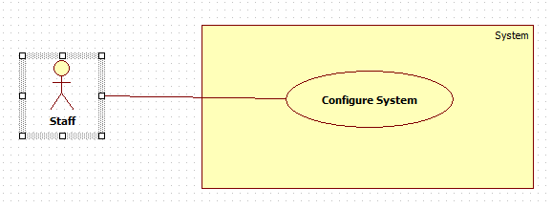

Figure : <Staff> Configure System

Use Case Specification

|  |  |  |  |
| --- | --- | --- | --- |
| **USE CASE – CPS009** | | | |
| **Use Case No.** | CPS009 | **Use Case Version** | 1.0 |
| **Use Case Name** | Configure system | | |
| **Author** | Pham Hong Sang | | |
| **Date** | 02/06/2014 | **Priority** | High |
| **Actor:**   * Staff.   **Summary:**   * This use case allows staff to configure the system.   **Goal:**   * System parameters will be configured by admin.   **Triggers:**   * Staff wants to change system parameter, such as epsilon number,” Số lần được đề cử của mỗi sản phẩm chờ duyệt” or “Số lần được đề cử của một người dùng trên một sản phẩm”. * From the sidebar:   + Choose “Hệ thống” menu.   + Choose “Cấu hình hệ thống” sub-menu.   **Preconditions:**   * User must log in the system with Staff role.   **Post Conditions:**   * **Success:** New parameter will be saved to configuration file. * **Fail:** Nothing is saved to configuration file.   **Main Success Scenario:**   |  |  |  | | --- | --- | --- | | Step | Actor Action | System Response | | 1 | Click at “Cấu hình hệ thống” link in sub-menu. | Show “Cấu hình hệ thống” page which contains:   * “Thời gian chạy parser mỗi ngày”: textbox, min time: 00:00, max time: 23.58, type: time, required. * “Thời gian cập nhập giá mỗi ngày”: textbox, min time: 00:00, max time: 23.58, type: time, required. * Lưu: button. | | 2 | Staff changes system parameters. |  | | 3 | Click on “Lưu” button.  [Exception 1] | * Save data to configuration file. * Show success message. |   **Alternative Scenario:** N/A  **Exceptions:**   |  |  |  | | --- | --- | --- | | No | Actor Action | System Response | | 1 | Connection to database error. | Show error message: “Không thể cập nhập thời gian cấu hình cho hệ thống, vui lòng thử lại sau!” |   **Relationships:** N/A  **Business Rules:**   * “Thời gian chạy parser mỗi ngày” mean time the system auto parser product by link staff approved. * “Thời gian cập nhập giá mỗi ngày” mean time the system auto update product price from parser available. | | | |

Table : Staff> Configure System

##### <Staff> Force parse data

Use Case Diagram

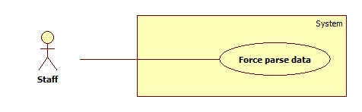

Figure 14: <Staff> Force parses data

Use Case Specification

|  |  |  |  |
| --- | --- | --- | --- |
| **USE CASE – CPS0010** | | | |
| **Use Case No.** | CPS0010 | **Use Case Version** | 1.0 |
| **Use Case Name** | Force Parse Data | | |
| **Author** | Huynh Thanh Viet | | |
| **Date** | 19/05/2014 | **Priority** | High |
| **Actor:**   * Staff.   **Summary:**   * Staff can force system to parse data at any time.   **Goal:**   * Get data from the url which user suggested.   **Triggers:**   * Staff wants to run the parser at that time. * Staff inputs the url which user suggested to “Đường dẫn sản phẩm” textbox.   **Preconditions:**   * User logged in with “Staff” role.   **Post Conditions:**   * **Success:** New data is inserted to database. Success log file is generated. * **Fail:** Show error message, fail log file is generated.   **Main Success Scenario:**   |  |  |  | | --- | --- | --- | | Step | Actor Action | System Response | | 1 | At parse data page, staff input a url of product into textbox in “Đường dẫn sản phẩm” panel, then click “Xem trước” button. | * Show “Các bước parse dữ liệu” panel includes a wizard to create a parser with 8 steps. * Show “Xem trước” panel include a frame preview the page of the url which staff inputted. | | 2 | At steps 1: “Tên sản phẩm”, staff clicks the mouse at the area which include product’s name in “Xem trước” panel, then click “Tiếp theo” button. | * Textbox “Xpath tới tên sản phẩm” filled with the xpath string, required. * Show step 2 of the wizard: “Giá” includes “Xpath tới Giá” textbox. * Show “Xem trước” panel includes a frame preview the page of the URL which staff inputted. * [Exception 2] | | 3 | At steps 2: “Giá sản phẩm”, staff clicks the mouse at the area which include product’s price in “Xem trước” panel, then click “Tiếp theo” button. | * Textbox “Xpath tới giá sản phẩm” filled with the xpath string, required. * Show step 3 of the wizard: “Ảnh” includes “Xpath tới Ảnh” textbox. * Show “Xem trước” panel includes a frame preview the page of the URL which staff inputted. * [Exception 3] | | 4 | At step 3: “Ảnh”, staff clicks the mouse at the area which include image information in “Xem trước” panel, then click “Tiếp theo” button. | * Textbox “Xpath tới ảnh sản phẩm” filled with the xpath string, required. * Show step 4 of the wizard: “CPU” includes “Xpath tới CPU” textbox. * Show “Xem trước” panel includes a frame preview the page of the URL which staff inputted. * [Exception 4] | | 5 | At step 4:”CPU”, staff click the mouse at the area which includes CPU information in “Xem trước” panel, then click “Tiếp theo” button. | * Textbox “Xpath tới CPU” filled with the xpath string, required. * Show step 5 of the wizard: “VGA” includes “Xpath tới độ phân giải màn hình” textbox. * Show “Xem trước” panel includes a frame preview the page of the URL which staff inputted. * [Exception 5] | | 6 | At step 5:”Card màn hình”, staff click the mouse at the area which include VGA information in “Xem trước” panel, then click “Tiếp theo” button. | * Textbox “Xpath tới HDD” filled with the xpath string, required. * Show step 6 of the wizard: “HDD” includes “Xpath tới HDD” textbox. * Show “Xem trước” panel includes a frame preview the page of the URL which staff inputted. * [Exception 6] | | 7 | At step 6: “HDD hình”, staff click the mouse at the area which include HDD information in “Xem trước” panel, then click “Tiếp theo” button. | * Textbox “Xpath tới HDD” filled with the xpath string, required. * Show step 7 of the wizard: “Ram” includes “Xpath tới Ram sản phẩm” textbox. * Show “Xem trước” panel includes a frame preview the page of the URL which staff inputted. * [Exception 7] | | 8 | At step 7:”Display sản phẩm”, staff click the mouse at the area which include product’s screen solution information in “Xem trước” panel, then click “Tiếp theo” button. [Alternative 2] | * Textbox “Xpath tới độ rộng màn hình” filled with the xpath string, required. * Show “Hoàn thành” button. * Show “Xem trước” panel includes a frame preview the page of the URL which staff inputted. * [Exception 8] | | 9 | Staff click “Hoàn thành” button. | * Send request to the parsed link. * Fetch data from the response based on the inputted XPaths. * Validate data [Exception 1]. * If data is valid, insert to database [Alternative 2]. * Generate success log file. |   **Alternative Scenario:**   |  |  |  | | --- | --- | --- | | Step | Actor Action | System Response | | 1 | At step 7: “Độ phân giải màn hình”, staff click “Tiếp theo” button. [Alternative 1] | * Show step 8 of the wizard: “Giá sản phẩm” includes “Xpath tới giá sản phẩm” textbox. * Show “Xem trước” panel includes a frame preview the page of the url which staff inputted. | | 2 | At step 8: “Giá sản phẩm”, staff click “Tiếp theo” button. [Alternative 2] | * Show “Hoàn thành” button. * Show “Xem trước” panel includes a frame preview the page of the url which staff inputted. | | 3 | Staffs follow the wizard to complete the process, then click “Hoàn thành” button. | * If data is valid, insert to database [Alternative 3]. * If fetched product is already in the database, update its information. * Generate success log file. |   **Exceptions:**   |  |  |  | | --- | --- | --- | | No | Actor Action | System Response | | 1 | “Link cần lấy” is a blank. | * Show message error:”Vui long nhập thông tin vào ô Link cần lấy”. | | 2 | “Xpath tới tên sản phẩm” is a blank. | * Show message error:”Vui long nhập thông tin vào ô Xpath tới tên sản phẩm”. | | 3 | “Xpath tới tên sản phẩm” is a blank. | * Show message error:”Vui long nhập thông tin vào ô Xpath tới tên sản phẩm”. | | 4 | “Xpath tới ảnh sản phẩm” is a blank. | * Show message error:”Vui long nhập thông tin vào ô Xpath tới ảnh sản phẩm”. | | 5 | “Xpath tới CPU” is a blank | * Show message error:”Vui long nhập thông tin vào ô Xpath tới CPU”. | | 6 | “Xpath tới card màn hình” is a blank. | * Show message error:”Vui long nhập thông tin vào ô Xpath tới card màn hình”. | | 7 | “Xpath tới RAM” is a blank | * Show message error:”Vui long nhập thông tin vào ô Xpath tới RAM”. | | 8 | “Xpath tới độ phân giải màn hình” is a blank. | * Show message error:”Vui long nhập thông tin vào ô Xpath tới độ phân giải màn hình”. |   **Relationships:** Login  **Business Rules:**   * If the value of RAM, product’s price is negative or not a number, consider invalid. | | | |

Table : <Staff> Force parses data

##### <Staff> Create Product

Use Case Diagram

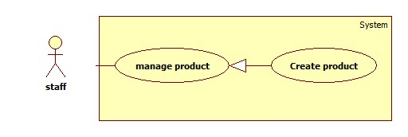

Figure 15: <Staff> Create Product

Use Case Specification

|  |  |  |  |
| --- | --- | --- | --- |
| **USE CASE – CPS0011** | | | |
| **Use Case No.** | CPS0011 | **Use Case Version** | 1.0 |
| **Use Case Name** | Create Product | | |
| **Author** | Ha Chi Danh | | |
| **Date** | 30/05/2014 | **Priority** | Normal |
| **Actor:**   * Staff.   **Summary:**   * This use case allows staff to create product.   **Goal:**   * New product will be added to the database.   **Triggers:**   * Staff wants to create new product. * To input product manually, staff must do the following steps:   + Click “Quản lý sản phẩm” in the menu.   + Click “Tạo sản phẩm” button.   **Preconditions:**   * User must log in the system with staff role.   **Post Conditions:**   * **Success**: New product will be added to the database. * **Fail:** Show error message.   **Main Success Scenario:**   |  |  |  | | --- | --- | --- | | Step | Actor Action | System Response | | 1 | Click “Tạo sản phẩm” button. | Navigate to “Tạo sản phẩm” page which contains:   * Tên sản phẩm: textbox (min length: 5, max length: 100), required. * Link lien quan: textbox (min length: 5, max length: 200), required. * Giá sản phẩm: textbox (float), required. * Hình Ảnh: textbox. * Cửa hàng: dropdownlist. * Hãng: dropdownlist. * Vi xử lý: dropdownlist. * Bộ nhớ: dropdownlist. * Ổ đỉa cứng: dropdownlist. * Card đồ họa: dropdownlist. * Màn hình: dropdownlist. * Mô tả chi tiết: rich textbox. * “Thêm sản phẩm” button. * “Hủy” button. | | 2 | Enter information into text fields.  Click “Thêm sản phẩm” button to finish. | System will add product into database.  A new product will be displayed in list product page. Then, redirect to “Quản lý sản phẩm” page. [Exception 1, 2,3,4] |   **Alternative Scenario:** N/A  **Exceptions:**   |  |  |  | | --- | --- | --- | | Step | Actor Action | System Response | | 1 | “Tên sản phẩm” is not in range [5, 100]. | Display error message: “Tên sản phẩm phải từ 5 đến 100 ký tự”. | | 2 | “Tên sản phẩm” is a blank. | Display error message: “Vui lòng nhập Tên sản phẩm”. | | 3 | “Link liên quan” is not in range [5,200]. | Display error message: “Link liên quản phải từ 5 tới 200 ký tự”. | | 4 | “Giá ản phẩm” is not float. | Display error message: “Giá sản phẩm phải là số nguyên”. |   **Relationships:** N/A  **Business Rules:**   * Staff clicks on “thêm sản phẩm” button. * System will save new product into database. | | | |

Table : < Staff> Create Product

##### <Staff> Update Product

Use Case Diagram



Figure : <Staff> Update Product

Use Case Specification

|  |  |  |  |
| --- | --- | --- | --- |
| **USE CASE – CPS0012** | | | |
| **Use Case No.** | CPS0012 | **Use Case Version** |  |
| **Use Case Name** | Update Product | | |
| **Author** | Ha Chi Danh | | |
| **Date** | 30/05/2014 | **Priority** | Normal |
| **Actor:**   * Staff.   **Summary:**   * This use case allows staff to update product information.   **Goal:**   * New information will be updated to selected product.   **Triggers:**   * Staff wants to change product information. * To change product information, staff must do the following steps:   + Choose “Quản lý sản phẩm” in sidebar menu.   + Click at product.   + Change information.   + Click “Cập nhật” button to save new data to database.   **Preconditions:**   * User must log in the system with staff role. * There is at least one product in the database.   **Post Conditions:**   * **Success**: New information will be updated to selected product. * **Fail:** Show error message.   **Main Success Scenario:**   |  |  |  | | --- | --- | --- | | Step | Actor Action | System Response | | 1 | Click “Quản lý sản phẩm” sub-menu. | Navigate to “Quản lý sản phẩm” page which contains:   * + Số thứ tự: label.   + Tên sản phẩm: label.   + Giá sản phẩm: label.   + Đường dẫn: link button.   + Chỉnh sửa: button.   + Hoạt động: button. | | 2 | Click at any product “Chỉnh sửa button”. | Navigate to “Thông tin sản phẩm” page which contains:   * Tên sản phẩm: textbox (min length: 5, max length: 100), required. * Link lien quan: textbox (min length: 5, max length: 200), required. * Giá sản phẩm: textbox (float), required. * Hình Ảnh: textbox. * Cửa hàng: dropdownlist. * Hãng: dropdownlist. * Vi xử lý: dropdownlist. * Bộ nhớ: dropdownlist. * Ổ đỉa cứng: dropdownlist. * Card đồ họa: dropdownlist. * Màn hình: dropdownlist. * Mô tả chi tiết: rich textbox. * Cập nhật: button. | | 3 | Click “Cập nhật” button. | Save new data to the database. Redirect to “Quản lý sản phẩm” page.[Exception 1, 2,3] |   **Alternative Scenario:** N/A  **Exceptions:**   |  |  |  | | --- | --- | --- | | Step | Actor Action | System Response | | 1 | “Tên sản phẩm” is not in range [5, 100]. | Display error message: “Tên sản phẩm phải từ 5 đến 100 ký tự”. | | 2 | “Tên sản phẩm” is a blank. | Display error message: “Vui lòng nhập Tên sản phẩm”. | | 3 | “Link liên quan” is not in range [5,200]. | Display error message: “Link liên quản phải từ 5 tới 200 ký tự”. | | 4 | “Giá ản phẩm” is not float. | Display error message: “Giá sản phẩm phải là số nguyên”. |   **Relationships:** N/A.  **Business Rules:**   * Staff clicks “cập nhật” button. * This product will be update information in database. | | | |

Table : <Staff> Update Product

##### <Staff> Deactivate Product

Use Case Diagram



Figure 17: <Staff> Deactivate Product

Use Case Specification

|  |  |  |  |
| --- | --- | --- | --- |
| **USE CASE – CPS0013** | | | |
| **Use Case No.** | CPS0013 | **Use Case Version** | 2.0 |
| **Use Case Name** | Deactivate Product | | |
| **Author** | Ha Chi Danh | | |
| **Date** | 30/05/2014 | **Priority** | Normal |
| **Actor:**   * Staff.   **Summary:**   * This use case allows staff to deactivate product.   **Goal:**   * Selected product will be deactivated.   **Triggers:**   * Staff wants to deactivate a product in the system. * To deactivate a product, staff must do the following steps:   + Choose “Quản lý sản phẩm” in sidebar menu.   + Click on “Hoạt động” button.  **Preconditions:**   * User must log in the system with staff role. * There is at least one product activated in database.   **Post Conditions:**   * **Success**: Selected product will be deactivated. * **Fail:** Show error message.   **Main Success Scenario:**   |  |  |  | | --- | --- | --- | | Step | Actor Action | System Response | | 1 | Click “Quản lý sản phẩm” menu. | Navigate to “Quản lý sản phẩm” page which contains:   * A table has 6 columns:   + Số thứ tự: label.   + Tên sản phẩm: label.   + Giá sản phẩm: label.   + Đường dẫn: link button.   + Chỉnh sửa: button.   + Hoạt động: button. | | 2 | Click on “Hoạt động” button. | Deactivate selected product. “Hoạt động” button chage to “Ngưng hoạt động” button.  [Exception 1] |   **Alternative Scenario:** N/A  **Exceptions:**   |  |  |  | | --- | --- | --- | | No | Actor Action | System Response | | 1 | Cannot deactivate product due to database connection problem | Show error message: “Thao tác thất bại. Vui lòng thử lại sau!” |   **Relationships: N/A**  **Business Rules:**   * Staff clicks “Không hoạt động” button. * Button is changed label from “Hoạt động” to “Không hoạt động” and colour to red. | | | |

Table 22: <Staff> Deactivate Product

##### <Staff> Import product file

Use Case Diagram



Figure : <Staff> Import product file

Use Case Specification

|  |  |  |  |
| --- | --- | --- | --- |
| **USE CASE – CPS0014** | | | |
| **Use Case No.** | CPS0014 | **Use Case Version** | 1.0 |
| **Use Case Name** | Import product file | | |
| **Author** | Tran Tan Len | | |
| **Date** | 1/06/2014 | **Priority** | High |
| **Actor:**   * Staff   **Summary:**   * This use case allows staff upload excel file about product (laptop) to server and divide data into three lists to show on page.   **Goal:**   * Show three lists on page.   **Triggers:**   * To import a file, staff must do the following steps:   + Click “Nhập laptop từ excel” menu.   + Choose the file, click “Tải lên” button.   **Preconditions:**   * User must log in the system with staff role.   **Post Conditions:**   * **Success**: Show three list include: * Error product list show on “Danh sách sản phẩm lỗi” tab. * Duplicate product list show on “Danh sách sản phẩm trùng” tab. * Correct product list show on “Danh sách sản phẩm đúng” * **Fail:** File input is wrong format or file size more than 2mb. Show error message.   **Main Success Scenario:**   |  |  |  | | --- | --- | --- | | Step | Actor Action | System Response | | 1 | From the staff’s page, staff clicks “Nhập laptop từ excel” link. | Show “Nhập laptop từ excel” page with 2 buttons:   * “Browse” button. * “Tải lên” button. * Three tab include: * “Danh sách sản phẩm đúng” tab. * “Danh sách sản phẩm lỗi” tab. * “Danh sách sản phẩm trùng” tab. | | 2 | From “Nhập laptop từ excel” page, staff clicks “Browse” button, then clicks “Mở”. | System will get file path and show excel name on text box. | | 3 | Staff clicks “Tải lên” button. | File is uploaded to server, then redirect back to “Nhập laptop từ excel” page, contains:   * System will be showed correct product list on table with 11   columns in “Danh sách sản phẩm đúng” tab:   * + “STT”: label.   + “Tên máy”: label.   + “Địa chỉ ảnh”: label.   + “CPU”: label.   + “VGA”: label.   + “HDD”: label.   + “Màn Hình”: label.   + “Ram”: label.   + “Giá”: label.   + “Địa chỉ bán”: label.   + “Xóa” button.   + “Sửa” button. * System will be showed error product list on table with 10 columns in “Danh sách sản phẩm lỗi” tab:   + “STT” : label   + “Tên Máy”: textbox (min length: 5 max length: 100, required).   + “Địa chỉ ảnh”: textbox (image URL is exists, required).   + “CPU”: textbox (min length: 5 max length: 100, required).   + “VGA”: textbox (min length: 5 max length: 100, required).   + “Màn Hình”: textbox (min length: 1 max length: 100, required).   + “Ram”: textbox (min length: 1 max length: 100, required).   + “Giá”: textbox (Double, required).   + “Địa chỉ bán”: textbox (URL is exits, required).   + “Lưu” button. * System will be showed tables include duplicate product with 11 columns in “Danh sách sản phẩm trùng” tab:   + Checkbox.   + “Tên Máy” labels.   + “Địa chỉ ảnh” labels.   + “CPU” labels.   + “VGA” labels.   + “HDD” labels.   + “Màn hình” labels.   + “Ram” labels.   + “Giá” labels.   + “Địa chỉ máy” labels.   + “Chọn tên chính” radio button.   + “Gộp” button.   + “Tách” button.   [Exception1,2,3] |   **Alternative Scenario:** N/A  **Exceptions:**   |  |  |  | | --- | --- | --- | | Step | Actor Action | System Response | | 1 | File input is wrong format. | Display error message: “Hệ thống chỉ hỗ trợ file excel”. | | 2 | File size not range [0- 2] Mb. | Display error message: “Kích thước file không được vượt quá 2Mb. | | 3 | File has more 5 errors. | Display error message: “File có quá nhiều lỗi vui lòng sửa lại trước khi sử dụng”. Show line error. |   **Relationships:** N/A  **Business Rules:**   * Format file is excel (.xlsx/.xls) * Max length of file is 2Mb. * The product exists in database will be ignored. * Valid file format :      * If system detects more than 5 errors, System will show error message list error products. * Else system will show three list include: * System will check and move error products to error products list and show that on “Danh sách sản phẩm lỗi” tab. * Error products include error: * “Tên Máy” is not in range [5, 100]. * “Địa chỉ ảnh” does not exist. * “Kích thước màn hình”is not in range [1, 100]. * “CPU” is not in range [5, 100]. * “HDD” is not in range [5, 100]. * “VGA” is not in range [5, 100]. * “Ram” is not in range [5, 100]. * “Giá” is not in range [5, 100]. * “Địa chỉ máy” does not exist. * System detect by compare product name algorithms and after that move duplicate products to duplicate products list and show that on “Danh sách sản phẩm trùng” tab. * Duplicate products are product similar name >80% by algorithms:   Example:  FRANCE: {FR, RA, AN, NC, CE}  FRENCH: {FR, RE, EN, NC, CH}  = = 0.4   * System will show correct product list on “Danh sách sản phẩm đúng” tab. | | | |

Table 23: <Staff> Import File

##### <Staff> Process error product

System

**Staff**

**Manager product**

**Import product file**

**Save corect product**

<<extend>>

**Process error product**

<<extend>>

Figure 19: <Staff> Process error product

|  |  |  |  |
| --- | --- | --- | --- |
| **USE CASE – CPS0016** | | | |
| **Use Case No.** | CPS0016 | **Use Case Version** | 1.0 |
| **Use Case Name** | Process error product | | |
| **Author** | Tran Tan Len | | |
| **Date** | 1/06/2014 | **Priority** | High |
| **Actor:**   * Staff   **Summary:**   * This use case allows staff to process error products.   **Goal:**   * Get correct product from error products.   **Triggers:**   * Staff wants to fix product information in error product list. * To process an error product, staff must do the following steps: * Edit product information. * Click “Lưu” button.   **Preconditions:**   * User must log in the system with staff role. * Parse data from excel successful. Error product list is available.   **Post Conditions:**   * **Success**: * Error product will be fixed and transfer to correct product list or duplication product list. * **Fail:** Fixed product still error. Show error message.   **Main Success Scenario:**   |  |  |  | | --- | --- | --- | | Step | Actor Action | System Response | | 1 | Recondition error product list available. Staff clicks “Danh sách sản phẩm lỗi” tab. | * Interface appears, table with 10 columns:   + “STT” : label   + “Tên Máy”: textbox (min length: 5 max length: 100, required).   + “Địa chỉ ảnh”: textbox (image URL is exists, required).   + “CPU”: textbox (min length: 5 max length: 100, required).   + “VGA”: textbox (min length: 5 max length: 100, required).   + “Màn Hình”: textbox (min length: 1 max length: 100, required).   + “Ram”: textbox (min length: 1 max length: 100, required).   + “Giá”: textbox (Double, required).   + “Địa chỉ bán”: textbox (URL is exits, required).   + “Lưu” button | | 2 | Edit product information in row. Then click “Lưu” button | Product information will be updated.  The system will be compared this product name with products in duplicate products list and correct products list. System detects duplicate products. Then move duplicate products to duplicate products list. Else system transfer product to correct product list.  [Exception 1, 2, 3, 4, 5, 6, 7, 8, 9] |   **Alternative Scenario:** N/A  **Exceptions:**   |  |  |  | | --- | --- | --- | | No | Actor Action | System Response | | 1 | “Tên Máy” is not in range [5, 100]. | Display error message: “Lỗi tên sản phẩm (phải từ 5 tới 100 ký tự)”. “Tên Máy” border color textbox is red. | | 2 | “Địa chỉ ảnh” does not exist. | Display error message: “Lỗi liên kết ảnh sản phẩm (phải tồn tại)”. “Địa chỉ ảnh” border color textbox is red. | | 3 | “Kích thước màn hình”is not in range [1, 100]. | Display error message: “Thông tin kích thướng màn hình (không được để trống)”. “Kích thước màn hình” border color textbox is red. | | 4 | “CPU” is not in range [5, 100]. | Display error message: “Lỗi thông tin CPU sản phẩm (phải từ 5 tới 100 ký tự)”. “CPU” border color textbox is red. | | 5 | “HDD” is not in range [5, 100]. | Display error message: “Lỗi thông tin HDD của sản phẩm (Không được để trống và quá 100 ký tự)”. “HDD” border color textbox is red. | | 6 | “VGA” is not in range [5, 100]. | Display error message: “Lỗi thông tin VGA sản phẩm (phải từ 5 tới 100 ký tự)”. “VGA” border color textbox is red. | | 7 | “Ram” is not in range [5, 100]. | Display error message: “Lỗi thông tin Ram của sản phẩm (Không được để trống và quá 100 ký tự)”. “Ram” border color textbox is red. | | 8 | “Giá” is not in range [5, 100]. | Display error message: “Lỗi thông tin Giá của sản phẩm (Phải là số nguyên dương)”. “Giá” border color textbox is red. | | 9 | “Địa chỉ máy” does not exist. | Display error message: “Lỗi liên kết sản phẩm (phải tồn tại)”. “Địa chỉ máy” border color textbox is red. |   **Relationships:** Login, Import Product File.  **Business Rules:**   * System compare products by product name with compare product name algorithms between fixed product and duplicate product list, correct product list. * If systems detect duplicate products, System will move duplicate products to duplicate products list. * Duplicate products are product similar name >80% by algorithms:   Example:  FRANCE: {FR, RA, AN, NC, CE}  FRENCH: {FR, RE, EN, NC, CH}  = = 0.4   * Else system will move correct products to list products. | | | |

Table 24: <Staff> Process error product

##### <Staff> Process duplicate product

System

**Staff**

**Manager product**

**Import product file**

**Save corect product**

<<extend>>

**Process duplicate product**

<<extend>>

Figure 20: <Staff> Process duplicate product

|  |  |  |  |
| --- | --- | --- | --- |
| **USE CASE – CPS0017** | | | |
| **Use Case No.** | CPS0017 | **Use Case Version** | 1.0 |
| **Use Case Name** | Process duplicate product | | |
| **Author** | Tran Tan Len | | |
| **Date** | 1/06/2014 | **Priority** | High |
| **Actor:**   * Staff   **Summary:**   * This use case allows staff to process duplicate products.   **Goal:**   * Get correct product from duplicate products.   **Triggers:**   * Staff wants to join or divide products in duplicate products list. * To join products, staff must do the following steps: * Select at least 2 products. * Click “Gộp” button. * To divide products, staff must do the following steps: * Select products by checkbox. * Click “Tách” button.   **Preconditions:**   * User must log in the system with staff role. * Parse data from excel successful. Duplicate product list is available.   **Post Conditions:**   * **Success**: Duplicate product will be joined or divided and transfer to correct product list. * **Fail:** Not enough products to join, not yet choose product key name. Show error message.   **Main Success Scenario:**   |  |  |  | | --- | --- | --- | | Step | Actor Action | System Response | | 1 | Recondition duplicate product list available.  Click “Danh sách sản phẩm trùng” tab. | Interface appears:   * Tables include duplicate product with 11 columns:   + Checkbox.   + “Tên Máy” labels.   + “Địa chỉ ảnh” labels.   + “CPU” labels.   + “VGA” labels.   + “HDD” labels.   + “Màn hình” labels.   + “Ram” labels.   + “Giá” labels.   + “Địa chỉ máy” labels.   + “Chọn tên chính” radio button. * “Gộp” button. * “Tách” button. | | 2 | Select products by checkbox and select “Chọn tên chính” radio button, Then click “Gộp” button.  [Alternative1] | Selected products will be joined. And move to correct products list. If table still only 1 product. The product move to correct product list.  [Exception 1,2] |   **Alternative Scenario:**   |  |  |  | | --- | --- | --- | | No | Actor Action | System Response | | 1 | Click “Tách” button  [Alternative2] | Products in table will be divided. And move to correct products list. |  |  |  |  | | --- | --- | --- | | No | Actor Action | System Response | | 2 | Select products by checkbox. Then click “Tách” button | New table create and contain selected products. If old table still only 1 product. The product move to correct product list.  [Exception 1] |   **Exceptions:**   |  |  |  | | --- | --- | --- | | Step | Actor Action | System Response | | 1 | Check only 1 checkbox. | Display error message: “Vui lòng chọn ít nhất 2 sản phẩm”. | | 2 | Don’t select “Chọn tên chính” radio button for checked product. | Display error message: “Vui lòng chọn tên chính cho những sản phẩm đã chọn”. |   **Relationships:** Login, Import File.  **Business Rules:**   * Products will be joined by product name. * Merge: make two or more names refer to one product. System will be joined products by product name and separated by “;”. Then, system will be move joined products to correct product list. * Split: different names mean different products. System will move both products to correct product list. | | | |

Table 25: <Staff> Process duplicate product

##### <Staff> Save correct product

System

**Staff**

**Manager product**

**Import product file**

**Save corect product**

<<extend>>

Figure 21: <Staff>save correct product

|  |  |  |  |
| --- | --- | --- | --- |
| **USE CASE – CPS0018** | | | |
| **Use Case No.** | CPS0018 | **Use Case Version** | 1.0 |
| **Use Case Name** | Save correct product | | |
| **Author** | Tran Tan Len | | |
| **Date** | 1/06/2014 | **Priority** | High |
| **Actor:**   * Staff   **Summary:**   * This use case allows staff adds products to database by import data from excel files.   **Goal:**   * Add new many products from imported files.   **Triggers:**   * Staff wants to save correct products by importing excel files. * To save correct products, staff must do the following steps:   + Click “Danh sách sản phẩm đúng” tab.   + Click “Lưu” button.   + Click “Hoàn Thành” button on popup.   **Preconditions:**   * User must log in the system with staff role. * Parse data from excel successful. Correct product list is available.   **Post Conditions:**   * **Success**: Products not available in database will be added to the database.   Products similar name with product in database will be moved to duplicate products list.   * **Fail:** Show error list and require staff try one more time.   **Main Success Scenario:**   |  |  |  | | --- | --- | --- | | Step | Actor Action | System Response | | 1 | Recondition correct product list available.  Click “Danh sách sản phẩm trùng” in menu tab. | File is uploaded to server, then redirect back to “Nhập từ excel” page, contains:   * “Danh sách sản phẩm đúng” tab:   + “STT”: label.   + “Tên máy”: label.   + “Địa chỉ ảnh”: label.   + “CPU”: label.   + “VGA”: label.   + “HDD”: label.   + “Màn Hình”: label.   + “Ram”: label.   + “Giá”: label.   + “Địa chỉ bán”: label.   + “Xóa” button.   + “Sửa” button. * “Lưu” button. * “Hủy” button. | | 2 | Staff clicks “Xóa” button to delete a product.  [Alternative 1] | The product will be deleted in correct product list. | | 3 | Staff clicks “Lưu” button to save product. [Alternative 2] | Compare products in correct products list with database by product name.  Duplicate products will be moved to duplicate products list.  Correct product will be inserted into database.  [Exception 1] | | 4 | Recondition duplicate product list available.  Click “Danh sách sản phẩm trùng” tab. | Interface appears:   * “Lưu file” button. * Tables include duplicate product with 10 columns:   + Checkbox.   + “Tên Máy” labels.   + “Địa chỉ ảnh” labels.   + “CPU” labels.   + “VGA” labels.   + “HDD” labels.   + “Màn hình” labels.   + “Ram” labels.   + “Giá” labels.   + “Địa chỉ máy” labels. * “Gộp” button. * “Tách” button. | | 5 | Staff click “Gộp” button.  [Alternative3] | The product will be inserting to database. Its alias name of a product available in database. |   **Alternative Scenario:**  [Alternative1]   |  |  |  | | --- | --- | --- | | Step | Actor Action | System Response | | 1 | Staff clicks “Sửa” button to fix product. | Popup Interface appears:   * + “Tên Laptop”: textbox (min length: 5 max length: 100, required).   + “Đường dẫn ảnh”: textbox (image URL is exists, required).   + “CPU”: textbox (min length: 5 max length: 100, required).   + “VGA”: textbox (min length: 5 max length: 100, required).   + “Màn Hình”: textbox (min length: 1 max length: 100, required).   + “Ram”: textbox (min length: 1 max length: 100, required).   + “Giá”: textbox (Double, required).   + “Địa chỉ bán”: textbox (URL is exits, required).   “Lưu” button | | 2 | Staff clicks “Lưu” button to fix product. | Product information will be update and popup close.  [Exception 2, 3, 4, 5, 6, 7, 8, 9, 10] |   [Alternative2]   |  |  |  | | --- | --- | --- | | Step | Actor Action | System Response | | 1 | Staff clicks “Hủy” button to finish. | Refresh current page and clear all data. |   [Alternative3]   |  |  |  | | --- | --- | --- | | Step | Actor Action | System Response | | 1 | Staff click “Tách” button. | Product will be inserting to database. Its new product in database. |   **Exceptions:**   |  |  |  | | --- | --- | --- | | Step | Actor Action | System Response | | 1 | Don’t have any product to save. | Display error message: “Chưa có sản phẩm nào để lưu”. | | 2 | “Tên Máy” is not in range [5, 100]. | Display error message: “Lỗi tên sản phẩm (phải từ 5 tới 100 ký tự)”. “Tên Máy” border color textbox is red. | | 3 | “Địa chỉ ảnh” does not exist. | Display error message: “Lỗi liên kết ảnh sản phẩm (phải tồn tại)”. “Địa chỉ ảnh” border color textbox is red. | | 4 | “Kích thước màn hình”is not in range [1, 100]. | Display error message: “Thông tin kích thướng màn hình (không được để trống)”. “Kích thước màn hình” border color textbox is red. | | 5 | “CPU” is not in range [5, 100]. | Display error message: “Lỗi thông tin CPU sản phẩm (phải từ 5 tới 100 ký tự)”. “CPU” border color textbox is red. | | 6 | “HDD” is not in range [5, 100]. | Display error message: “Lỗi thông tin HDD của sản phẩm (Không được để trống và quá 100 ký tự)”. “HDD” border color textbox is red. | | 7 | “VGA” is not in range [5, 100]. | Display error message: “Lỗi thông tin VGA sản phẩm (phải từ 5 tới 100 ký tự)”. “VGA” border color textbox is red. | | 8 | “Ram” is not in range [5, 100]. | Display error message: “Lỗi thông tin Ram của sản phẩm (Không được để trống và quá 100 ký tự)”. “Ram” border color textbox is red. | | 9 | “Giá” is not in range [5, 100]. | Display error message: “Lỗi thông tin Giá của sản phẩm (Phải là số nguyên dương)”. “Giá” border color textbox is red. | | 10 | “Địa chỉ máy” does not exist. | Display error message: “Lỗi liên kết sản phẩm (phải tồn tại)”. “Địa chỉ máy” border color textbox is red. |   **Relationships:** Login, Import File.  **Business Rules:**   * System will compare correct product list with database by compare string algorithms. * If systems detect duplicate products, System will move duplicate products to duplicate product list. * System will add correct products to database. | | | |

Table 26: <Staff> save correct product

##### <Staff> Write log file

System

**Staff**

**Manager product**

**Import product file**

**Write log file**

<<extend>>

Figure 22: <Staff> Write log file

|  |  |  |  |
| --- | --- | --- | --- |
| **USE CASE – CPS0019** | | | |
| **Use Case No.** | CPS0019 | **Use Case Version** | 1.0 |
| **Use Case Name** | Write log file | | |
| **Author** | Tran Tan Len | | |
| **Date** | 1/06/2014 | **Priority** | High |
| **Actor:**   * Staff   **Summary:**   * This use case allows staff to create log file of duplicate products.   **Goal:**   * Log file will be generated.   **Triggers:**   * Staff wants to create log file of duplicate products. * To create log file, staff must do:   + Click “Lưu” button in “Danh sách sản phẩm đúng” tab.   + Click “Sản phẩm trùng” checkbox or “Sản phẩm lỗi” checkbox on popup.   + Click “Hoàn thành” button.   **Preconditions:**   * User must log in the system with staff role. * Parse data from excel successful.   **Post Conditions:**   * **Success**: Log file will be generated. * **Fail:** Show error message and require staff try one more time.   **Main Success Scenario:**   |  |  |  | | --- | --- | --- | | Step | Actor Action | System Response | | 1 | Recondition duplicate product list or error product list available.  Staff clicks “Danh sách sản phẩm đúng” tab. | * “Danh sách sản phẩm đúng” tab:   + “STT”: label.   + “Tên máy”: label.   + “Địa chỉ ảnh”: label.   + “CPU”: label.   + “VGA”: label.   + “HDD”: label.   + “Màn Hình”: label.   + “Ram”: label.   + “Giá”: label.   + “Địa chỉ bán”: label.   + “Xóa” button.   + “Sửa” button. * “Lưu” button. * “Hủy” button. | | 2 | Staff clicks “Lưu” button | * Popup will show include:   + “Sản phẩm trùng”: checkbox.   + “Sản phẩm lỗi”: checkbox.   + “Hoàn Thành” button. | | 3 | Staff checks “Sản Phẩm Trùng”, “Sản phẩm lỗi” checkbox. | * System will save duplicate product on duplicate product list to LapDataTraning.txt text file on server. System will save error product on error product list to ErrorLap.txt text file on server. |   **Alternative Scenario:** N/A  **Exceptions:** N/A  **Relationships:** Login, Import File.  **Business Rules:**   * System recorded log file and staff will use them for training the system then. * Product duplicate will be recorded by each row of each table and seceded by “#”. The product name, image link, cpu, vga, ram, display, price seceded by “|”. * Product error will be recorded by each row of each table and seceded by “#”. | | | |

Table 27: <Staff> Write log file

##### <Staff> Import hardware file

System

**Staff**

**Manager product**

**Import hardware file**

**Write log file**

**Save correct hardware**

<<extend>>

<<extend>>

Figure 23: <Staff> Import hardware file

|  |  |  |  |
| --- | --- | --- | --- |
| **USE CASE – CPS0014** | | | |
| **Use Case No.** | CPS0014 | **Use Case Version** | 1.0 |
| **Use Case Name** | Import hardware file | | |
| **Author** | Tran Tan Len | | |
| **Date** | 1/06/2014 | **Priority** | High |
| **Actor:**   * Staff   **Summary:**   * This use case allows staff upload excel file about hardware (cpu, vga, hdd display, ram) to server and divide data into three lists.   **Goal:**   * Divide data into three lists and show on page.   **Triggers:**   * To import a file, staff must do the following steps:   + Click “Nhập từ excel” menu.   + Choose the file, click “Tải lên” button.   **Preconditions:**   * User must log in the system with staff role.   **Post Conditions:**   * **Success**: : Show three list include: * Error hardware list show on “Danh sách thành phần lỗi” tab. * Duplicate hardware list show on “Danh sách thành phần trùng” tab. * Correct hardware list show on “Danh sách thành phần đúng” * **Fail:** File input is wrong format or file size more than 2mb. Show error message.   **Main Success Scenario:**   |  |  |  | | --- | --- | --- | | Step | Actor Action | System Response | | 1 | From the staff’s page, staff clicks “Nhập linh kiện từ Excel” link. | Show “Nhập linh kiện từ excel” page with 2 buttons:   * “Browse” button. * “Tải lên” button. | | 2 | From “Nhập linh kiện từ excel” page, staff clicks “Browse” button, then clicks “Mở”. | System will get file path and show excel name on text box. | | 3 | Staff clicks “Tải lên” button. | File is uploaded to server, then redirect back to “Nhập từ excel” page, contains:   * System will be showed correct hardware list on table with 5 columns in “Danh sách thành phần đúng” tab:   + “STT”: label.   + “Tên thành phần”: label.   + “Trọng số”: label.   + “Loại”: label.   + “Xóa” button. * System will be showed error hardware list on table with 5 columns in “Danh sách thành phần lỗi” tab:   + “STT” : label   + “Tên thành phần”: textbox (min length: 5 max length: 100, required).   + “Trọng số”: textbox (interger required).   + “Loại”: textbox (“C” or “V” or “R” or “H” or “D”, required).   + “Lưu” button. * System will be showed duplicate hardware lists on tables with 4 columns in “Danh sách thành phần trùng” tab:   + “Chọn” checkbox.   + “Tên”: textbox (min length: 5 max length: 100, required).   + “Trọng số”: textbox (min length: 1 max length: 100, required).   + “Loại”: textbox (min length: 1 max length: 5, required).   + “Chọn tên chính” radio button.   + “Gộp” button.   + “Tách” button.   [Exception1,2,3] |   **Alternative Scenario:** N/A  **Exceptions:**   |  |  |  | | --- | --- | --- | | Step | Actor Action | System Response | | 1 | File input is wrong format. | Display error message: “Hệ thống chỉ hỗ trợ file excel”. | | 2 | File size not range [0- 2] Mb. | Display error message: Kích thước file không được vượt quá 2Mb”. | | 3 | File has more than 5 errors | Display number of error rows. |   **Relationships:** N/A  **Business Rules:**   * Format file is excel (.xlsx/.xls) * Max length of file is 2Mb. * Valid file format : * If system detects more than 5 errors, System will show error message list errer hardwares. * Else system will show three list include: * System will check and move error hardwares to error hardwares list and show that on “Danh sách thành phần lỗi” tab. * Error products in excel:   C:\Users\hiepkhach\Desktop\error.png   * System detect by compare hardwares name algorithms and after that move duplicate hardwares to duplicate hardwares list and show that on “Danh sách thành phần trùng” tab. * Duplicate products in excel:   C:\Users\hiepkhach\Desktop\Duplicate.png   * Duplicate hardwares are hardwares similar name >80% by algorithms:   Example:  FRANCE: {FR, RA, AN, NC, CE}  FRENCH: {FR, RE, EN, NC, CH}  = = 0.4  System will show correct hardwares list on “Danh sách thành phần đúng” tab. | | | |

Table 28: <Staff> Import hardware File

##### <Staff> Process error hardware



Figure 24: <Staff> Process error hardware

|  |  |  |  |
| --- | --- | --- | --- |
| **USE CASE – CPS0016** | | | |
| **Use Case No.** | CPS0016 | **Use Case Version** | 1.0 |
| **Use Case Name** | Process error hardware | | |
| **Author** | Tran Tan Len | | |
| **Date** | 1/06/2014 | **Priority** | High |
| **Actor:**   * Staff   **Summary:**   * This use case allows staff to process error hardware.   **Goal:**   * Get correct hardware from error hardware.   **Triggers:**   * Staff wants to fix hardware information in error hardware list.   + To process an error hardware, staff must do the following steps: * Edit hardware information. * Click “Lưu” button.   **Preconditions:**   * User must log in the system with staff role. * Parse data from excel successful. Error hardware list is available.   **Post Conditions:**   * **Success**: Error hardware will be fixed and transfer to correct product list or duplication hardware list. * **Fail:** Fixed hardware still error. Show error message.   **Main Success Scenario:**   |  |  |  | | --- | --- | --- | | Step | Actor Action | System Response | | 1 | Recondition error hardware list available.  Click “Thành phần cấu hình lỗi” tab. | Interface appears, include table with 4 columns:   * + “STT” : label   + “Tên thành phần”: textbox (min length: 5 max length: 100, required).   + “Trọng số”: textbox (min length: 1 max length: 100, required).   + “Loại”: textbox (min length: 1 max length: 5, required).   + “Lưu” button. | | 2 | Edit hardware information in row. Then click “Lưu” button | Hardware information will be updated.  The system will be compared this hardware name with hardware in duplicate hardwares list and correct hardwares list.  If system detects duplicate hardwares. Then move duplicate hardwares to duplicate hardwares list.  Else system transfer correct hardware to correct hardware list. |   **Alternative Scenario:** N/A  **Exceptions:**   |  |  |  | | --- | --- | --- | | Step | Actor Action | System Response | | 1 | “Tên” is not in range [5, 100]. | Display error message: “Tên thành phần phải từ 5 đến 100 ký tự”. | | 2 | “Trọng số” is not in range [5, 100]. | Display error message: “Trọng số phải từ 1 đến 100”. | | 3 | “Loại” is not “C” or “V” or “R” or “H” or “D”. | Display error message: “Loại” phải là “C” hoặc “V” hoặc “R” hoặc “H” hoặc “D”. |   **Relationships:** Login, Import File.  **Business Rules:**   * System compare hardwares by hardware name with compare hardware name algorithms between fixed hardware and duplicate product list, correct hardware list. * If systems detect duplicate hardwares, System will move duplicate hardwares to duplicate products list. * Else system will move correct hardwares to list products. | | | |

Table 29: <Staff> Process error hardware

##### <Staff> Process duplicate hardware



Figure 25: <Staff> Process duplicate hardware

|  |  |  |  |
| --- | --- | --- | --- |
| **USE CASE – CPS0017** | | | |
| **Use Case No.** | CPS0017 | **Use Case Version** | 1.0 |
| **Use Case Name** | Process duplicate hardware | | |
| **Author** | Tran Tan Len | | |
| **Date** | 1/06/2014 | **Priority** | High |
| **Actor:**   * Staff   **Summary:**   * This use case allows staff to process duplicates hardwares.   **Goal:**   * Get correct product from duplicate hardwares.   **Triggers:**   * Staff wants to join or divide hardwares in duplicate hardwares list. * To join hardwares, staff must do the following steps: * Select at least 2 hardwares. * Click “Gộp” button. * To divide hardwares, staff must do the following steps: * Select hardwares by checkbox. * Click “Tách” button.   **Preconditions:**   * User must log in the system with staff role. * Parse data from excel successful. Duplicate hardware list is available.   **Post Conditions:**   * **Success**:   Duplicate hardware will be joined or divided and transfer to correct hardware list.   * **Fail:** Not enough hardwares to join, not yet choose hardwares key name. Show error message.   **Main Success Scenario:**   |  |  |  | | --- | --- | --- | | Step | Actor Action | System Response | | 1 | Recondition duplicate hardware list available.  Click “Thành phần cấu hình trùng” tab. | Interface appears:   * Tables include duplicate hardware with 5 columns:   + “Chọn” checkbox.   + “Tên”: textbox (min length: 5 max length: 100, required).   + “Trọng số”: textbox (min length: 1 max length: 100, required).   + “Loại”: textbox (“C” or “V” or “R” or “H” or “D).   + “Chọn tên chính” radio button.   “Gộp” button.  “Tách” button. | | 2 | Select hardwares by checkbox. Then click “Gộp” button.  [Alternative1] | Selected hardwares will be joined. And move to correct hardwares list. If table still only 1 hardware. The product move to correct product list.  [Exception 1,2] |   **Alternative Scenario:**  [Alternative1]   |  |  |  | | --- | --- | --- | | Step | Actor Action | System Response | | 1 | Click “Tách” button  [Alternative2] | Selected hardwares will be divided. And move to correct products list. |   [Alternative2]   |  |  |  | | --- | --- | --- | | Step | Actor Action | System Response | | 1 | Select hardwares by checkbox. Then click “Tách” button | New table create and contain selected hardwares. If old table has a hardware. The hardware move to correct hardware list.  [Exception 1] |   **Exceptions:**   |  |  |  | | --- | --- | --- | | No | Actor Action | System Response | | 1 | Select at least 2 products | Display error message: “Vui lòng chọn ít nhất 2 sản phẩm”. | | 2 | Don’t select “Chọn tên chính” radio button for checked hardware. | Display error message: “Vui lòng chọn tên chính cho những thành phần đã chọn”. |   **Relationships:** Login, Import File.  **Business Rules:**   * Products will be joined by product name. * Merge: make two or more names refer to one product. System will be joined products by product name and separated by “;”. Then, system will be move joined products to correct product list. * Split: different names mean different products. System will move both products to correct product list. | | | |

Table 30: <Staff> Process duplicate hardware

##### <Staff> Save correct hardware



Figure 26: <Staff>save correct hardware

|  |  |  |  |
| --- | --- | --- | --- |
| **USE CASE – CPS0018** | | | |
| **Use Case No.** | CPS0018 | **Use Case Version** | 1.0 |
| **Use Case Name** | Save correct hardware | | |
| **Author** | Tran Tan Len | | |
| **Date** | 1/06/2014 | **Priority** | High |
| **Actor:**   * Staff   **Summary:**   * This use case allows staff adds hardwares to database by import data from excel files.   **Goal:**   * Create much hardware from imported files.   **Triggers:**   * Staff wants to save correct hardwares by importing excel files. * To save correct hardwares, staff must do the following steps:   + Click “Danh sách thành phần đúng” tab.   + Click “Lưu” button.   + Click “Hoàn Thành” button on popup.   **Preconditions:**   * User must log in the system with staff role. * Parse data from excel successful. Correct hardware list is available.   **Post Conditions:**   * **Success**: Hardwares not available in database will be added to the database.   Hardwares similar name with hardware in database will be moved to duplicate hardware list.   * **Fail:** Show error list and require staff try one more time.   **Main Success Scenario:**   |  |  |  | | --- | --- | --- | | Step | Actor Action | System Response | | 1 | Recondition correct hardware list available.  Click “Danh sách thành phần đúng” in menu tab. | Interface appears:   * A 4-columns table show detail of hardwares in excel file. Column header includes:   + “STT” label.   + “Tên” label.   + “Trọng số” label.   + “Loại” label.   + “Xóa” button. * “Lưu” button. * “Hủy” button.   [Exception 1, 2, 3] | | 2 | Staff clicks “Xóa” button to delete a product. | The hardware will be deleted in correct hardwares list. | | 3 | Staff clicks “Lưu” button to save product. [Alternative 1] | Compare hardwares in correct hardwares list with database by hardware name. Duplicate hardwares will be moved to duplicate hardwares list.  Else correct hardware will be inserted into database.  [Exception 4] | | 4 | Recondition duplicate hardware list available.  Click “Danh sách thành phần trùng” tab. | Interface appears:   * “Lưu file” button. * Tables include duplicate product with 10 columns:   + Checkbox.   + “Tên Máy” labels.   + “Địa chỉ ảnh” labels.   + “CPU” labels.   + “VGA” labels.   + “HDD” labels.   + “Màn hình” labels.   + “Ram” labels.   + “Giá” labels.   + “Địa chỉ máy” labels. * “Gộp” button. * “Tác” button. | | 5 | Staff click “Gộp” button.  [Alternative2] | The hardware will be inserting to database. Its alias name of available hardware in database. |   **Alternative Scenario:**  [Alternative1]   |  |  |  | | --- | --- | --- | | Step | Actor Action | System Response | | 1 | Click on “Hủy” button to cancle all. | Refresh current page and clear all data. |   [Alternative2]   |  |  |  | | --- | --- | --- | | Step | Actor Action | System Response | | 1 | Staff click “Tách” button. | The hardware will be inserting to database. Its new hardware in database. |   **Exceptions:**   |  |  |  | | --- | --- | --- | | Step | Actor Action | System Response | | 1 | “Tên” is not in range [5, 100]. | Display error message: “Tên sản phẩm phải từ 5 đến 100 ký tự”. | | 2 | “Trọng số” is not in range [1, 100]. | Display error message: “Trọng số phải từ 1 đến 100”. | | 3 | “Loại”is not in range [1,5]. | Display error message: “Loại” phải từ 1 đến 5 ký tự”. | | 4 | Fail to insert to database. | Display error message: “Lỗi kết nốt cơ sở dữ liệu vui lòng thử lại”. |   **Relationships:** Login, Import File.  **Business Rules:**   * System will compare correct hardware list with database by compare string algorithms. * If systems detect duplicate hardwares, System will move duplicate hardwares to duplicate hardwares list. * System will add correct hardwares to database. | | | |

Table 31: <Staff> save correct hardware

##### <Staff> Write log file

System

**Staff**

**Manager product**

**Import hardware file**

**Write log file**

<<extend>>

Figure 27: <Staff> Write log file

|  |  |  |  |
| --- | --- | --- | --- |
| **USE CASE – CPS0019** | | | |
| **Use Case No.** | CPS0019 | **Use Case Version** | 1.0 |
| **Use Case Name** | Write log file | | |
| **Author** | Tran Tan Len | | |
| **Date** | 1/06/2014 | **Priority** | High |
| **Actor:**   * Staff   **Summary:**   * This use case allows staff to create log file of duplicate hardwares.   **Goal:**   * Log file will be generated.   **Triggers:**   * Staff wants to create log file of duplicate hardwares. * To create log file, staff must do:   + Click “Lưu” button in “Danh sách thành phần đúng” tab.   + Click “Hoàn thành” button on popup.   **Preconditions:**   * User must log in the system with staff role.   **Post Conditions:**   * **Success**: Log file will be generated. Show message. * **Fail:** Show error message and require staff try one more time.   **Main Success Scenario:**   |  |  |  | | --- | --- | --- | | Step | Actor Action | System Response | | 1 | Recondition duplicate hardwares list available.  Staff clicks “Danh sách thành phần đúng” in menu tab. | Interface appears:   * A 4-columns table show detail of hardwares in excel file. Column header includes:   + “STT” label.   + “Tên” label.   + “Trọng số” label.   + “Loại” label.   + “Xóa” button. * “Lưu” button. * “Hủy” button. | | 2 | Staff clicks “Lưu” button. | Popup show interface appears:   * “Sản phẩm trùng” checkbox (checked). * “Hoàn thành” button. | | 3 | Staff clicks “Hoàn thành” button. | System will generate duplicate hardware in duplicate hardware list to “ProductName.txt” file on server. |   **Alternative Scenario:** N/A  **Exceptions:** N/A  **Relationships:** Login, Import File.  **Business Rules:**  - System recorded log file and staff will use them for training the system then.  - Duplicate hardware will be recorded by each row of each table and seceded by “#”. The hardware name, type, weight seceded by “|”.  + Log file format:  C:\Users\hiepkhach\Desktop\logfileDuplicatehardware.png | | | |

Table 32: <Staff> Write log file

##### <Staff> Confirm new product.



Figure 28: <Staff> Confirm new product.

|  |  |  |  |
| --- | --- | --- | --- |
| **USE CASE – CPS0019** | | | |
| **Use Case No.** | CPS0019 | **Use Case Version** | 1.0 |
| **Use Case Name** | Confirm new product. | | |
| **Author** | Tran Tan Len | | |
| **Date** | 1/06/2014 | **Priority** | High |
| **Actor:**   * Staff   **Summary:**   * This use case allows staff to active or mapping new product (laptop) with available product (laptop) in database.   **Goal:**   * New laptop available in database.   **Triggers:**   * Staff wants to confirm new product. * To confirm new product, staff must do:   + Click “Xác nhận laptop mới” link on staff menu bar.   **Preconditions:**   * User must log in the system with staff role.   **Post Conditions:**   * **Success**: New product is active or new product is other name of available product in database. * **Fail:** Show error message and require staff try one more time.   **Main Success Scenario:**   |  |  |  | | --- | --- | --- | | Step | Actor Action | System Response | | 1 | Click menu item “Xác nhận laptop mới”. | Navigate to “Xác nhận laptop mới” page which contains:   * A table with 4 columns:   + “ID” (label).   + “Tên Laptop” (label).   + “Kích hoạt” (button).   + “Hủy bỏ” (link button). | | 2 | Staff clicks “Kích Hoạt” button. | * Popup will show with contents: * “Tên Laptop” (textbox) * “Tên Laptop Map” (dropdownlist). * “CPU” (textbox) * “CPU Map” (dropdownlist). * “VGA” (textbox) * “VGA Map” (dropdownlist). * “HDD” (textbox) * “HDD Map” (dropdownlist). * “Ram” (textbox) * “Ram Map” (dropdownlist). * “Display” (textbox). * “Display Map” (dropdownlist). * “Lưu” (button). | | 3 | Staff chosen dropdownlist maping and clicks “Lưu” button.  [Alternative2] | If staff mapping laptop, The laptop will be alias name of available laptop in database. Close popup. The product disappears on table.  Else system active product in database. Close popup. The product disappears on table. |   **Alternative Scenario:**  [Alternative1]   |  |  |  | | --- | --- | --- | | Step | Actor Action | System Response | | 1 | Staff clicks “Hủy bỏ” button. | System deactive product in database. The product disappears on table. |   **Exceptions:** N/A  **Relationships:** Login.  **Business Rules:**   * If product not yet available in database, staff will active product. * Else staff will mapping with available in database. | | | |

Table 33: <Staff> Confirm new product.

##### <Staff> Confirm new hardware.



Figure 29: <Staff> Confirm new hardware.

|  |  |  |  |
| --- | --- | --- | --- |
| **USE CASE – CPS0019** | | | |
| **Use Case No.** | CPS0019 | **Use Case Version** | 1.0 |
| **Use Case Name** | Confirm new hardware. | | |
| **Author** | Tran Tan Len | | |
| **Date** | 1/06/2014 | **Priority** | High |
| **Actor:**   * Staff   **Summary:**   * This use case allows staff to active or mapping new hardware (CPU, VGA, HDD, Ram, Display) with available hardware in database.   **Goal:**   * New hardware available in database.   **Triggers:**   * Staff wants to confirm new hardware. * To confirm new hardware, staff must do:   + Click “Xác nhận thành phần mới” link on staff menu bar.   **Preconditions:**   * User must log in the system with staff role.   **Post Conditions:**   * **Success**: New hardware is active or new hardware is other name of available hardware in database. * **Fail:** Show error message and require staff try one more time.   **Main Success Scenario:**   |  |  |  | | --- | --- | --- | | Step | Actor Action | System Response | | 1 | Click menu item “Xác nhận linh kiện mới”. | Navigate to “Xác nhận linh kiện mới” page which contains:   * A table with 4 columns:   + ID (label).   + Tên thành phần (label).   + Loại (label).   + Laptop chứa thành phần (label).   + Kích Hoạt (button).   + Hủy (button). | | 2 | Staff clicks “Kích Hoạt” button.  [Alternative1] | * Popup will show with contents: * “Laptop” textbox. * “Tên thành phần” textbox.   + “Thành phần Map” (dropdownlist).   + “Trọng số” (textbox) disable.   + “Lưu” (button). | | 3 | Staff clicks “Lưu” button. | If staff mapping hardware, The hardware will be alias name of available hardware in database. Close popup. The hardware disappears on table.  Else system active hardware in database. Close popup. The hardware disappears on table. |   **Alternative Scenario:**  [Alternative1]   |  |  |  | | --- | --- | --- | | Step | Actor Action | System Response | | 1 | Staff clicks “Hủy bỏ” button. | System deactive hardware in database. The hardware disappears on table. |   **Exceptions:** N/A  **Relationships:** Login.  **Business Rules:**   * If product not yet available in database, staff will active product. * Else staff will mapping with available in database. | | | |

Table 34: <Staff> Confirm new hardware.

##### <Staff> Confirm new hardware.

System

**Staff**

**TrainMachine**

**Confirm new hardware**

<<extend>>

Figure 30: <Staff> Confirm new hardware.

|  |  |  |  |
| --- | --- | --- | --- |
| **USE CASE – CPS0019** | | | |
| **Use Case No.** | CPS0019 | **Use Case Version** | 1.0 |
| **Use Case Name** | Confirm new hardware. | | |
| **Author** | Tran Tan Len | | |
| **Date** | 1/06/2014 | **Priority** | High |
| **Actor:**   * Staff   **Summary:**   * This use case allows staff to active or mapping new hardware (CPU, VGA, HDD, Ram, Display) with available hardware in database.   **Goal:**   * New hardware available in database.   **Triggers:**   * Staff wants to confirm new hardware. * To confirm new hardware, staff must do:   + Click “Xác nhận thành phần mới” link on staff menu bar.   **Preconditions:**   * User must log in the system with staff role.   **Post Conditions:**   * **Success**: New hardware is active or new hardware is other name of available hardware in database. * **Fail:** Show error message and require staff try one more time.   **Main Success Scenario:**   |  |  |  | | --- | --- | --- | | Step | Actor Action | System Response | | 1 | Click menu item “Xác nhận linh kiện mới”. | Navigate to “Xác nhận linh kiện mới” page which contains:   * A table with 4 columns:   + ID (label).   + Tên thành phần (label).   + Loại (label).   + Laptop chứa thành phần (label).   + Kích Hoạt (button).   + Hủy (button). | | 2 | Staff clicks “Kích Hoạt” button.  [Alternative1] | * Popup will show with contents: * “Laptop” textbox. * “Tên thành phần” textbox.   + “Thành phần Map” (dropdownlist).   + “Trọng số” (textbox) disable.   + “Lưu” (button). | | 3 | Staff clicks “Lưu” button. | If staff mapping hardware, The hardware will be alias name of available hardware in database. Close popup. The hardware disappears on table.  Else system active hardware in database. Close popup. The hardware disappears on table. |   **Alternative Scenario:**  [Alternative1]   |  |  |  | | --- | --- | --- | | Step | Actor Action | System Response | | 1 | Staff clicks “Hủy bỏ” button. | System deactive hardware in database. The hardware disappears on table. |   **Exceptions:** N/A  **Relationships:** Login.  **Business Rules:**   * If product not yet available in database, staff will active product. * Else staff will mapping with available in database. | | | |

Table 35: <Staff> Confirm new product.

#### <Member>Overview Use Case

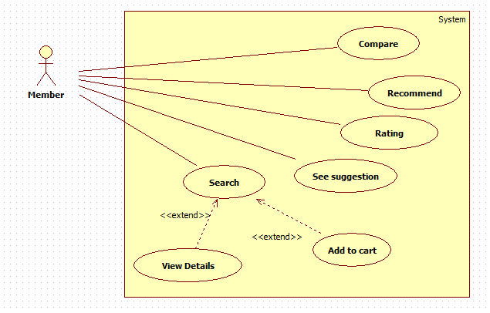

Figure 31: <Member> Overview Use Case

##### <Member> Recommend

Use Case Diagram



Figure 32: <Member> Recommend

Use Case Specification

|  |  |  |  |
| --- | --- | --- | --- |
| **USE CASE - CPS0020** | | | |
| **Use Case No.** | CPS0020 | **Use Case Version** | 1.0 |
| **Use Case Name** | Recommend | | |
| **Author** | Tran Tan Len | | |
| **Date** | 28/05/2014 | **Priority** | Normal |
| **Actor:**   * Member.   **Summary:**   * This use case allows member to recommend product.   **Goal:**   * New recommendation will be inserted into the database.   **Triggers:**   * Member wants to recommend product for the system. * To recommend, Member must do the following steps:   + From “Không tìm thấy” page:   Member fills data to textboxes in “Nguồn gốc” tab or textboxes in “Cấu hình” tab.  Click “Gửi” button to finish.  **Preconditions:**   * User has logged in system as member role. * Product is not found when member search.   **Post Conditions:**   * **Success**: Recommended product’s detail was sent successfully. Show successful message. * **Fail:** Database connection is not available. Show error message.   **Main Success Scenario:**   |  |  |  | | --- | --- | --- | | Step | Actor Action | System Response | | 1 | Member selected “Nguồn gốc” radio button.  [lterative1] | Interface appears, include:   * “Email” textbox, min length: 0, max length: 100, regular expression: ^[a-zA-Z0-9.!#$%&'*+/=?^_`{|}~-]+@[a-zA-Z0-9](?:[a-zA-Z0-9-]{0,61}[a-zA-Z0-9])?(?:\.[a-zA-Z0-9](?:[a-zA-Z0-9-]{0,61}[a-zA-Z0-9])?)*$, required. * “Tên laptop” textbox, min length: 6, max length: 30, required. * “Đường dẫn” textbox, min length: 6, max length: 300, regular expression: (http|ftp|https):\/\/[\w\-_]+(\.[\w\-_]+)+([\w\-\.,@?^=%&amp;:/~\+#]*[\w\-\@?^=%&amp;/~\+#])?   , required.   * “Mô tả” textbox, min length: 0, max length: 200. * “Gửi” Button | | 2 | Member fills data to textboxes.  Member clicks “Gửi” Button. | Show success message: “Thao tác thành công!”  Return “Trang chủ” page.  [Exception 1,2,3,5] |   **Alternative Scenario:**  [Alterative1]   |  |  |  | | --- | --- | --- | | Step | Actor Action | System Response | | 1 | Member selected “Cấu hình” radio button. | Interface appears, include:   * “Email” textbox, min length: 0, max length: 100, regular expression: ^[a-zA-Z0-9.!#$%&'*+/=?^_`{|}~-]+@[a-zA-Z0-9](?:[a-zA-Z0-9-]{0,61}[a-zA-Z0-9])?(?:\.[a-zA-Z0-9](?:[a-zA-Z0-9-]{0,61}[a-zA-Z0-9])?)*$, required. * “Tên laptop” textbox, min length: 6, max length: 30, required. * “Hình ảnh” textbox, min length: 6, max length: 300, required. , regular expression: (http|ftp|https):\/\/[\w\-_]+(\.[\w\-_]+)+([\w\-\.,@?^=%&amp;:/~\+#]*[\w\-\@?^=%&amp;/~\+#])? , required. * “Vi xử lý” textbox, min length: 3, max length: 30, required. * “Bộ nhớ” textbox: 3, max length: 30, required. * “Màn hình” textbox, min length: 3, max length: 30, required * “Ổ cứng” textbox, min length: 3, max length: 30, required * “Gửi” Button. | | 2 | Member fills data to text boxes.  Member clicks “Gửi” Button. | Show success message: “Thao tác thành công!”  Return “Trang chủ” page.  [Exception 1,2,3,4,5,6] |   **Exceptions:**   |  |  |  | | --- | --- | --- | | No | Actor Action | System Response | | 1 | Missing information. | Show error message: “Bạn đã điền thiếu thông tin vui lòng nhập đủ thông tin ở ô có dấu * ” | | 2 | Invalid “Email”. | Show error message: “Email không hợp lệ. Vui lòng thử lại!” | | 3 | “Mô Tả” not in range [0, 200]. | Show error message: “Mô Tả không được quá 200 ký tự. Vui lòng thử lại!” | | 4 | TênLaptop/ Cpu/Ram/Display/  HDD is not in range [3, 30]. | Show error message: “Thông tin phải từ 3 tới 30 ký tự. Vui lòng thử lại!” | | 5 | Invalid “Đường dẫn”. | Show error message: “Đường dẫn không hợp lệ. Vui lòng thử lại!” | | 6 | Invalid “Hình ảnh”. | Show error message: “Đường dẫn hình ảnh không hợp lệ. Vui lòng thử lại!” |   **Relationships:** Search.  **Business Rules:**  System will check duplicate between recommended product’s detail in database by “Tên Laptop”  - If system detect duplicated product, system will count times for recommending the product.  + If the time of recommendation is greater than 5, the system will send the request to staff for parsing.  - Else recommendation will be saved recommended product into database | | | |

Table 36: <Member> Recommend

##### <Member> Rating

Use Case Diagram



Figure 33: <Member> Rating

Use Case Specification

|  |  |  |  |
| --- | --- | --- | --- |
| **USE CASE - CPS0021** | | | |
| **Use Case No.** | CPS0021 | **Use Case Version** | 1.0 |
| **Use Case Name** | Rating | | |
| **Author** | Tran Tan Len | | |
| **Date** | 28/05/2014 | **Priority** | Normal |
| **Actor:**   * Member.   **Summary:**   * This use case allows member to rate the product.   **Goal:**   * Rating product.   **Triggers:**   * Member wants to rate the product in system. * For rating product, member must do the following steps:   + View product detail.   + Click rating icon.   **Preconditions:**   * User must log in the system with member role. * View product detail.   **Post Conditions:**   * **Success**: Rating information will be updated in database. * **Fail:** Database connection is not available. Show error message.   **Main Success Scenario:**   |  |  |  | | --- | --- | --- | | Step | Actor Action | System Response | | 1 | From the “Trang chủ”page.  Member clicks “Tên” product or “Hình ảnh” product in list product to view product detail. | Navigate to “Chi Tiết” page which contains:   * Product detail, product weight. * Rating icon. | | 2 | Click “Rating” icon. | Show popup message: “Bạn có chắc chắn với kết quả đánh giá của mình?”   * “Xác Nhận” button. * “Hủy Bỏ” button.   [Exceptions1,2] | | 1 | Click “Xác Nhận” button.  [Alternative1] | New rating will be updated to the database. |   **Alternative Scenario:**   |  |  |  | | --- | --- | --- | | Step | Ator Action | System Response | | 1 | Click “Hủy Bỏ” button | Return to “Chi Tiết” page. |   **Exceptions:**   |  |  |  | | --- | --- | --- | | Step | Actor Action | System Response | | 1 | Database connection is not available. | Show error message: “Không thể đánh giá sản phẩm! Vui lòng thử lại sau.” |   **Relationships:** N/A  **Business Rules:**  Member can rate only 1 time for a product. The Rating help system load bester rating product on home page. | | | |

Table 37: <Member> Rating

##### <Member> Add to cart

Use Case Diagram

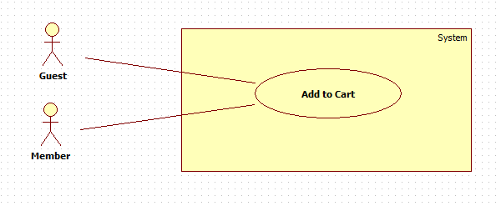

Figure 34: <Member> Add to cart

Use Case Specification

|  |  |  |  |
| --- | --- | --- | --- |
| **USE CASE – CPS0022** | | | |
| **Use Case No.** | CPS0022 | **Use Case Version** | 1.0 |
| **Use Case Name** | Add to Cart | | |
| **Author** | Pham Hong Sang | | |
| **Date** | 28/05/2014 | **Priority** | High |
| **Actor:**   * Guest/Member.   **Summary:**   * This use case allows guest/member to add product to cart.   **Goal:**   * A product will be added to guest/member’s cart.   **Triggers:**   * Guest/Member can add product to cart after search product or add to cart from homepage. * Guest/Member clicks on cart icon button on each result row.   **Preconditions:**   * N/A   **Post Conditions:**   * **Success**: The product will be added to cart. * **Fail:**   + Session is time out.  + System will show message “Your session has expired. Please try again”. Redirect to homepage.  **Main Success Scenario:**   |  |  |  | | --- | --- | --- | | Step | Actor Action | System Response | | 1 | Click cart icon button on result row. | * Check for the existence of the cart object in session [Exception 1]. * Add clicked product to cart [Alternative 1]. * Change the number of product in cart and display it for user. [Exception 2]. |   **Alternative Scenario:**   |  |  |  | | --- | --- | --- | | Step | Actor Action | System Response | | 1 | The product has existed in cart. | * Button “add to cart” will be hidden for preventing to add to cart again. |   **Exceptions:**   |  |  |  | | --- | --- | --- | | Step | Actor Action | System Response | | 1 | Session time out. | * Show pop-up which is included:   + Label:”Giỏ hàng của bạn đã hết phiên giao dịch.Mời bạn thử lại.”  + OK:button.[Exception 3]  + Cancel: button. [Exception 4] | | 2 | Cart is full of products | * Show error message:”Giỏ hàng của bạn chỉ chứa tối đa được 3 sản phẩm.” | | 3 | User clicks ”OK” button | * Create new cart object in session. * Add clicked product to cart. * Change the number of product in cart and display it for user. | | 4 | User clicks “Cancel” button. | * Do nothing. |   **Relationships:** N/A  **Business Rules:**   * Maximum size of cart is 3. * If session is out of time, it will show message for user. System will create a new session automatically when user clicks on “OK” button. * If cart only have 1 product, system will do nothing. System will progress if the size of cart is 2 or above. | | | |

Table 38: <Member> Add to cart

##### <Member> See suggestion

Use Case Diagram

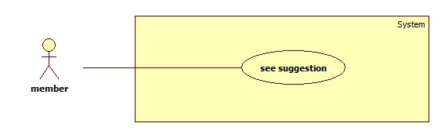

Figure 35: <Member> See suggestion

Use Case Specification

|  |  |  |  |
| --- | --- | --- | --- |
| **USE CASE – CPS0023** | | | |
| **Use Case No.** | CPS0023 | **Use Case Version** | 1.0 |
| **Use Case Name** | See suggestion | | |
| **Author** | Ha Chi Danh | | |
| **Date** | 30/05/2014 | **Priority** | Normal |
| **Actor:**   * Member.   **Summary:**   * This use case allows member to see suggestion when comparing products on website.   **Goal:**   * Member sees suggestion when comparing products in cart successfully.   **Triggers:**   * When cart has at least 2 products, member clicks “so sánh” button.   **Preconditions:**   * User must login with member role.   **Post Conditions:**   * **Success**:   **+** Show comparison table products.  **+** Show points of product.  **+** Show recommend as list of products.   * **Fail:** Show error message.   **Main Success Scenario:**   |  |  |  | | --- | --- | --- | | Step | Actor Action | System Response | | 1 | * Member adds 2 or 3 products to cart * Member clicks “So sánh” button.   [Alternative 1,2,3] | Navigate to “So sánh” page with contains:   * Comparison table with information:   + Product which is winner and which is (are) runner-up in cart.  + Show Point of products.  + Show recommend as list of products.  [Exception 1] |   **Alternative Scenario:**   |  |  |  | | --- | --- | --- | | No | Actor Action | System Response | | 1 | * Cart has no product. * Member clicks “So sánh” button. | Show error message:” Phải có ít nhất 2 sản phẩm trong giỏ”. | | 2 | * Member adds 1 product to cart. * Member clicks “So sánh” button. | Show error message:” Phải có ít nhất 2 sản phẩm trong giỏ”. | | 3 | Session time out. | Show error message:”Vui lòng đăng nhập lại để được hỗ trợ nhiều hơn”.  Redirect to login page |     **Exceptions:**   |  |  |  | | --- | --- | --- | | No | Actor Action | System Response | | 1 | Cannot compare product due to database connection. | Show error message:”Thao tác thất bại, xin hãy thử lại”. |   **Relationships:** Add to cart  **Business Rules:**  Member adds 2 or 3 products to cart.  Member clicks “So sánh” button, “So sánh” page will show in 2 situations:   * Situation 1: Error message ”Phải có ít nhất 2 sản phẩm trong giỏ” * Situation 2:   + Show comparison table.  + Points of products.  + Show recommend as list of products that similar with products in member’s cart. | | | |

Table 39: <Member> See Suggestion

##### <Authorized user> Log out

Use Case Diagram

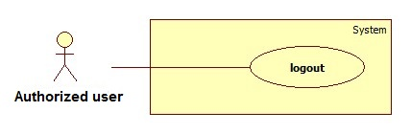

Figure 36: < Authorized > Log out

Use Case Specification

|  |  |  |  |
| --- | --- | --- | --- |
| **USE CASE – CPS0024** | | | |
| **Use Case No.** | CPS0024 | **Use Case Version** | 1.0 |
| **Use Case Name** | Logout | | |
| **Author** | Ha Chi Danh | | |
| **Date** | 30/05/2014 | **Priority** | Normal |
| **Actor:**   * Authorized user.   **Summary:**   * This use case allows Authorized user to log out of the system.   **Goal:**   * Authorized user logs out of the system. Authorized user’s current session is destroyed.   **Triggers:**   * Authorized user wants to log out. * Authorized user clicks “Đăng xuất” link.   **Preconditions:**   * Authorized user has logged in to the system.   **Post Conditions:**   * **Success**: Authorized user’s current session is destroyed. Redirect to homepage. * **Fail:** Show error message.   **Main Success Scenario:**   |  |  |  | | --- | --- | --- | | Step | Actor Action | System Response | | 1 | Authorized user clicks “Thoát” link. | Show message “Bạn thực sự muốn thoát”   * Xác nhận: button * Hủy: button | | 2 | Authorized user clicks “Xác nhận” button. [Alternative 1] | Destroy Authorized user’s session. Redirect to homepage. [Exception 1] |   **Alternative Scenario:**   |  |  |  | | --- | --- | --- | | No | Actor Action | System Response | | 1 | Authorized user clicks “Hủy” button. | Do nothing. |   **Exceptions:**   |  |  |  | | --- | --- | --- | | No | Actor Action | System Response | | 1 | Fail to destroy Authorized user’s session | Redirect to error page. |   **Relationships:** N/a  **Business Rules:**   * Authorized user clicks “thoát” link, * Authorized user’s role will be changed to guest. | | | |

Table 40: < Authorized > Log out

##### < Authorized user> Change Password

Use Case Diagram

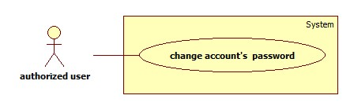

Figure 37: <Authorized user> Change Password

Use Case Specification

|  |  |  |  |
| --- | --- | --- | --- |
| **USE CASE – CPS0025** | | | |
| **Use Case No.** | CPS0025 | **Use Case Version** | 1.0 |
| **Use Case Name** | Change password | | |
| **Author** | Ha Chi Danh | | |
| **Date** | 30/05/2014 | **Priority** | Normal |
| **Actor:**   * Authorized user.   **Summary:**   * This use case allows Authorized user to change password.   **Goal:**   * Authorized user changes password successfully.   **Triggers:**   * Authorized user logins to website. * Authorized user clicks “Thay đổi mật khẩu” link.   **Preconditions:** Authorized user has register into the system.  **Post Conditions:**   * **Success:** New password has been updated into database. * **Fail:** Show error message.   **Main Success Scenario:**   |  |  |  | | --- | --- | --- | | Step | Actor Action | System Response | | 1 | Authorized user clicks “Thay đổi mật khẩu” link. | Show “Thay đổi mật khẩu ” page with includes:   * Mật khẩu cũ: textbox, password box, min length: 6, max length: 20, required. * Mật khẩu mới: textbox, password box, min length: 6, max length: 20, required. * Xác nhận mật khẩu mới: textbox, password box, min length: 6, max length: 20, required. * Thay đổi: button. * Xóa trắng: button. | |  | Authorized user clicks “Thay đổi” button [Alternative 1] | Show successful message and return to home page. [Exception 1,2, 3,4,5,6] |   **Alternative Scenario:**   |  |  |  | | --- | --- | --- | | No | Actr Action | System Response | | 1 | Authorized user clicks “Xóa trắng” button. | Clear all input fields. |   **Exceptions:**   |  |  |  | | --- | --- | --- | | No | Actor Action | System Response | | 1 | Length of password is not in range. | Show error message: “Độ dài mật khẩu phải từ 6-20 ký tự!” | | 2 | “Mật khẩu cũ” is wrong. | Show error message:”Sai mật khẩu.” | | 3 | “Mật khẩu cũ” is a blank. | Show error message:”Vui lòng nhập mật khẩu” | | 4 | “Mật khẩu mới” is a blank. | Show error message:”Vui lòng nhập mật khẩu mới” | | 5 | “Xác nhận mật khẩu mới” is a blank. | Show error message:”Vui lòng nhập xác nhận mật khẩu mới” | | 6 | “Mật khẩu mới” and “Xác nhận mật khẩu mới” is not similar. | Show error message: “Mật khẩu mới và Xác nhận mật khẩu mới không trùng khớp”. |   **Relationships:** N/A  **Business Rules:**   * Authorized user click “Thay đổi” button * New password has been updated into database. | | | |

Table 41: <Authorized user> Change Password

#### <Guest> Overview Use Case

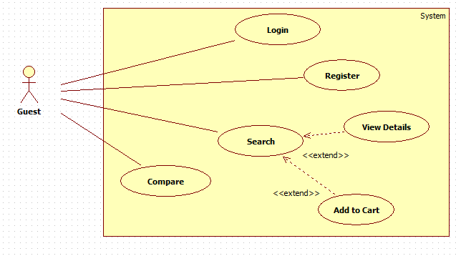

Figure 38: <Guest> Overview Use Case

##### <Guest> Register

Use Case Diagram



Figure : <Guest> Register

Use Case Specification

|  |  |  |  |
| --- | --- | --- | --- |
| **USE CASE – CPS0026** | | | |
| **Use Case No.** | CPS0026 | **Use Case Version** | 1.0 |
| **Use Case Name** | Register | | |
| **Author** | Ha Chi Danh | | |
| **Date** | 30/05/2014 | **Priority** | Normal |
| **Actor:**   * Guest.   **Summary:**   * This use case allows guest to register.   **Goal:**   * User can register new account to become a member of the system.   **Triggers:**   * Guest wants to be a member of the system. * To register, click “Đăng ký” link in menu bar.   **Preconditions:** N/A.  **Post Conditions:**   * **Success:** New member account is created. * **Fail:** Show error message.   **Main Success Scenario:**   |  |  |  | | --- | --- | --- | | Step | Actor Action | System Response | | 1 | Guest clicks “Đăng ký” link. | System show a register form which includes:   * Username: textbox, min length: 6, max length: 30, required. * Password: textbox, password box, min length: 6, max length: 20, required. * Đăng ký: button. * Xóa trắng: button. | | 2 | Guess enters required information, then clicks “Đăng ký” button. [Alternative 1] | Create new member account. Show success message.  [Exception 1,2, 3] |   **Alternative Scenario:**   |  |  |  | | --- | --- | --- | | N | Actor Action | System Response | | 1 | Guest clicks “Xóa trắng” button. | Clear all input fields. |   **Exceptions:**   |  |  |  | | --- | --- | --- | | No | Actor Action | System Response | | 1 | Length of username is not in range. | Show error message: “Độ dài username phải từ 6-30 ký tự!” | | 2 | Length of passwod is not in range. | Show error message: “Độ dài password phải từ 6-20 ký tự!” | | 3 | Username’s existed already. | Show error message: “Trùng tên đăng nhập! Vui lòng chọn tên khác!” |   **Relationships:** N/A  **Business Rules:**   * The role of new created account is “member”. | | | |

Table 42: <Guest> Register

##### <Guest> Login

Use Case Diagram



Figure 40: <Guest> Login

|  |  |  |  |
| --- | --- | --- | --- |
| **USE CASE – CPS0027** | | | |
| **Use Case No.** | CPS0027 | **Use Case Version** | 1.0 |
| **Use Case Name** | Login | | |
| **Author** | Ha Chi Danh | | |
| **Date** | 30/05/2014 | **Priority** | Normal |
| **Actor:**   * Guest.   **Summary:**   * This use case allows guest to login to the system.   **Goal:**   * Allow authentication and authorization of the system.   **Triggers:**   * Guest want to login into system. * To login: Guests go to the login link, enter username and password, and click “Đăng nhập” button to login.   **Preconditions:**   * Database has a registered account.   **Post Conditions:**   * **Success:** Guest is authorized, redirect to corresponding page. * **Fail:** System will show error on current page.   **Main Success Scenario:**   |  |  |  | | --- | --- | --- | | Step | Actr Action | System Response | | 1 | Guest goes to login page. | System show a login form, includes:   * Username: textbox, required. * Password: textbox, required. * Đăng nhập: button. * Hủy: button * Create new account. | | 2 | Guess enter username and password into textboxes.  Press “Đăng nhập” button.[Alternative 1] | * Show message successful * “Ghi nhớ tài khoản”: check box   [Exception 1] |   **Alternative Scenario:**   |  |  |  | | --- | --- | --- | | No | Actor Action | System Response | | 1 | Press “Cancel” button. | Navigate to home page. |   **Exceptions:**   |  |  |  | | --- | --- | --- | | No | Actor Action | System Response | | 1 | “Tên tài khoản” or “Mật khẩu” are wrong. | Show error message: “Tên tài khoản hoặc mật khẩu không đúng, vui lòng thử lại!” |   **Relationships:** N/A.  **Business Rules:**   * Each member, staff, admin has an account. * Only active account can log in. | | | |

Table 43: <Guest> Login

##### <Guest> View Detail

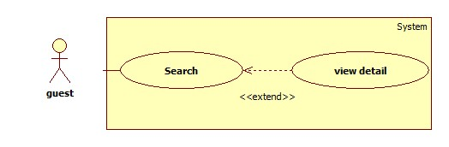

Figure 41: <Guest> View Detail

|  |  |  |  |
| --- | --- | --- | --- |
| **USE CASE – CPS0028** | | | |
| **Use Case No.** | CPS0028 | **Use Case Version** | 1.0 |
| **Use Case Name** | View detail | | |
| **Author** | Ha Chi Danh | | |
| **Date** | 30/05/2014 | **Priority** | Normal |
| **Actor:**   * Guest.   **Summary:**   * This use case allows guest to search and view product information.   **Goal:**   * A page detail of products will be shown to guest.   **Triggers:**   * Guest inputs to a blank textbox then clicks “Tìm kiếm” button. * Guest inputs URL of product or serial number then they search all products with relative URL or serial number which they inputted. The searching results will show product detail.   **Preconditions:** N/A  **Post Conditions:**   * **Success**: Show search results as a page of product with URL or serial number that guest inputted * **Fail:** Show an error message.   **Main Success Scenario:**   |  |  |  | | --- | --- | --- | | Step | Actor Action | System Response | | 1 | Guest inputs the product’s URL or serial number into textbox. | Show “Search” page with includes:   * Tìm bằng đường dẫn/ tìm bằng số seri: drop down list. * Search: textbox * Tìm kiếm: button | | 2 | Guest clicks “Tìm kiếm” button. | * System will show page detail product by product URL or serial number.[Exception1] |   **Alternative Scenario:** N/A  **Exceptions:**   |  |  |  | | --- | --- | --- | | Step | Actor Action | System Response | | 1 | Search not found | Redirect to Not found page.  Show message:”Vui lòng đăng nhập để được hỗ trợ nhiều hơn”. |   **Relationships:** Search  **Business Rules:**   * User search by URL or serial number of product * System will search all products in database. * If that product is existed, system will show detail page of that product. | | | |

Table 44: <Guest> View Detail

##### <Guest> Add Product to Cart

* Reference use case CPS0022.

## Software System Attribute

### Usability

#### Graphic User Interface

* All the texts, labels and should be written in Vietnamese.

#### Usability

* Admin, staff should need less than one week of training to be productive with the system.
* Guest and member can use the system easily without training.

#### Installation

* The system must be easy to deploy. Customer can deploy successfully and learn to configure, maintain the system within one day of training.
* The attached manual guide must be clear. User can read and do themselves without developer’s help.

### Reliability

* The price should be updated every day.
* The parser should be updated every day.
* If the product is already existed, system will notify for user.

### Availability

* N/A.

### Security

* Privacy: Each role of user has a specific permission to interact with system.
* System always checks authorization and authentication before doing anything.
* Only admin can grant permission to staff.

### Maintainability

* The system is divided into separated modules.
* The code is easy to maintain and upgrade.

### Portability

* N/A

### Performance

* Parsing speed should be 5ms per product.
* The speed of suggestion algorithm is less than 3 seconds.

## Conceptual Diagram

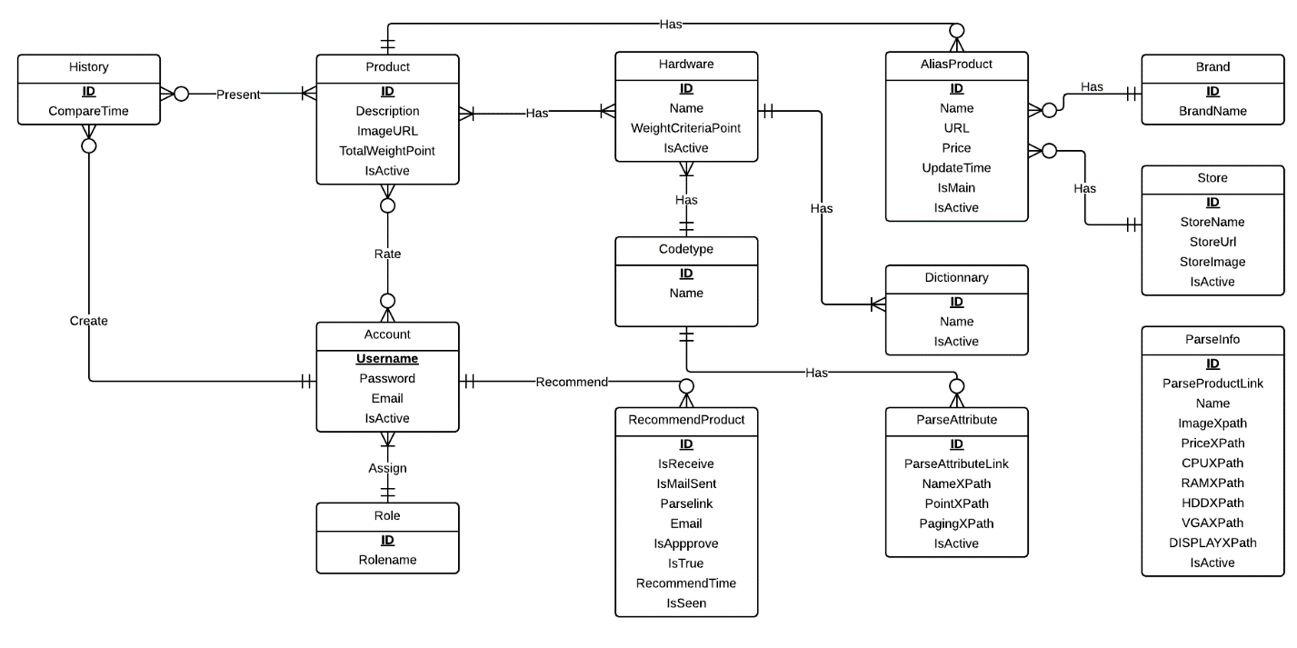

Figure 42: Conceptual Diagram

### Data Dictionary

|  |  |
| --- | --- |
| **Entity Data dictionary: describe content of all entities** | |
| **Entity Name** | **Description** |
| Codetype | Describe all codetype in the system. |
| ParseInfo | Describe all data needed to parse 1 specified product |
| Hardware | Describe all hardwares of a product. |
| Product | Describe all products in the system. |
| ProductAttribute | Describe hardware of each product. |
| AliasProdcut | Describe all alias name of product in the system. |
| Dictionary | Describe all possible hardwares names in the system. |
| Account | Describe all accounts in the system. Account includes: admin, staff, member, guest… |
| RecommendProduct | Describe the product that user recommend for system. |
| History | Describe all compare histories of user in the system. |
| HistoryDetail | Describe detail compare of user. |
| Role | Describe all roles in the system. One user has only one role. |
| ParserAttribute | Describe all data needed to parse 1 websites to get hardware |
| ParserInfo | Describe all data needed to parse 1 websites to get laptop |
| RatingProduct | Describe rating point of product and user rating. |
| Brand | Describe all brand that product is included. |
| Store | Describe all store that product is included. |

Table 45: Entity Data dictionary - Describe content of all entities

# Software Design Description

## Design Overview

* This document describes the technical and user interface design CPS System using web. It includes the architectural design, the detailed design of common functions and business functions and the design of database model.
* The architectural design describes the overall architecture of the system and the architecture of each main component and subsystem.
* The detailed design describes static and dynamic structure for each component and functions. It includes class diagrams, class explanations and sequence diagrams for each use cases.
* The database design describes the relationships between entities and details of each entity.
* Document overview:
* Section 2: gives an overall description of the system architecture design.
* Section 3: gives component diagrams that describe the connection and integration of the system.
* Section 4: gives the detail design description which includes class diagram, class explanation, and sequence diagram to details the application functions.
* Section 5: describe an ERD with logical diagram.

## System Architectural Design

### Web Architecture

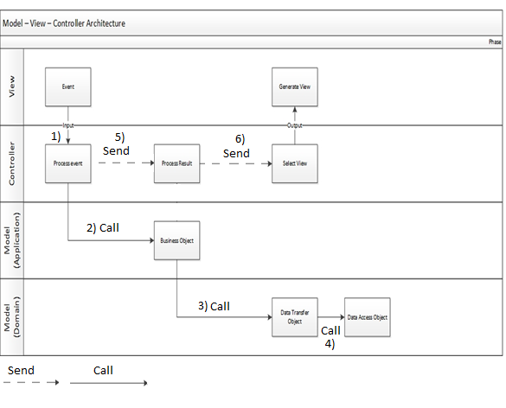

Figure 43: MVC Architecture

* **Model** is the part of the application that handles the logic for the application data. Often model objects retrieve data (and store data) from a database.
* **View** is the parts of the application that handles the display of the data. Most often the views are created from the model data.
* **Controller** is the part of the application that handles user interaction. Typically controllers read data from a view, control user input, and send input data to the model.

## Component Diagram

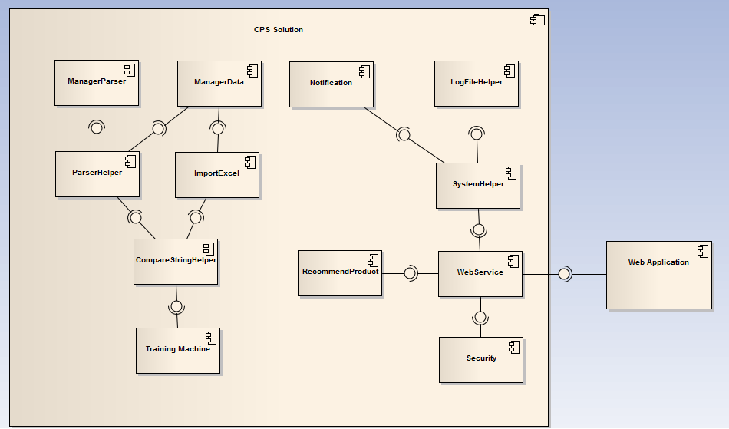

Figure 44: Component Diagram

## Detailed Description of Components

### Class Diagram

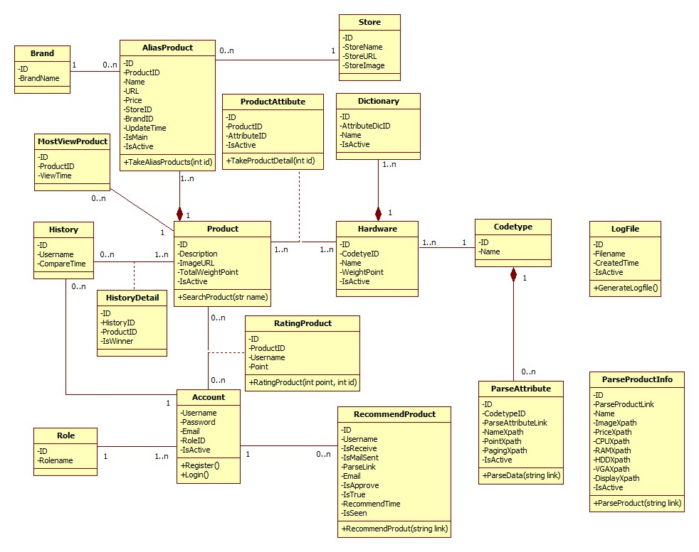

Figure 45: Class Diagram

### Class Diagram Explanation

#### Codetype

Attribute

|  |  |  |  |
| --- | --- | --- | --- |
| **Attribute** | **Type** | **Visibility** | **Description** |
| Id | Integer | Public | Unique identifier of each code type |
| Name | String | Public | Name of code type |
| IsActive | Boolean | Public | Status of code type |

#### ParseAttribute

Attribute

|  |  |  |  |
| --- | --- | --- | --- |
| **Attribute** | **Type** | **Visibility** | **Description** |
| Id | Integer | Public | Unique identifier of each item |
| CodetypeID | String | Public | Id of codetype |
| ParseAttributeLink | String | Public | Link used to parse |
| NameXpath | String | Public | Xpath to get the name of attribute |
| PointXpath | String | Public | Xpath to get the point of attribute |
| PagingXpath | String | Public | Xpath to get the paging |
| IsActive | Boolean | Public | Status of attribute |

Method

|  |  |  |  |
| --- | --- | --- | --- |
| **Method** | **Return type** | **Visibility** | **Description** |
| ParseData | Void | Public | Run parser to get data |

#### Hardware

Attribute

|  |  |  |  |
| --- | --- | --- | --- |
| **Attribute** | **Type** | **Visibility** | **Description** |
| Id | Integer | Public | Unique identifier of each item |
| CodetypeId | Integer | Public | Id of codetype |
| Name | String | Public | Name of attribute |
| WeightCriteriaPoint | Integer | Public | Point of each hardware |
| IsActive | Boolean | Public | Status of Hardware |

#### Dictionary

Attribute

|  |  |  |  |
| --- | --- | --- | --- |
| **Attribute** | **Type** | **Visibility** | **Description** |
| Id | Integer | Public | Unique identifier of each product |
| AttributeID | Integer | Public | Id of attribute |
| Name | String | Public | Name of attribute |
| IsActive | Boolean | Public | Status of Dictionnary |

#### Product

Attribute

|  |  |  |  |
| --- | --- | --- | --- |
| **Attribute** | **Type** | **Visibility** | **Description** |
| Id | Integer | Public | Unique identifier of each item |
| Description | String | Public | Description of this product |
| ImageURL | String | Public | ImageURL of this product |
| TotalWeightPoint | Double | Public | Point of this product |
| IsActive | Boolean | Public | Status of product |

Method

|  |  |  |  |
| --- | --- | --- | --- |
| **Method** | **Return type** | **Visibility** | **Description** |
| Search Product | Product | Public | Search product in system |

#### MostViewProduct

Attribute

|  |  |  |  |
| --- | --- | --- | --- |
| **Attribute** | **Type** | **Visibility** | **Description** |
| Id | Integer | Public | Unique identifier of each item |
| ProductID | String | Public | ID of each Product |
| ViewTime | Int | Public | View time of each product. |

Method

|  |  |  |  |
| --- | --- | --- | --- |
| **Method** | **Return type** | **Visibility** | **Description** |
| LoadMostProduct | Product | Public | Load most view product |

#### Product Attribute

Attribute

|  |  |  |  |
| --- | --- | --- | --- |
| **Attribute** | **Type** | **Visibility** | **Description** |
| Id | Integer | Public | Unique identifier of each item |
| ProductID | Int | Public | Id of product |
| AttributeID | Int | Public | Id of attribute |
| IsActive | Boolean | Public | Status of each attribute |

#### AliasProduct

Attribute

|  |  |  |  |
| --- | --- | --- | --- |
| **Attribute** | **Type** | **Visibility** | **Description** |
| ID | Int | Public | Unique identifier of each item |
| ProductID | Int | Public | Id of product |
| Name | String | Public | Product name |
| URL | String | Public | URL of product |
| Price | Double | Public | Price of each produt |
| StoreID | Int | Public | Id of store |
| BrandID | Int | Public | Id of brand |
| UpdateTime | Datetime | Public | Time update that product |
| IsMain | Boolean | Public | Describe which main product is. |
| IsActive | Boolean | Public | Status of this productalias |

#### History

Attribute

|  |  |  |  |
| --- | --- | --- | --- |
| **Attribute** | **Type** | **Visibility** | **Description** |
| Id | Integer | Public | Unique identifier of each history |
| Username | String | Public | Owner of this history |
| CompareTime | DateTime | Public | The time when owner compare product |

#### History Detail

Attribute

|  |  |  |  |
| --- | --- | --- | --- |
| **Attribute** | **Type** | **Visibility** | **Description** |
| Id | Integer | Public | Unique identifier of each item |
| HistoryId | Integer | Public | Id of history |
| ProductId | Integer | Public | Id of product |
| IsWinner | Boolean | Public | Winner Product |

#### Role

Attribute

|  |  |  |  |
| --- | --- | --- | --- |
| **Attribute** | **Type** | **Visibility** | **Description** |
| Id | Integer | Public | Unique identifier of each role |
| Name | String | Public | Role name |

#### Log File

Attribute

|  |  |  |  |
| --- | --- | --- | --- |
| **Attribute** | **Type** | **Visibility** | **Description** |
| Id | Integer | Public | Unique identifier of each file |
| FileName | String | Public | File name |
| CreatedTime | DateTime | Public | The time when this file is created |
| IsActive | Boolean | Public | Status of this file |

Method

|  |  |  |  |
| --- | --- | --- | --- |
| **Method** | **Return type** | **Visibility** | **Description** |
| GenerateLogFile | Boolean | Public | Generate log file for each time system runs the parser |

#### Rating Product

Attribute

|  |  |  |  |
| --- | --- | --- | --- |
| **Attribute** | **Type** | **Visibility** | **Description** |
| Id | Integer | Public | Unique id of each item |
| Username | String | Public | The name of the user |
| ProductId | Integer | Public | The identifier of that product |
| Point | Integer | Public | Rating point of each product |

|  |  |  |  |
| --- | --- | --- | --- |
| **Method** | **Return type** | **Visibility** | **Description** |
| RatingProduct | Void | Public | rating price for the system |

#### Recommend Product

|  |  |  |  |
| --- | --- | --- | --- |
| **Attribute** | **Type** | **Visibility** | **Description** |
| Id | Integer | Public | Unique id of each item |
| Username | String | Public | The name of the user |
| IsReceive | Boolean | Public | Receive mail when update product/ |
| IsMailSent | Boolean | Public | Send email or not yet. |
| Parselink | String | Public | Link that user recommend |
| Email | String | Public | Email of user |
| IsApprove | Boolean | Public | Status of recommend |
| IsTrue | Boolean | Public | Status of auto parse recommend. |
| RecommendTime | Datetime | Public | Time that user recommend |
| IsSeen | Boolean | Public | Status of notification for user |

|  |  |  |  |
| --- | --- | --- | --- |
| **Method** | **Return type** | **Visibility** | **Description** |
| RecommendProduct | Void | Public | Recommend product for system |

#### Parse Product Info

|  |  |  |  |
| --- | --- | --- | --- |
| **Attribute** | **Type** | **Visibility** | **Description** |
| Id | Integer | Public | Unique id of each item |
| ParseLink | String | Public | Link to get parser |
| Name | String | Public | Xpath to get the Name |
| PriceXpath | String | Public | Xpath to get the Price |
| ImageXpath | String | Public | Image to get the Name |
| CPUXpath | String | Public | Xpath to get the CPU |
| HDDXpath | String | Public | Xpath to get the HDD |
| VGAXpath | String | Public | Xpath to get the VGA |
| RAMXpath | String | Public | Xpath to get the RAM |
| DisplayXpath | String | Public | Xpath to get the Display |
| IsActive | String | Public | Status of parser |

#### Account

Attribute

|  |  |  |  |
| --- | --- | --- | --- |
| **Attribute** | **Type** | **Visibility** | **Description** |
| Username | String | Public | Unique username of each user |
| Password | String | Public | Password of user |
| Email | String | Public | Email of User |
| RoleId | Int | Public | Account roles ID |
| IsActive | String | Public | Status of account |

Method

|  |  |  |  |
| --- | --- | --- | --- |
| **Method** | **Return type** | **Visibility** | **Description** |
| Register | Boolean | Public | Register a new account in system |
| Login | Boolean | Public | Check if is existed account in system |

#### Store

Attribute

|  |  |  |  |
| --- | --- | --- | --- |
| **Attribute** | **Type** | **Visibility** | **Description** |
| ID | Int | Public | Unique of each store |
| StoreName | String | Public | Name of store |
| StoreUrl | String | Public | Url of each store |
| LogoImage | String | Public | Image URL of each store |
| IsActive | String | Public | Status of store |

#### Brand

Attribute

|  |  |  |  |
| --- | --- | --- | --- |
| **Attribute** | **Type** | **Visibility** | **Description** |
| ID | Int | Public | Unique of each Brand |
| BrandName | String | Public | Name of each Brand |

### Sequence Diagram

#### Force Parse Data

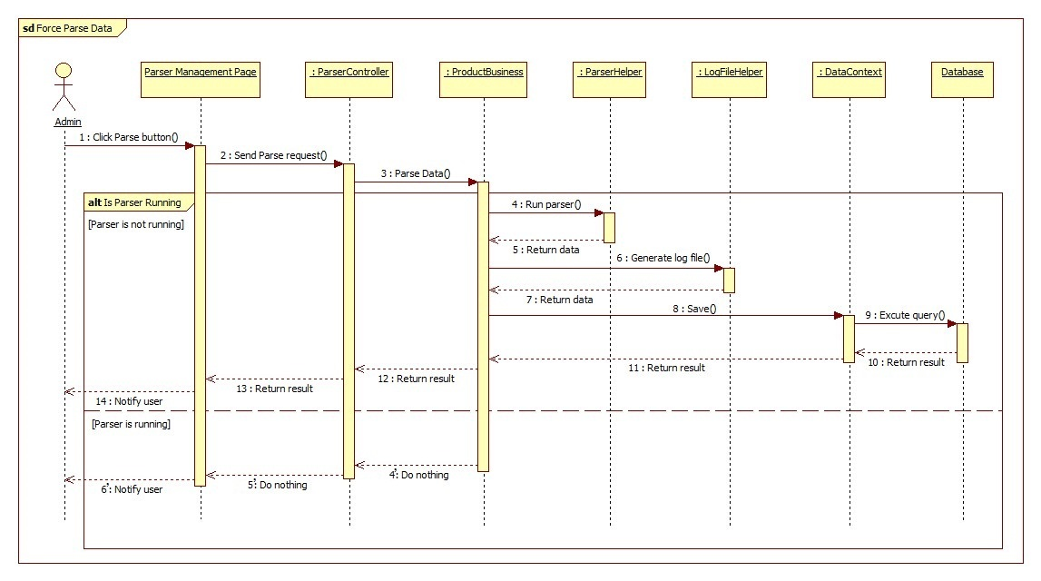

Figure 46: Force Parse Data Sequence Diagram

#### Import Excel

##### Import Product

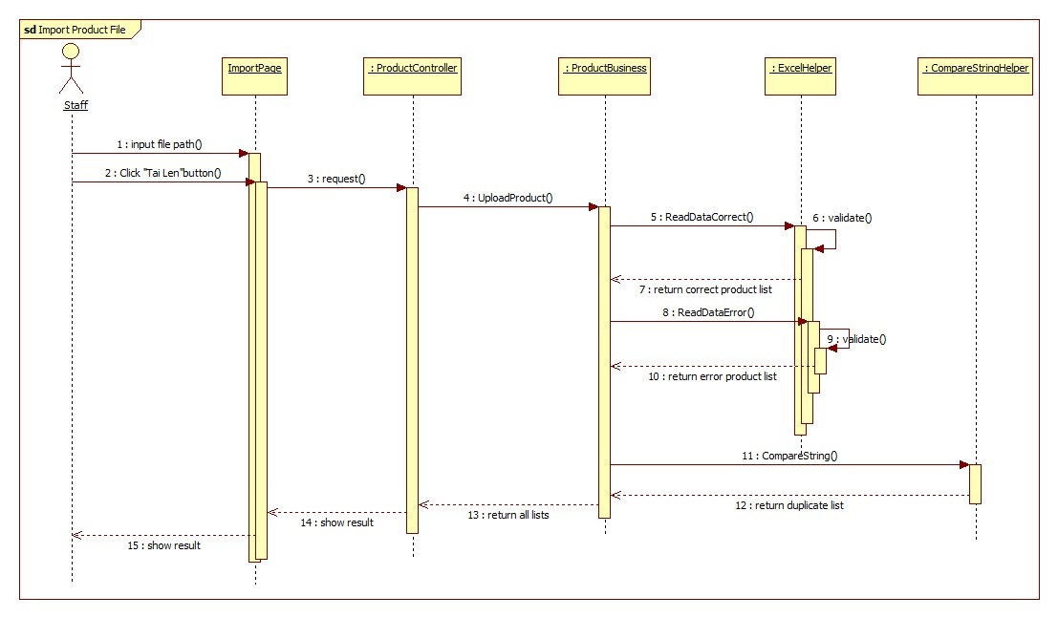

Figure 47: Import Product Sequence Diagram

##### Process Error Products

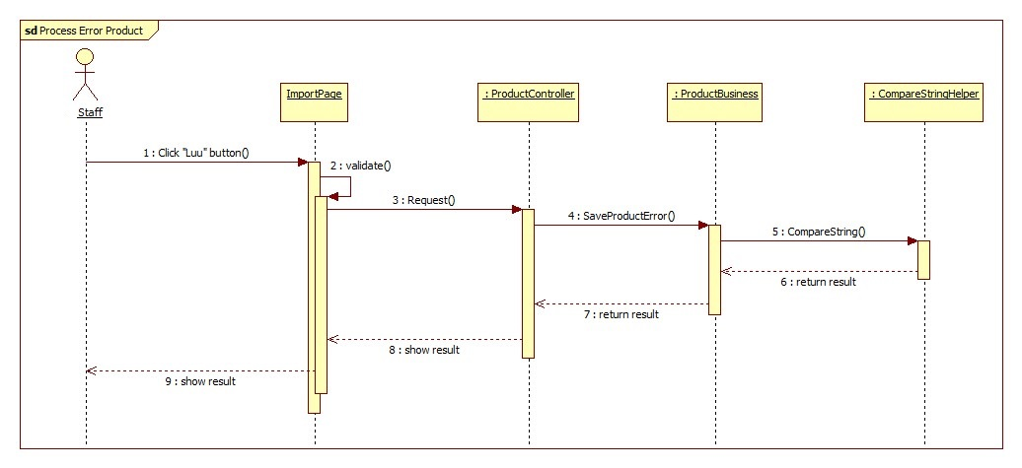

Figure 48: Process Error Products Sequence Diagram

##### Process Duplicated Products

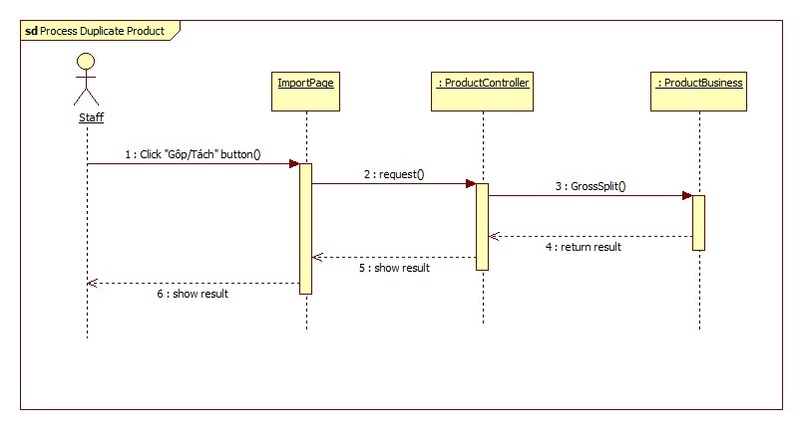

Figure 49: Process Duplicated Products Sequence Diagram

##### Save Correct Products

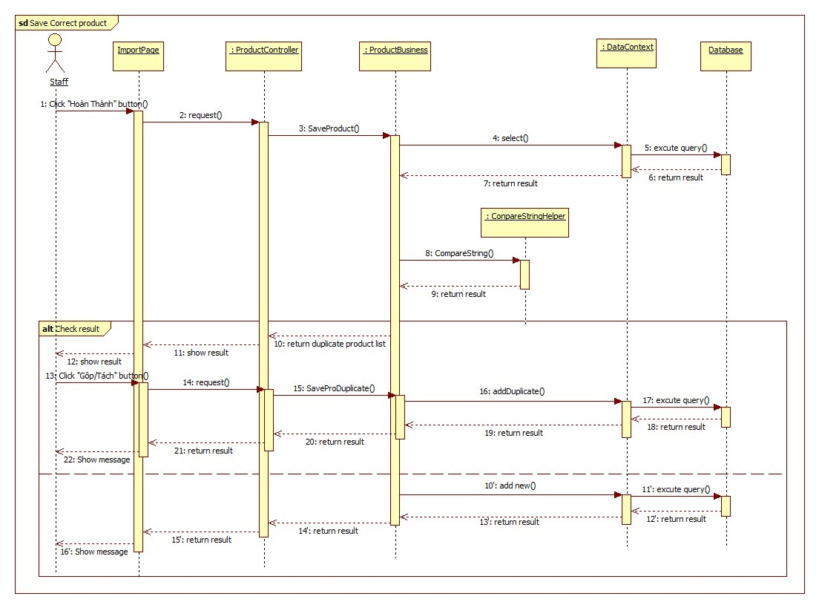

Figure 50: Save Correct Products Sequence Diagram

##### Log File

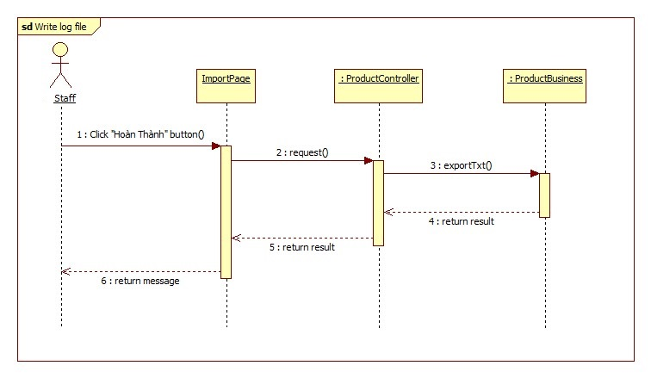

Figure 51: Log File Sequence Diagram

#### Recommend

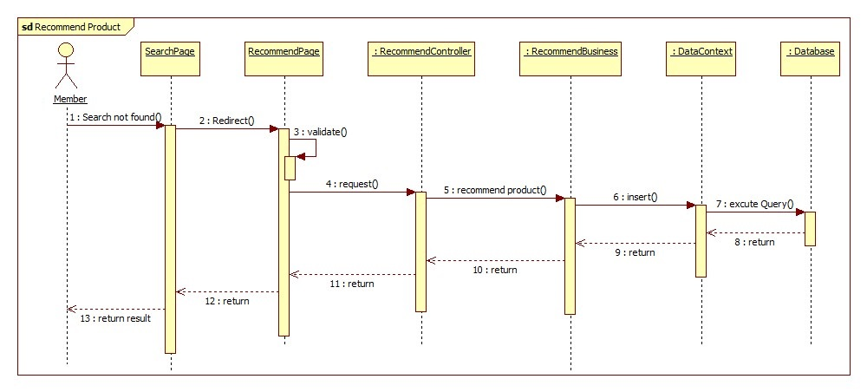

#### Figure 52: Recommend Sequence Diagram

#### View History

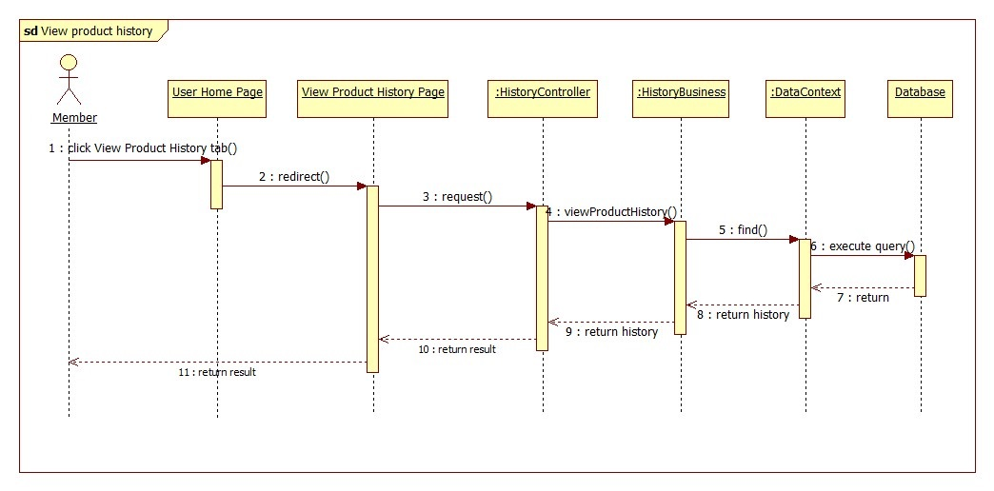

Figure 53: View History Sequence Diagram

#### Search Product

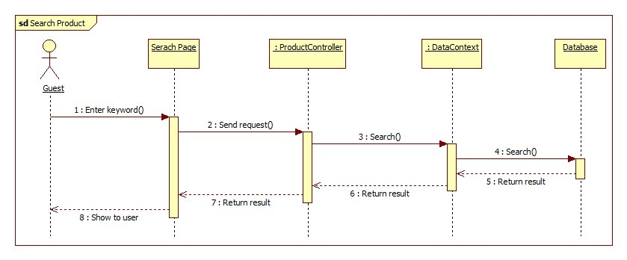

Figure 54: Search Product Sequence Diagram

#### Configure System

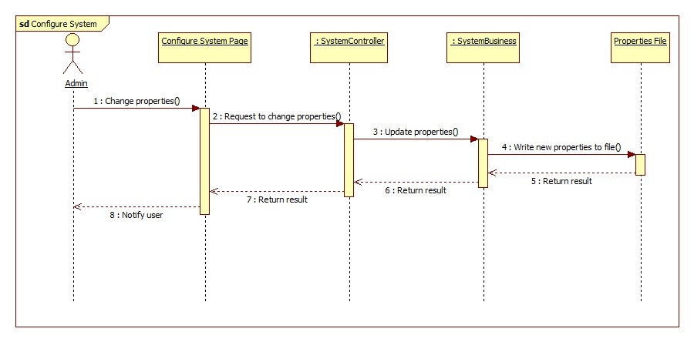

Figure 55: Configure System Sequence Diagram

#### Confirm New Product

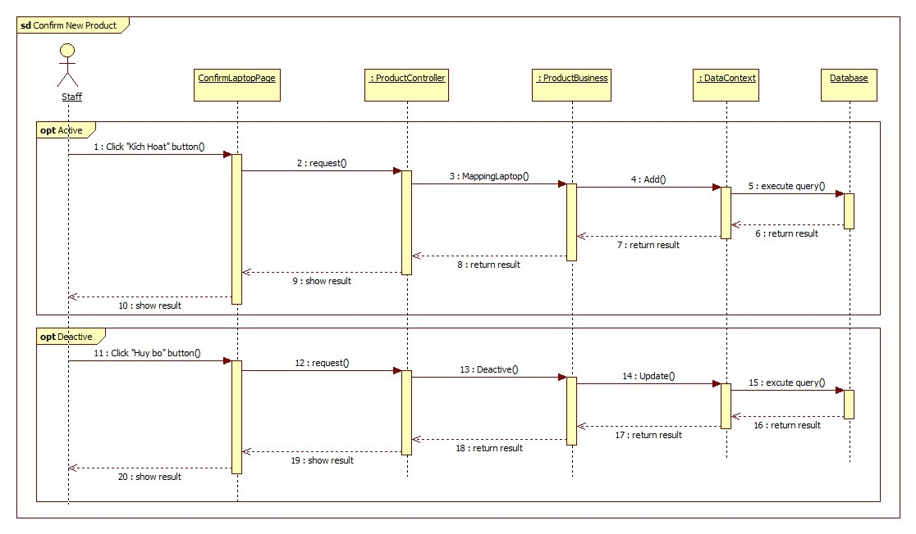

Figure 56: Confim New Product

#### Training Machine

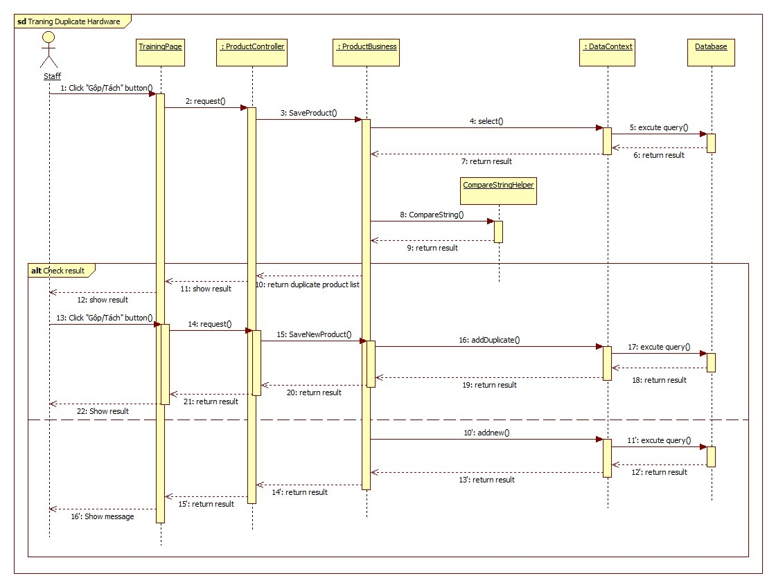

Figure 57: Training Machine

## User Interface Design

### Guest, Member Interface Design

#### Guest Home Page

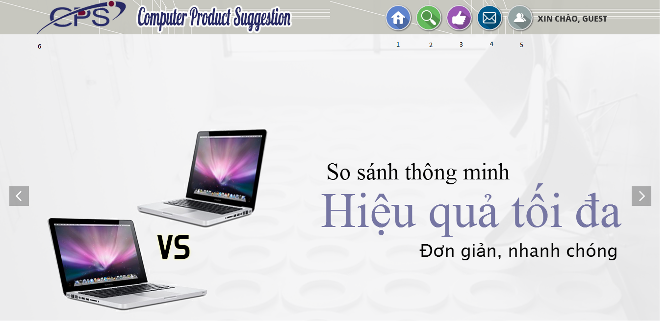

Figure 58: Guest Home Page

**Fields**

|  |  |  |  |  |  |  |  |
| --- | --- | --- | --- | --- | --- | --- | --- |
| **No** | **Field Name** | **Description** | **Read only** | **Mandatory** | **Control Type** | **Data Type** | **Length** |
| 6 | Slide | Slide about website | No | No | Slide | N/A | N/A |

**Buttons/ Hyperlinks**

|  |  |  |  |  |
| --- | --- | --- | --- | --- |
| **No** | **Function** | **Description** | **Validation** | **Outcome** |
| 1 | Home page | Click to transfer to home page | No | Transfer to Home page |
| 2 | Search product | Click to transfer to search page | No | Transfer to Search page |
| 3 | Highlight | Click to view highlight product | No | Transfer to  Highlight page |
| 4 | Recommend | Click to transfer to recommend page | No | Transfer to recommend page |
| 5 | Login page | Click to transfer to Login page | No | Transfer to Login page |

#### Login

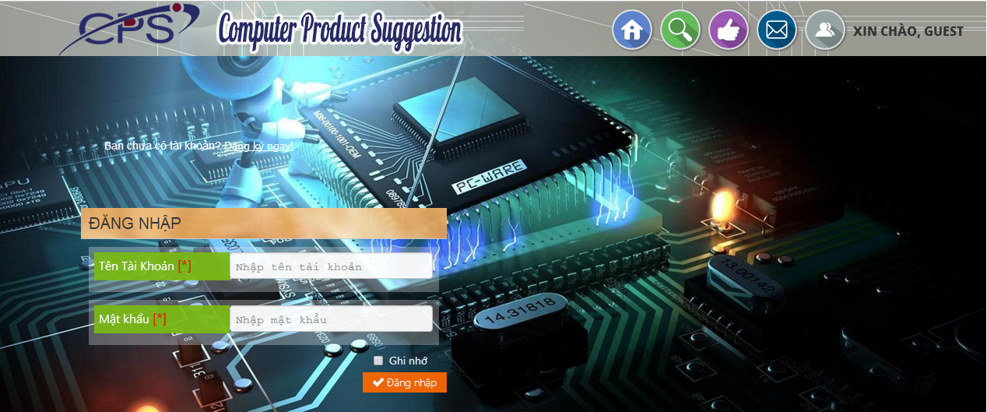

4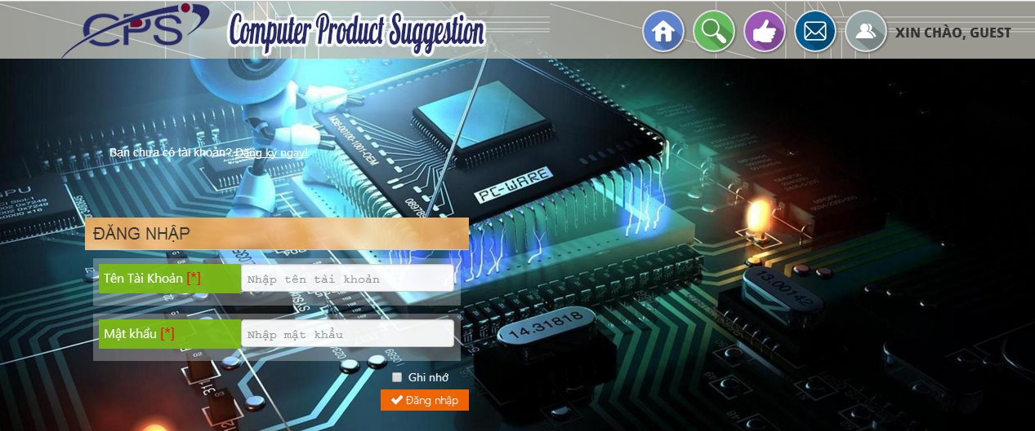

2

1

5

3

Figure 59: Login

**Fields**

|  |  |  |  |  |  |  |  |
| --- | --- | --- | --- | --- | --- | --- | --- |
| **No** | **Field Name** | **Description** | **Read only** | **Mandatory** | **Control Type** | **Data Type** | **Length** |
| 1 | Account name | Fill account name | No | Yes | Textbox | String | N/A |
| 2 | Password | Fill password | No | Yes | Password | String | N/A |

**Buttons/Hyperlinks**

|  |  |  |  |  |
| --- | --- | --- | --- | --- |
| **No** | **Function** | **Description** | **Validation** | **Outcome** |
| 3 | Remember | Click to remember username and password | N/A | N/A |
| 4 | Login | Log-in into the system | N/A | Transfer to home page |
| 5 | Register | Click to register account | N/A | Transfer to register page |

#### Register Page

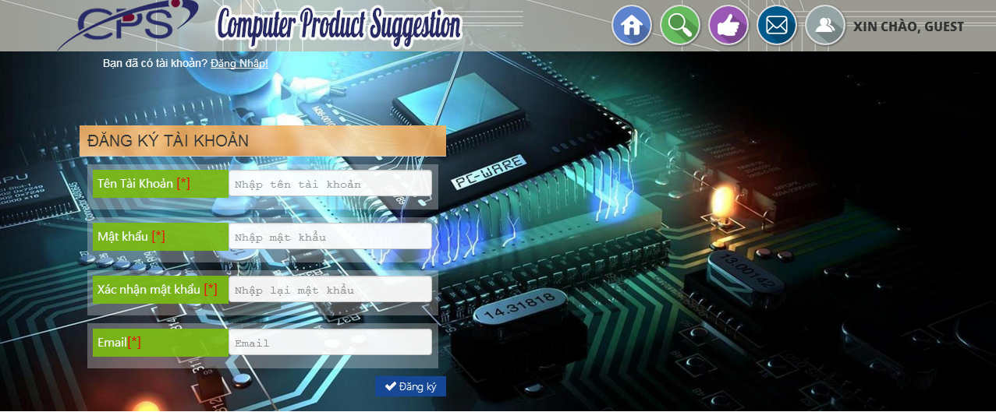

5

4

3

2

1

6

Figure 60: Register Page

**Fields**

|  |  |  |  |  |  |  |  |
| --- | --- | --- | --- | --- | --- | --- | --- |
| **No** | **Field Name** | **Description** | **Read only** | **Mandatory** | **Control Type** | **Data Type** | **Length** |
| 1 | Account name | Fill account name | No | Yes | Textbox | String | N/A |
| 2 | Password | Fill password | No | Yes | Password | String | N/A |
| 3 | Confirm password | Fill password | No | Yes | Password | String | N/A |
| 4 | Email | Fill email | No | Yes | Email | String | N/A |

**Buttons/Hyperlinks**

|  |  |  |  |  |
| --- | --- | --- | --- | --- |
| **No** | **Function** | **Description** | **Validation** | **Outcome** |
| 5 | Register | Register new account | N/A | Transfer to home page |
| 6 | Login | Click to log-in into the system | N/A | Transfer to login page |

#### Member Home Page

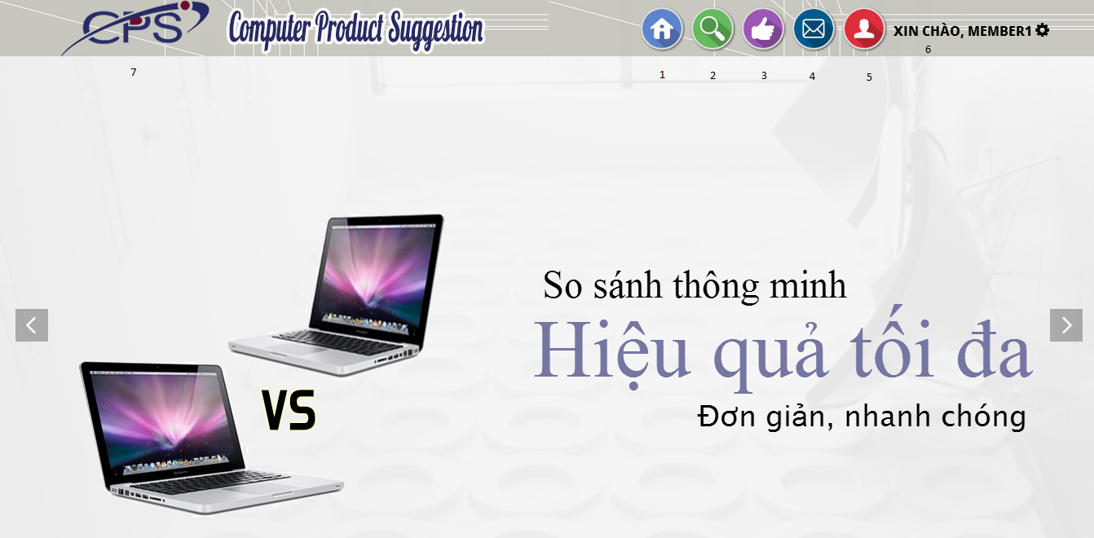

Figure 61: Member Home Page

**Buttons/ Hyperlinks**

|  |  |  |  |  |
| --- | --- | --- | --- | --- |
| **No** | **Function** | **Description** | **Validation** | **Outcome** |
| 1 | Home page | Click to transfer to home page | No | Transfer to Home page |
| 2 | Search product | Click to transfer to search page | No | Transfer to Search page |
| 3 | Highlight | Click to view highlight product | No | Transfer to  Highlight page |
| 4 | Recommend | Click to transfer to recommend page | No | Transfer to recommend page |
| 5 | User Account | Click to transfer to Login page | No | Transfer to Login page |
| 6 | Account Detail | Click to transfer to account detail page | No | Transfer to Account detail page |

#### Search Page

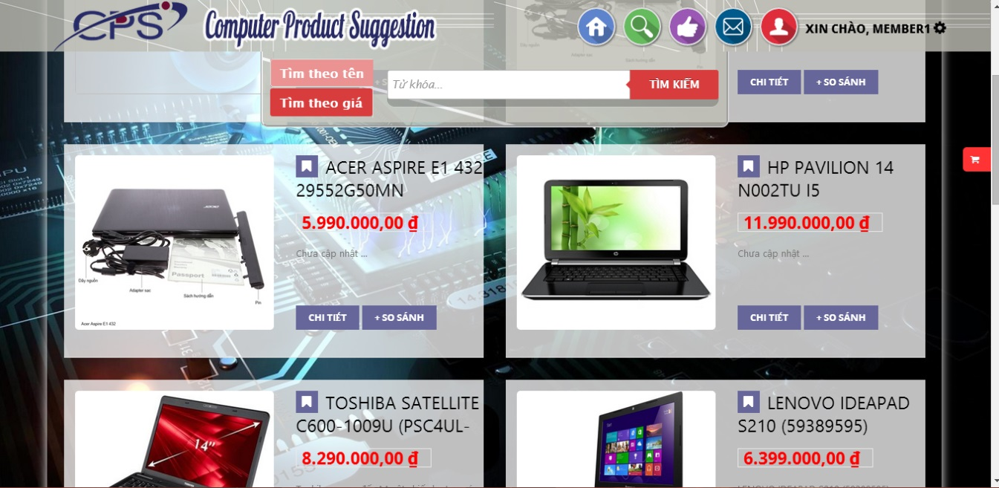

7

8

5

6

3

2

1

4

Figure 62: Search Page

**Fields**

|  |  |  |  |  |  |  |  |
| --- | --- | --- | --- | --- | --- | --- | --- |
| **No** | **Field Name** | **Description** | **Read only** | **Mandatory** | **Control Type** | **Data Type** | **Length** |
| 3 | Product name | Fill product name | No | No | Textbox | String | N/A |
| 7 | Product grid | Show list product | Yes | Yes | Grid list view | N/A | N/A |

**Button/ Hyperlink**

|  |  |  |  |  |
| --- | --- | --- | --- | --- |
| **No** | **Function** | **Description** | **Validation** | **Outcome** |
| 1 | Search by Name | Search by name | N/A | N/A |
| 2 | Search by Price | Search by price | N/A | N/A |
| 4 | Search | Click to search | N/A | N/A |
| 5 | Add to cart | Add item to cart | N/A | Add item to cart |
| 6 | Details | Show details page | N/A | Transfer to detail page |
| 8 | View cart | View cart details | N/A | Show cart which product is added |

**Product List includes**

|  |  |  |  |  |  |
| --- | --- | --- | --- | --- | --- |
| **Field Name** | **Description** | **Read only** | **Control Type** | **Data Type** | **Length** |
| Product name | Show product name | Yes | Textview | String | N/A |
| Price | Show product price | Yes | Textview | Integer | N/A |
| Action | Action for product | N/A | Button | N/A | N/A |
| Description | Show description | N/A | Textview | N/A | N/A |

#### Recommend

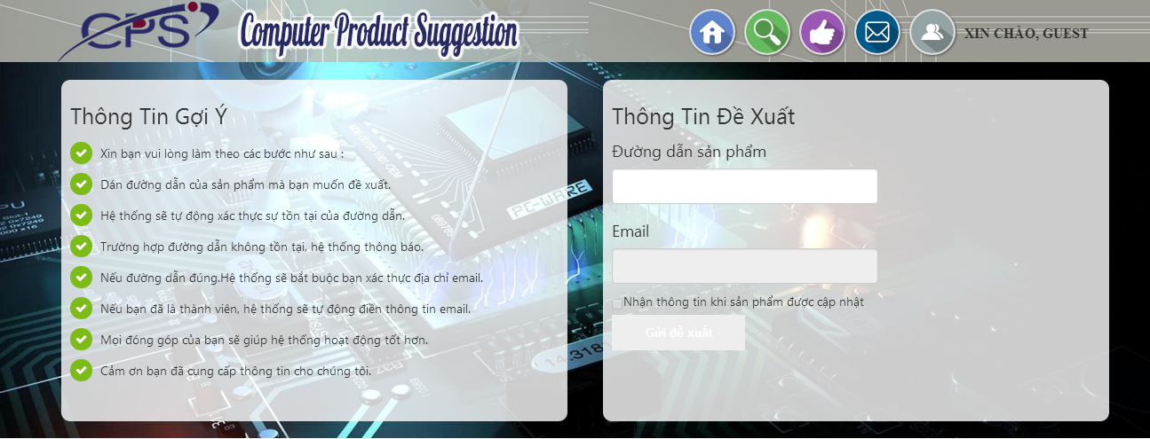

6

5

3

4

2

1

Figure 63: Recommend

**Fields**

|  |  |  |  |  |  |  |  |
| --- | --- | --- | --- | --- | --- | --- | --- |
| **No** | **Field Name** | **Description** | **Read only** | **Mandatory** | **Control Type** | **Data Type** | **Length** |
| 1 | Link | Recommend product link. | N/A | N/A | Label | String | N/A |
| 2 | Fill recommend product link | Fill recommend product link | Yes | N/A | Textbox | String | N/A |
| 3 | Email label | Email address | No | Yes | Label | String | N/A |
| 4 | Email | Fill Email address | No | Yes | Textbox | String | N/A |
| 5 | MailReceive | Check if user want receive email | NO | N/A | Checkboc | Bool | N/A |

**Button/ Hyperlink**

|  |  |  |  |  |
| --- | --- | --- | --- | --- |
| **No** | **Function** | **Description** | **Validation** | **Outcome** |
| 6 | Recommend | Click to recommend product | Yes | Tranfer to thanks you page. |

#### Highlight

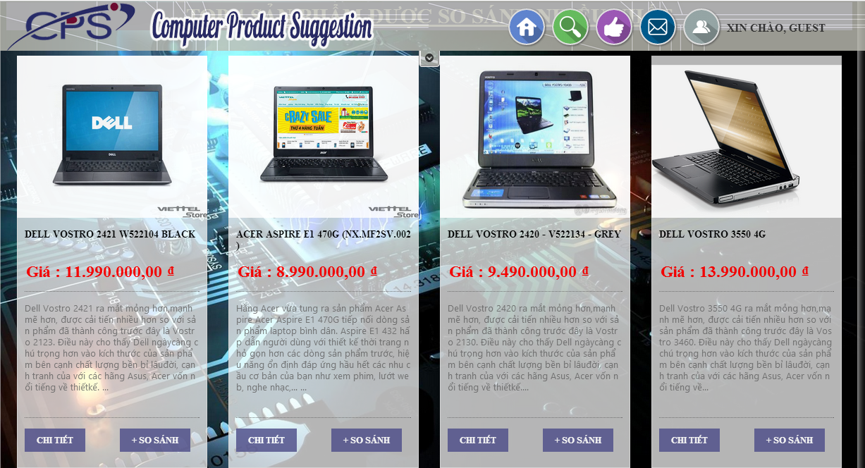

3

2

1

Figure 64: Highlight

**Button/ Hyperlink**

|  |  |  |  |  |
| --- | --- | --- | --- | --- |
| **No** | **Function** | **Description** | **Validation** | **Outcome** |
| 1 | Detail | Click to view detail | N/A | Transfer to detail page |
| 2 | Add to cart | Add item to cart | N/A | Add item to cart |

**Product List includes**

|  |  |  |  |  |  |
| --- | --- | --- | --- | --- | --- |
| **Field Name** | **Description** | **Read only** | **Control Type** | **Data Type** | **Length** |
| Product Image | Show product image | Yes | Image | String | N/A |
| Product name | Show product name | Yes | Textview | String | N/A |
| Price | Show product price | Yes | Textview | Integer | N/A |
| Description | Show description | Yes | Textview | String | N/A |
| Action | Action for product | No | Button | N/A | N/A |

#### View Compare

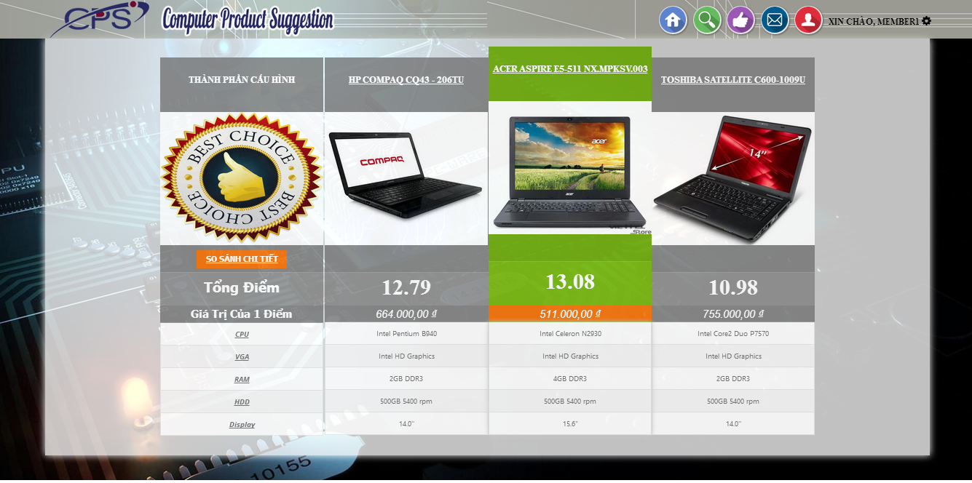

1

2

Figure 65: View Compare

**Button/ Hyperlink**

|  |  |  |  |  |
| --- | --- | --- | --- | --- |
| **No** | **Function** | **Description** | **Validation** | **Outcome** |
| 1 | Detail Compare | Click to view compare detail | N/A | Transfer to order detail compare page |
| 2 | Detail | Click to view details | N/A | Tranfser to detail page |

**Compare List includes**

|  |  |  |  |  |  |
| --- | --- | --- | --- | --- | --- |
| **Field Name** | **Description** | **Read only** | **Control Type** | **Data Type** | **Length** |
| Image | Image of product | Yes | Image | Bitmap | N/A |
| Point | Point of each product | Yes | Textview | Integer | N/A |
| Price/point | Price per each point | Yes | Textview | Integer | 1-100 |
| CPU | CPU of each product | Yes | Textview | String | N/A |
| VGA | VGA of each product | Yes | Textview | String | N/A |
| RAM | Ram of each product | Yes | Textview | String | N/A |
| HDD | HDD of each product | Yes | Textview | String | N/A |
| Display | Display of each product | Yes | Textview | String | N/A |

#### Compare Details

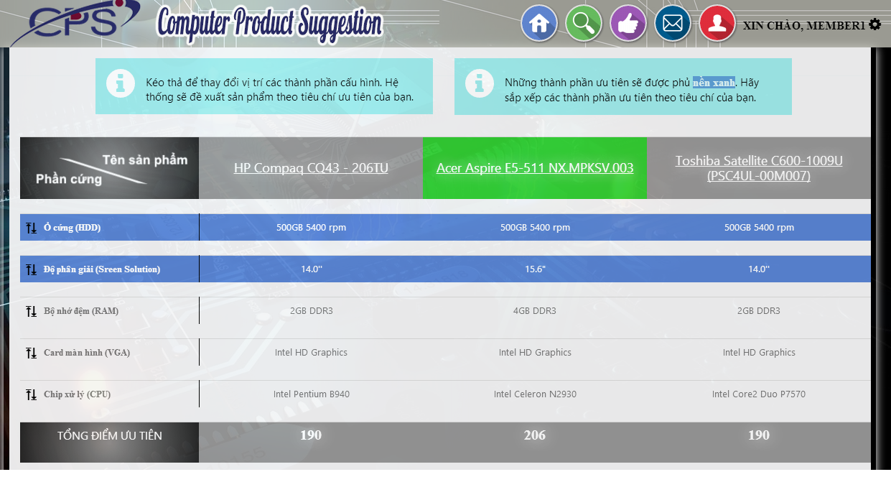

1

Figure 66: History Details

**Button/ Hyperlink**

|  |  |  |  |  |
| --- | --- | --- | --- | --- |
| **No** | **Function** | **Description** | **Validation** | **Outcome** |
| 1 | Detail | Click to view details | N/A | Tranfser to detail page |

**Compare Detail List includes**

|  |  |  |  |  |  |
| --- | --- | --- | --- | --- | --- |
| **Field Name** | **Description** | **Read only** | **Control Type** | **Data Type** | **Length** |
| Image | Image of product | Yes | Image | Bitmap | N/A |
| Point | Point of each product | Yes | Textview | Integer | N/A |
| Price/point | Price per each point | Yes | Textview | Integer | 1-100 |
| CPU | CPU of each product | Yes | Textview | String | N/A |
| VGA | VGA of each product | Yes | Textview | String | N/A |
| RAM | Ram of each product | Yes | Textview | String | N/A |
| HDD | HDD of each product | Yes | Textview | String | N/A |
| Display | Display of each product | Yes | Textview | String | N/A |

### Admin Interface Design

#### Login Page

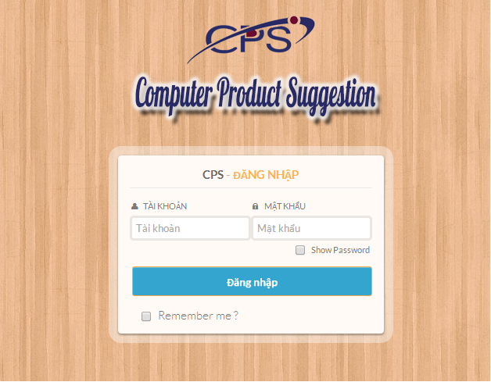

3

4

2

1

Figure 67: Admin/Staff Login Page

**Fields**

|  |  |  |  |  |  |  |  |
| --- | --- | --- | --- | --- | --- | --- | --- |
| **No** | **Field name** | **Description** | **Read only** | **Mandatory** | **Control type** | **Data type** | **Length** |
| 1 | Username | Fill username | No | Yes | Textbox | String | [6-20] |
| 2 | Password | Fill password | No | Yes | Password | String | [6-20]] |
| 3 | Show Password | Show password | NO | N/A | checkbox | Bool | N/A |

**Button/Hyperlink**

|  |  |  |  |  |
| --- | --- | --- | --- | --- |
| **No** | **Function** | **Description** | **Validation** | **Outcome** |
| 4 | Login | Click to login into the system | Yes | Transfer to Admin/Staff Home page |

#### User List Page

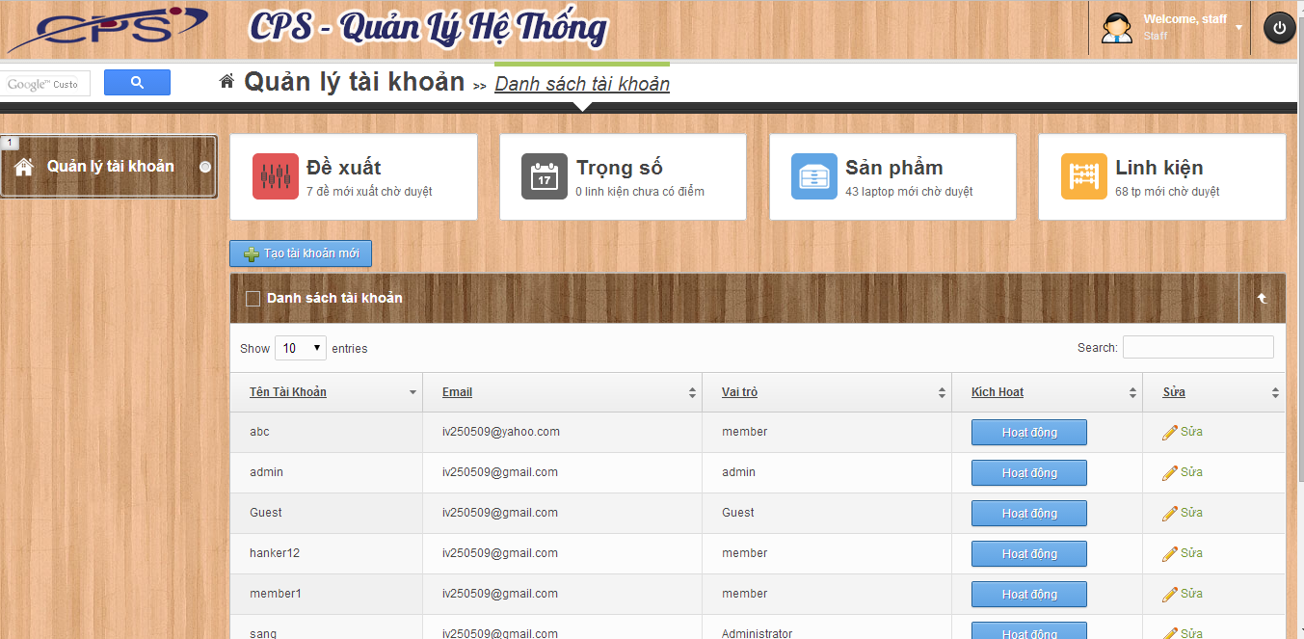

3

6

7

5

4

2

1

Figure 68: User List Page

**Fields**

|  |  |  |  |  |  |  |  |
| --- | --- | --- | --- | --- | --- | --- | --- |
| **No** | **Field name** | **Description** | **Read only** | **Mandatory** | **Control type** | **Data type** | **Length** |
| 1 | Account info | Username of admin | N/A | N/A | Label | N/A | N/A |
| 5 | User list | Table showing | Yes | Yes | Table | N/A | N/A |

**Button/ Hyperlink**

|  |  |  |  |  |
| --- | --- | --- | --- | --- |
| **No** | **Function** | **Description** | **Validation** | **Outcome** |
| 2 | Logout | Click to logout account | No | Transfer to Admin/Staff Login page |
| 3 | Manage user account | Click to go to manage user page | No | Transfer to Manage user page |
| 4 | Create new account | Click to go to create new user page | No | Transfer to Create new user page |
| 6 | Enable/Disable account | Click to Enable/Disable the user | No | Message completed |
| 7 | Edit Account | Click to edit account | No | Transfer to edit user page |

**Table User List includes**

|  |  |  |  |  |  |
| --- | --- | --- | --- | --- | --- |
| **Field name** | **Description** | **Read only** | **Control type** | **Data type** | **Length** |
| Email | Email | N/A | Label | String | N/A |
| Username | Username | N/A | Label | String | N/A |
| Role | Role of user | N/A | Label | String | N/A |
| Status | Enable/Disable account | No | Button | N/A | N/A |

#### Create New User Page

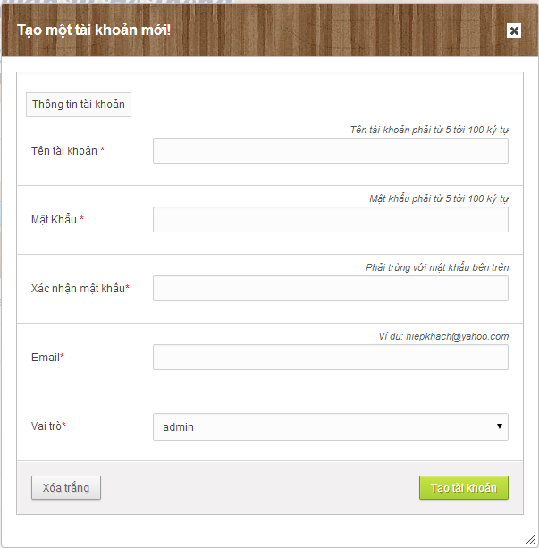

7

6

5

4

3

2

1

Figure 69: Create New User Page

**Fields**

|  |  |  |  |  |  |  |  |
| --- | --- | --- | --- | --- | --- | --- | --- |
| **No** | **Field name** | **Description** | **Read only** | **Mandatory** | **Control type** | **Data type** | **Length** |
| 1 | Username | Fill username of user | No | Yes | Textbox | String | [6-20] |
| 2 | Password | Fill password | No | Yes | Password | String | [6-20] |
| 3 | Confrm password | Fill password | No | Yes | Password | String | [6-20] |
| 4 | Email | Fill Email | No | Yes | Textbox | String | [1-200] |
| 5 | Role | Select role of user | No | Yes | Drop down list | N/A | N/A |

**Button/ Hyperlink**

|  |  |  |  |  |
| --- | --- | --- | --- | --- |
| **No** | **Function** | **Description** | **Validation** | **Outcome** |
| 7 | Create new user | Create new user | Yes | Transfer to Manage user page |
| 6 | Clear text | Clear text | No | N/A |

### Staff Interface Design

#### Train Machine Page

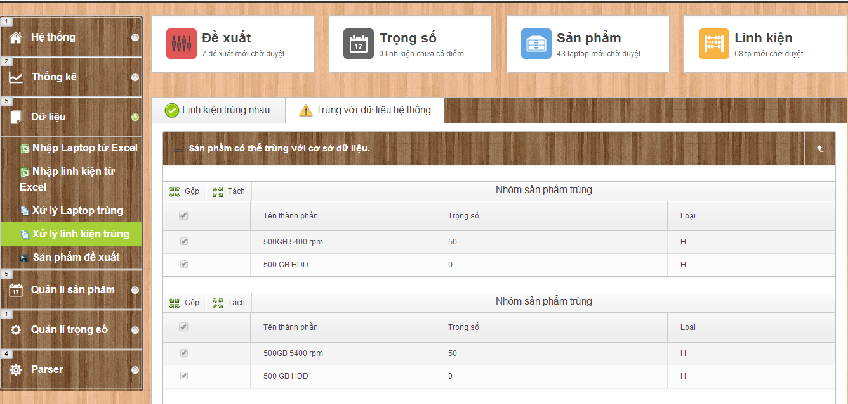

8

4

11

10

9

7

3

19

20

16

18

17

12

13

14

15

5

6

2

1

Figure 70: Train Machine Page

**Fields**

|  |  |  |  |  |  |  |  |
| --- | --- | --- | --- | --- | --- | --- | --- |
| **No** | **Field name** | **Description** | **Read only** | **Mandatory** | **Control type** | **Data type** | **Length** |
| 1 | Home page | Home page | N/A | Yes | Label | N/A | N/A |
| 2 | Statictis | Statictis | N/A | Yes | Label | N/A | N/A |
| 3 | Data | Data | N/A | Yes | Label | N/A | N/A |
| 4 | Manage product | Manage product | N/A | Yes | Label | N/A | N/A |
| 5 | Manage weight point | Manage weight point | N/A | Yes | Label | N/A | N/A |
| 6 | Parser | Manage parse data | N/A | Yes | Label | N/A | N/A |
| 16 | Data training list | Table showing | No | Yes | Table | N/A | N/A |

**Button/ Hyperlink**

|  |  |  |  |  |
| --- | --- | --- | --- | --- |
| **No** | **Function** | **Description** | **Validation** | **Outcome** |
| 7 | Import laptop | Click to go to import excel page | No | Transfer to Import excel page |
| 8 | Import hardware | Click to go to import excel page | No | Transfer to Import excel page |
| 9 | Training match | Click to go to training match page | No | Transfer to Training match page |
| 10 | Training match | Click to go to training match page | No | Transfer to Training match page |
| 11 | create recommend laptop | Click to go create recommend laptop page | No | Transfer to create recommend laptop page |
| 12 | Recommend laptop list | Click to go manage recommend laptop page | No | Transfer to manage recommend laptop page |
| 13 | point list | Click to go point list page | No | Transfer to point list page |
| 14 | Confirm new laptop list | Click to go Confirm new recommend laptop page | No | Transfer to Confirm new laptop list page |
| 15 | Confirm new hardware list | Click to go Confirm new hardware page | No | Transfer to Confirm new hardware list page |
| 17 | Duplicate list | Click to go Confirm Duplicate list page | No | Click to go Confirm Duplicate list page |
| 18 | Duplicate list with database | Click to go Confirm Duplicate list in database | No | Click to go Confirm Duplicate list page in database |
| 19 | Merge | Click to merge product | Yes | N/A |
| 20 | Split | Click to split product | Yes | N/A |

**Table data training List includes**

|  |  |  |  |  |  |
| --- | --- | --- | --- | --- | --- |
| **Field name** | **Description** | **Read only** | **Control type** | **Data type** | **Length** |
| Checkbox field | Select product | No | Checkbox | N/A | N/A |
| Product name | Product name | N/A | Label | String | N/A |

#### Import Excel Page

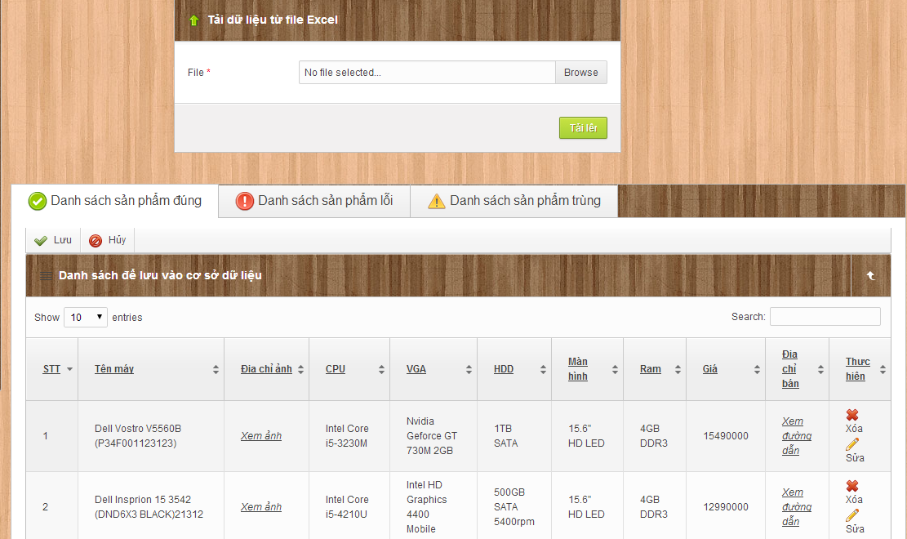

4

10

7

9

8

6

5

3

2

1

Figure 71: Import Excel – Correct Data List

**Fields**

|  |  |  |  |  |  |  |  |
| --- | --- | --- | --- | --- | --- | --- | --- |
| **No** | **Field Name** | **Description** | **Read only** | **Mandatory** | **Control Type** | **Data Type** | **Length** |
| 3 | Product list | Show list product | No | N/A | Table list view | N/A | N/A |
| 10 | Tab content | Tab content | No | N/A | Tab view | N/A | N/A |

**Button/ Hyperlink**

|  |  |  |  |  |
| --- | --- | --- | --- | --- |
| **No** | **Function** | **Description** | **Validation** | **Outcome** |
| 1 | Select excel file | Click to select excel file | N/A | N/A |
| 2 | Upload excel file | Get data in excel file | N/A | N/A |
| 4 | Save product | Click to save product into database | N/A | Show message result. |
| 5 | Cancel import | Click to cancel import product | N/A | N/A |
| 6 | Remove product | Click to remove product | N/A | N/A |
| 7 | Edit product | Click to edit product | N/A | N/A |
| 8 | Error product list | Click to transfer to error product list | N/A | Transfer to error product tab |
| 9 | Duplicate product list | Click to transfer to duplicate product list | N/A | Transfer to duplicate product tab |

**Product List includes**

|  |  |  |  |  |  |
| --- | --- | --- | --- | --- | --- |
| **Field Name** | **Description** | **Read only** | **Control Type** | **Data Type** | **Length** |
| Number row | Number of row | N/A | Label | String | N/A |
| Product name | Show product name | N/A | Label | String | N/A |
| Image | Show image | N/A | Label | String | N/A |
| CPU | CPU of product | N/A | Label | String | N/A |
| VGA | VGA of product | N/A | Label | String | N/A |
| Display | Display of product | N/A | Label | String | N/A |
| HDD | HDD of product | N/A | Label | String | N/A |
| RAM | RAM of product | N/A | Label | String | N/A |
| Price | Show product price | N/A | Label | Integer | N/A |
| URL | URL of product | N/A | Label | String | N/A |
| Action | Action for product | No | Button | N/A | N/A |

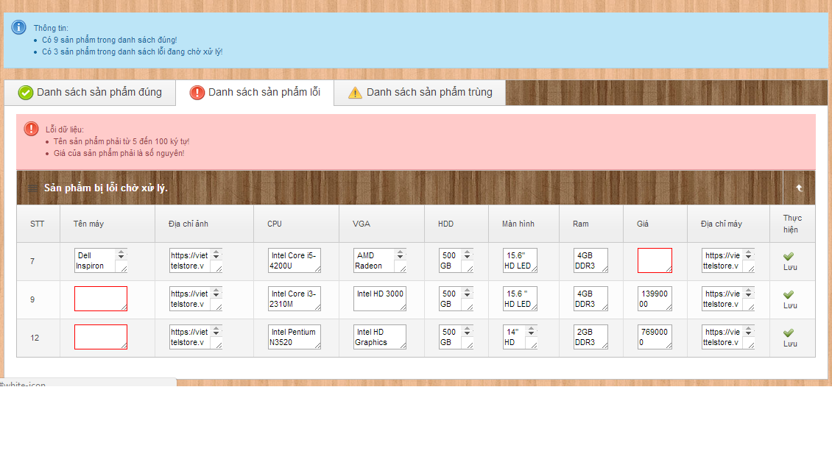Figure 72: Import Excel – Error Data List

13

15

14

12

11

10

9

8

7

6

5

4

3

2

1

**Fields**

|  |  |  |  |  |  |  |  |
| --- | --- | --- | --- | --- | --- | --- | --- |
| **No** | **Field Name** | **Description** | **Read only** | **Mandatory** | **Control Type** | **Data Type** | **Length** |
| 1 | Message | Show error message | N/A | N/A | Label | String | N/A |
| 2 | Error Product list | Show list product | No | N/A | Table list view | N/A | N/A |
| 4 | Product name | Fill name of product | No | Yes | Textbox | String | N/A |
| 5 | URL Image | Fill URL Image of product | No | Yes | Textbox | String | N/A |
| 6 | CPU | Fill CPU of product | No | Yes | Textbox | String | N/A |
| 7 | VGA | Fill VGA of product | No | Yes | Textbox | String | N/A |
| 8 | Display | Fill Display of product | No | Yes | Textbox | String | N/A |
| 9 | HDD | Fill HDD of product | No | Yes | Textbox | String | N/A |
| 10 | RAM | Fill RAM of product | No | Yes | Textbox | String | N/A |
| 11 | Price | Fill price of product | No | Yes | Textbox | Integer | [N/A] |
| 12 | URL | Fill URL of product | No | Yes | Textbox | String | N/A |
| 13 | General Message | Show message | No | No | Textbox | String | N/A |

**Button/ Hyperlink**

|  |  |  |  |  |
| --- | --- | --- | --- | --- |
| **No** | **Function** | **Description** | **Validation** | **Outcome** |
| 3 | Save product | Click to save product | N/A | N/A |
| 14 | Correct product list | Click to transfer to correct product list | N/A | Transfer to correct product tab |
| 15 | Duplicate product list | Click to transfer to duplicate product list | N/A | Transfer to duplicate product tab |

**Error Product List includes**

|  |  |  |  |  |  |
| --- | --- | --- | --- | --- | --- |
| **Field Name** | **Description** | **Read only** | **Control Type** | **Data Type** | **Length** |
| Number row | Number of row | N/A | Label | String | N/A |
| Product name | Show product name | N/A | Label | String | N/A |
| Image | Show image | N/A | Label | String | N/A |
| CPU | CPU of product | N/A | Label | String | N/A |
| VGA | VGA of product | N/A | Label | String | N/A |
| Display | Display of product | N/A | Label | String | N/A |
| HDD | HDD of product | N/A | Label | String | N/A |
| RAM | RAM of product | N/A | Label | String | N/A |
| Price | Show product price | N/A | Label | Integer | N/A |
| URL | URL of product | N/A | Label | String | N/A |
| Action | Action for product | No | Button | N/A | N/A |

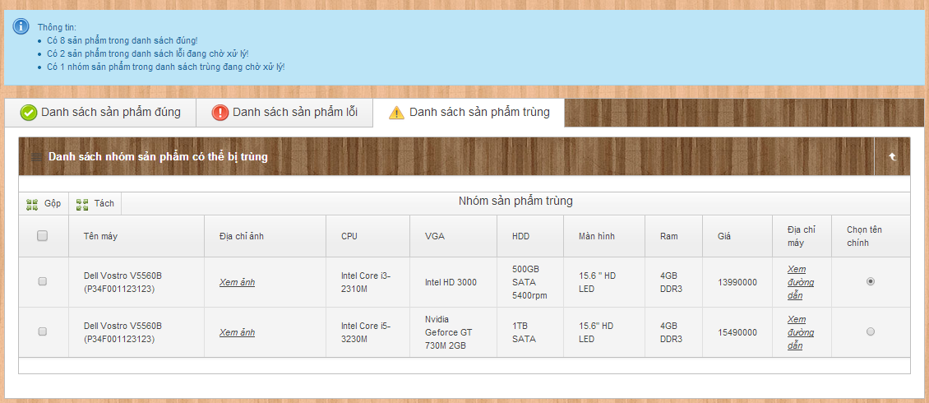

1

2

4

3

5

8

7

6

Figure 73: Import Excel - Name Conflict

**Fields**

|  |  |  |  |  |  |  |  |
| --- | --- | --- | --- | --- | --- | --- | --- |
| **No** | **Field Name** | **Description** | **Read only** | **Mandatory** | **Control Type** | **Data Type** | **Length** |
| 5 | Duplicate product table | Show duplicate product | N/A | N/A | Table list view | N/A | N/A |

**Button/ Hyperlink**

|  |  |  |  |  |
| --- | --- | --- | --- | --- |
| **No** | **Function** | **Description** | **Validation** | **Outcome** |
| 1 | Join product | Click to join products in each table | N/A | N/A |
| 2 | Divide product | Click to divide product in each table | N/A | N/A |
| 3 | Checkbox product | Click to select product | N/A | N/A |
| 4 | Chose name of product | Select name of product | N/A | N/A |
| 6 | General message | Show message | N/A | N/A |
| 7 | Correct product list | Click to transfer to correct product list | N/A | Transfer to correct product tab |
| 8 | Duplicate product list | Click to transfer to duplicate product list | N/A | Transfer to duplicate product tab |

**Duplicate Product List includes**

|  |  |  |  |  |  |
| --- | --- | --- | --- | --- | --- |
| **Field Name** | **Description** | **Read only** | **Control Type** | **Data Type** | **Length** |
| Number row | Number of row | N/A | Label | String | N/A |
| Product name | Show product name | N/A | Label | String | N/A |
| Image | Show image | N/A | Label | String | N/A |
| CPU | CPU of product | N/A | Label | String | N/A |
| VGA | VGA of product | N/A | Label | String | N/A |
| Display | Display of product | N/A | Label | String | N/A |
| HDD | HDD of product | N/A | Label | String | N/A |
| RAM | RAM of product | N/A | Label | String | N/A |
| Price | Show product price | N/A | Label | Integer | N/A |
| URL | URL of product | N/A | Label | String | N/A |
| Action | Action for product | No | Button | N/A | N/A |

1

#### Manage Recommend Product

10

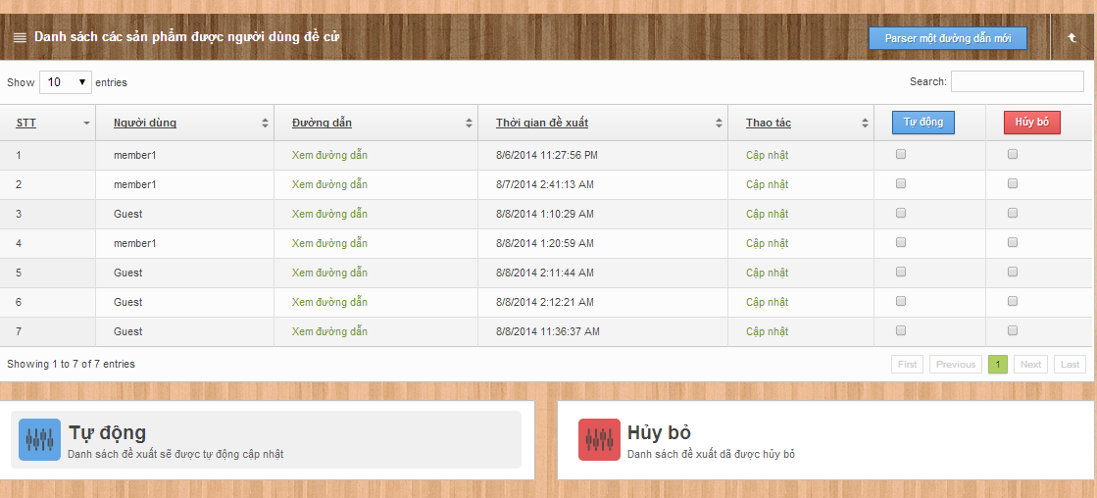

8

9

6

7

4

5

3

2

Figure 74: Manage Recommend Product

**Fields**

|  |  |  |  |  |  |  |  |
| --- | --- | --- | --- | --- | --- | --- | --- |
| **No** | **Field name** | **Description** | **Read only** | **Mandatory** | **Control type** | **Data type** | **Length** |
| 10 | User price list | Table showing | No | Yes | Table | N/A | N/A |
| 4 | Select product | Select recommend product to auto list | No | N/A | Check box | N/A | N/A |
| 5 | Select product | Select recommend product to Ignore list | No | N/A | Check box | N/A | N/A |
|  |  |  |  |  |  |  |  |

**Button/ Hyperlink**

|  |  |  |  |  |
| --- | --- | --- | --- | --- |
| **No** | **Function** | **Description** | **Validation** | **Outcome** |
| 2 | Add to Auto recommend product list | Click to add to auto recommend product list | No | Reload page and update list |
| 3 | Add to Ignore recommend product list | Click to add to Ignore recommend product list | No | Reload page and update list |
| 6 | Create product parser | Click to move parse page | No | Transfer to parse page |
| 7 | None | Click to view product | No | Transfer to product page |
| 8 | Auto Product list | Click to move to auto product list page | No | Transfer to auto list product |
| 9 | Ignore Product list | Click to move to ignore product list page | No | Transfer to ignore list product |

**Table Recommend List includes**

|  |  |  |  |  |  |
| --- | --- | --- | --- | --- | --- |
| **Field name** | **Description** | **Read only** | **Control type** | **Data type** | **Length** |
| Username | Username | N/A | Label | String | N/A |
| URL | URL of product | N/A | Label | String | N/A |
| RecommendTime | Recommend time | N/A | Label | Datetime | N/A |
| Action | Action of staff | No | Button, Checkbox | N/A | N/A |

#### Configure System

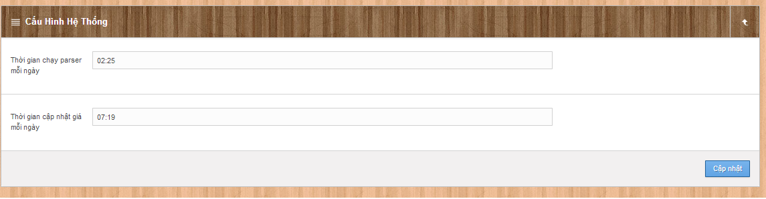

3

2

1

Figure 75: Configure System

**Fields**

|  |  |  |  |  |  |  |  |
| --- | --- | --- | --- | --- | --- | --- | --- |
| **No** | **Field name** | **Description** | **Read only** | **Mandatory** | **Control type** | **Data type** | **Length** |
| 1 | Time auto parse product | Fill time auto parse product | No | Yes | Time picker | Date Time | N/A |
| 2 | Time auto update price of product | Fill time auto update price of product | No | Yes | Time picker | Date Time | N/A |

**Button/Hyperlink**

|  |  |  |  |  |
| --- | --- | --- | --- | --- |
| **No** | **Function** | **Description** | **Validation** | **Outcome** |
| 3 | Update configuration | Click to update configuration system | Yes | Message completed |

#### Manage Product

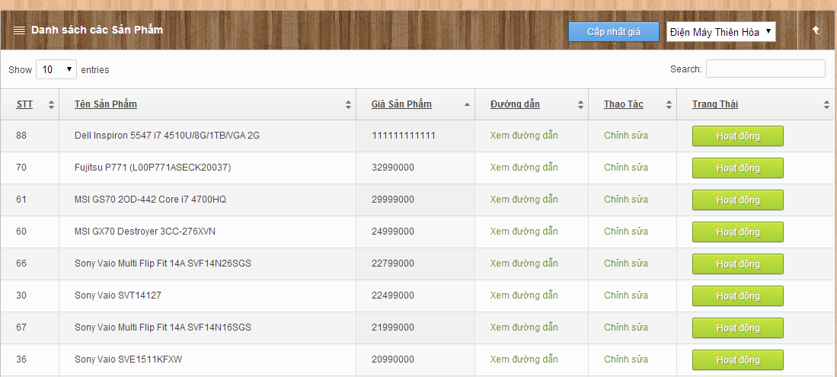

6

5

4

1

2

3

Figure 76: Manage Product

**Fields**

|  |  |  |  |  |  |  |  |
| --- | --- | --- | --- | --- | --- | --- | --- |
| **No** | **Field Name** | **Description** | **Read only** | **Mandatory** | **Control Type** | **Data Type** | **Length** |
| 1 | Product table | Show product | No | N/A | Table list view | N/A | N/A |
| 3 | Store nname | Show store name | Yes | N/A | Drop down list | N/A | N/A |

**Button/ Hyperlink**

|  |  |  |  |  |
| --- | --- | --- | --- | --- |
| **No** | **Function** | **Description** | **Validation** | **Outcome** |
| 4 | URL | Click to view URL | N/A | Transfer to view URL |
| 5 | Edit Product | Click to go to Edit product | N/A | Transfer to Edit product page |
| 6 | Enable/Disable product | Click to Enable/Disable product | N/A | Message completed |

**Product List includes**

|  |  |  |  |  |  |
| --- | --- | --- | --- | --- | --- |
| **Field Name** | **Description** | **Read only** | **Control Type** | **Data Type** | **Length** |
| Number row | Number of row | N/A | Label | String | N/A |
| Product name | Show product name | N/A | String | N/A | N/A |
| Price | Show product price | N/A | Label | Integer | N/A |
| URL | Show URL | N/A | Link | String | N/A |
| Action | Action | N/A | Link | N/A | N/A |
| Status | Enable/Disable product | No | Button | boolean | N/A |

#### Create New Product

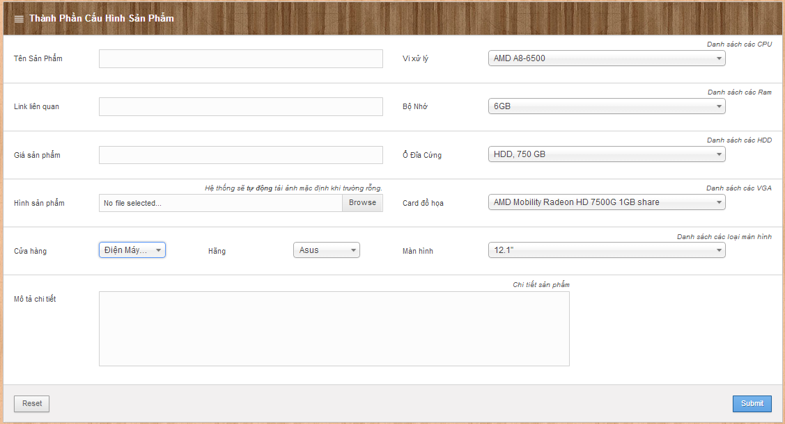

14

13

12

11

9

8

10

7

6

5

4

3

2

1

Figure 77: Create New Product

**Fields**

|  |  |  |  |  |  |  |  |
| --- | --- | --- | --- | --- | --- | --- | --- |
| **No** | **Field Name** | **Description** | **Read only** | **Mandatory** | **Control Type** | **Data Type** | **Length** |
| 1 | Product name | Fill name of product | No | Yes | Textbox | String | N/A |
| 3 | CPU | Fill CPU | No | Yes | Dropdown list | String | N/A |
| 4 | RAM | Fill RAM | No | Yes | Dropdown list | String | N/A |
| 5 | HDD | Fill HDD | No | Yes | Dropdown list | String | N/A |
| 6 | VGA | Fill VGA | No | Yes | Dropdown list | String | N/A |
| 7 | Display | Fill Display | No | Yes | Dropdown list | String | N/A |
| 9 | Brand | Fill Brand | No | Yes | Dropdown list | String | N/A |
| 11 | Description | Fill Description | No | Yes | Multi textview | String | N/A |
| 12 | Store | Fill Store | No | Yes | Dropdown list | String | N/A |
| 13 | Price | Fill Price | No | Yes | Textview | Integer | N/A |
| 14 | URL | Fill URL | No | Yes | Textview | String | N/A |

**Button/ Hyperlink**

|  |  |  |  |  |
| --- | --- | --- | --- | --- |
| **No** | **Function** | **Description** | **Validation** | **Outcome** |
| 8 | Save product | Click to save product into database | Yes | Transfer to manage product pages. |
| 2 | Upload Image | Click to browse image | No | Upload image |
| 10 | Reset | Click to reset | No | Reset all field |

#### Edit Product

8

10

7

6

5

4

3

2

11

12

13

14

1

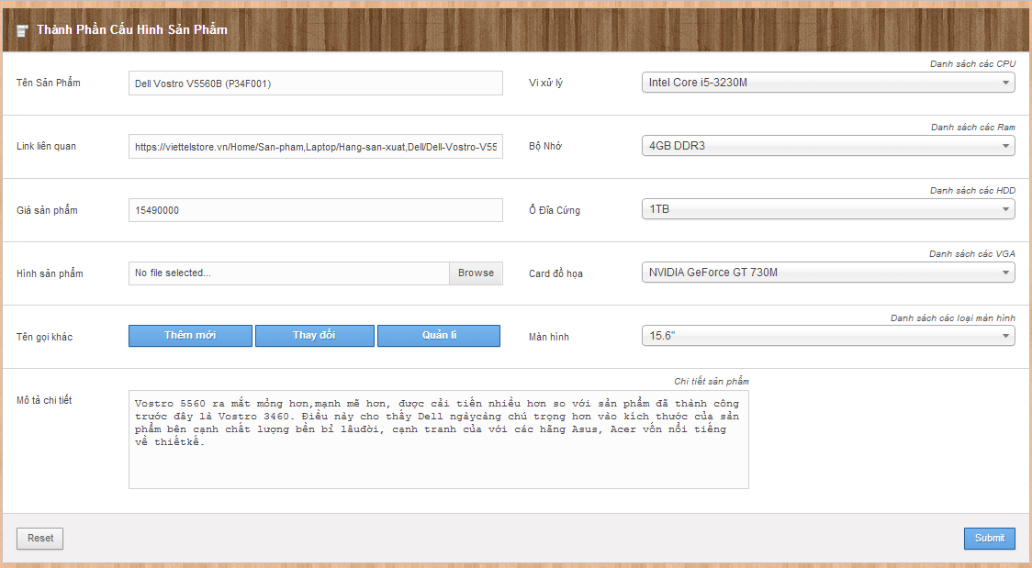

15

9

Figure 78: Edit product

**Fields**

|  |  |  |  |  |  |  |  |
| --- | --- | --- | --- | --- | --- | --- | --- |
| **No** | **Field Name** | **Description** | **Read only** | **Mandatory** | **Control Type** | **Data Type** | **Length** |
| 1 | Product name | Fill name of product | No | Yes | Textbox | String | N/A |
| 3 | CPU | Fill CPU | No | Yes | Dropdown list | String | N/A |
| 4 | RAM | Fill RAM | No | Yes | Dropdown list | String | N/A |
| 5 | HDD | Fill HDD | No | Yes | Dropdown list | String | N/A |
| 6 | VGA | Fill VGA | No | Yes | Dropdown list | String | N/A |
| 7 | Display | Fill Display | No | Yes | Dropdown list | String | N/A |
| 11 | Description | Fill Description | No | Yes | Multi textview | String | N/A |
| 13 | Price | Fill Price | No | Yes | Textview | Integer | N/A |
| 14 | URL | Fill URL | No | Yes | Textview | String | N/A |

**Button/ Hyperlink**

|  |  |  |  |  |
| --- | --- | --- | --- | --- |
| **No** | **Function** | **Description** | **Validation** | **Outcome** |
| 8 | Save product | Click to save product into database | Yes | Transfer to manage product pages. |
| 2 | Upload Image | Click to browse image | No | Upload image |
| 10 | Reset | Click to reset | No | Reset all field |
| 9 | Manage alias product name | Click to move alias product name | No | Transfer to manage alias product name |
| 12 | Create new alias name | Click to move new create alias name | No | Transfer to create a new alias name |
| 15 | Edit new alias name | Click to move Edit alias name | No | Transfer to Edit an alias name |

#### Create Alias Name

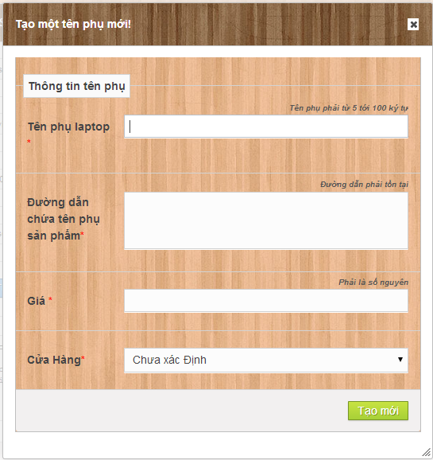

5

4

3

2

1

Figure 79: Create Alias Name

**Fields**

|  |  |  |  |  |  |  |  |
| --- | --- | --- | --- | --- | --- | --- | --- |
| **No** | **Field name** | **Description** | **Read only** | **Mandatory** | **Control type** | **Data type** | **Length** |
| 1 | Alias name | Fill alias name | No | Yes | Textbox | String | N/A |
| 2 | URL of alias product | Fill URL of alias product | No | Yes | Textbox | String | N/A |
| 3 | Price | Fill Price | N/A | Yes | Textbox | Integer | N/A |
| 4 | Store | Fill Store | N/A | Yes | Dropdownlist | String | N/A |

**Button/Hyperlink**

|  |  |  |  |  |
| --- | --- | --- | --- | --- |
| **No** | **Function** | **Description** | **Validation** | **Outcome** |
| 5 | Create new alias product | Create new alias product | Yes | Transfer to manage edit product page |

#### Edit Alias Name

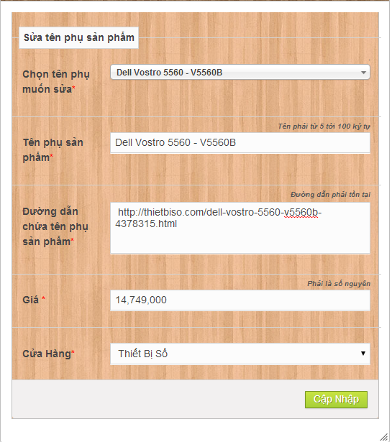

4

5

3

2

1

Figure 80: Edit Alias Product

**Fields**

|  |  |  |  |  |  |  |  |
| --- | --- | --- | --- | --- | --- | --- | --- |
| **No** | **Field name** | **Description** | **Read only** | **Mandatory** | **Control type** | **Data type** | **Length** |
| 1 | Alias name | Fill alias name | No | Yes | Dropdownlist | String | N/A |
| 2 | URL of alias product | Fill URL of alias product | No | Yes | Textbox | String | N/A |
| 3 | Price | Fill Price | N/A | Yes | Textbox | Integer | N/A |
| 4 | Store | Fill Store | N/A | Yes | Dropdownlist | String | N/A |

**Button/Hyperlink**

|  |  |  |  |  |
| --- | --- | --- | --- | --- |
| **No** | **Function** | **Description** | **Validation** | **Outcome** |
| 5 | Edit alias product | Edit an alias product | Yes | Transfer to manage edit product page |

#### Manage Alias name

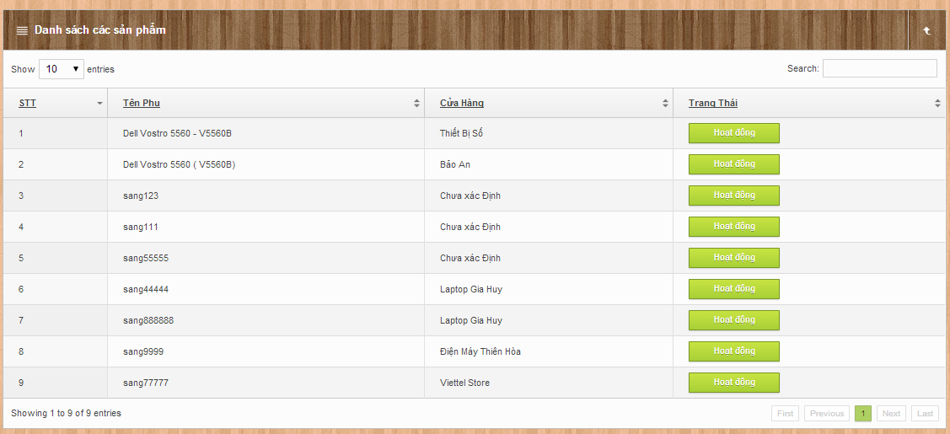

1

2

**Fields**

|  |  |  |  |  |  |  |  |
| --- | --- | --- | --- | --- | --- | --- | --- |
| **No** | **Field name** | **Description** | **Read only** | **Mandatory** | **Control type** | **Data type** | **Length** |
| 1 | Alias list | Show alias list | Yes | No | Table list | N/A | N/A |

**Button/Hyperlink**

|  |  |  |  |  |
| --- | --- | --- | --- | --- |
| **No** | **Function** | **Description** | **Validation** | **Outcome** |
| 2 | Enable or disable alias name | Enable or disable alias name | No | Update List and reload page |

**Alias List includes**

|  |  |  |  |  |  |
| --- | --- | --- | --- | --- | --- |
| **Field Name** | **Description** | **Read only** | **Control Type** | **Data Type** | **Length** |
| Number row | Number of row | N/A | Label | String | N/A |
| Alias Product name | Show Alias product name | N/A | String | N/A | N/A |
| Store | Show product Store | N/A | Label | String | N/A |
| Status | Enable/Disable alias | No | Button | boolean | N/A |

#### Manage Parser

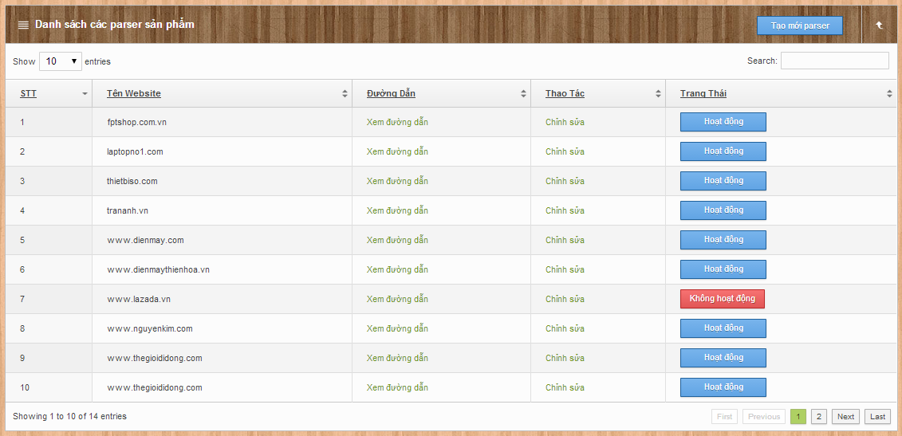

1

5

3

4

2

Figure 81: Manage Parser

**Fields**

|  |  |  |  |  |  |  |  |
| --- | --- | --- | --- | --- | --- | --- | --- |
| **No** | **Field name** | **Description** | **Read only** | **Mandatory** | **Control type** | **Data type** | **Length** |
| 5 | Parsers list | Table showing | No | Yes | Table | N/A | N/A |

**Button/Hyperlink**

|  |  |  |  |  |
| --- | --- | --- | --- | --- |
| **No** | **Function** | **Description** | **Validation** | **Outcome** |
| 1 | Create parser | Click to go to create parser page | No | Transfer to create parser page |
| 2 | Enable/Disable parser | Click to Enable/Disable parser | N/A | Message completed |
| 3 | Edit parser | Click to edit parser | No | Transfer to edit parser page |
| 4 | View parser URL | Click to view Parser URL | No | Transfer to URL |

**Table Parser List includes**

|  |  |  |  |  |  |
| --- | --- | --- | --- | --- | --- |
| **Field name** | **Description** | **Read only** | **Control type** | **Data type** | **Length** |
| No. | Number | N/A | Label | Integer | N/A |
| Website name | Website name | N/A | Label | String | N/A |
| Link | Link to parse | N/A | Label | String | N/A |
| Action | Click to edit parser | No | Link | N/A | N/A |
| Status | Enable/Disable parser | No | Button | N/A | N/A |

#### Create Parser

##### Step 1

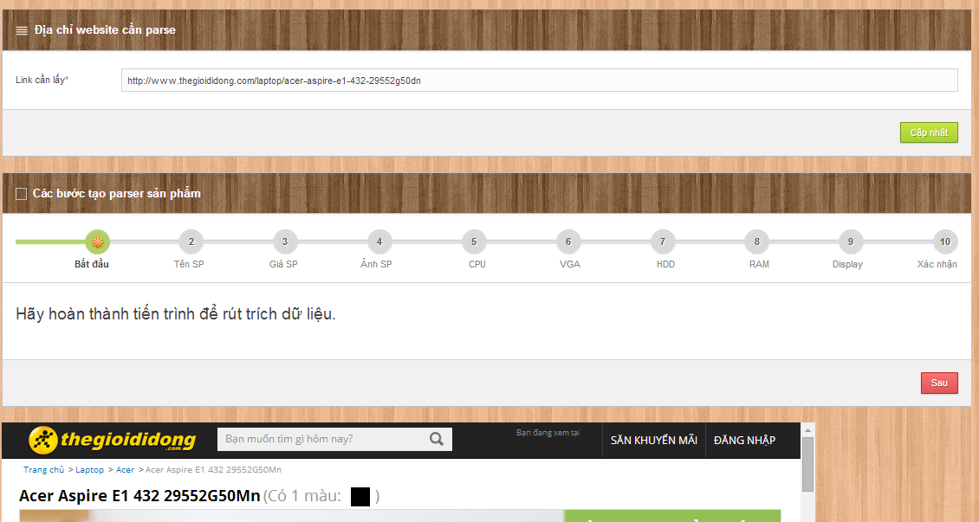

3

14

13

12

11

10

9

8

7

6

5

4

2

1

Figure 82: Create Parser - Step 1

**Fields**

|  |  |  |  |  |  |  |  |
| --- | --- | --- | --- | --- | --- | --- | --- |
| **No** | **Field name** | **Description** | **Read only** | **Mandatory** | **Control type** | **Data type** | **Length** |
| 1 | Link | Link to parse | No | Yes | Textbox | String | N/A |
| 14 | Web view | Web view | No | N/A | Web view | N/A | N/A |

**Button/Hyperlink**

|  |  |  |  |  |
| --- | --- | --- | --- | --- |
| **No** | **Function** | **Description** | **Validation** | **Outcome** |
| 2 | View web | View web from link | No | Display web view |
| 3 | Starting | Welcome message | No | Transfer to step 2 |
| 4 | Name xpath | Click to go to step 3 | Yes | Transfer to step 3 |
| 5 | Price xpath | Click to go to step 4 | No | Transfer to step 4 |
| 6 | Image xpath | Click to go to step 5-CPU xpath | No | Transfer to step 5 |
| 7 | CPU xPath | Click to go to step 6– VGA xpath | No | Transfer to step 6 |
| 8 | VGA xPath | Click to go to step 7– HDD xpath | No | Transfer to step 7 |
| 9 | HDD xPath | Click to go to step 8– RAM xpath | No | Transfer to step 8 |
| 10 | RAM xPath | Click to go to step 9– Display xpath | No | Transfer to step 10 |
| 11 | Display xPath | Click to go to step 10– Finish | No | Transfer to Finish step |

##### Step 2

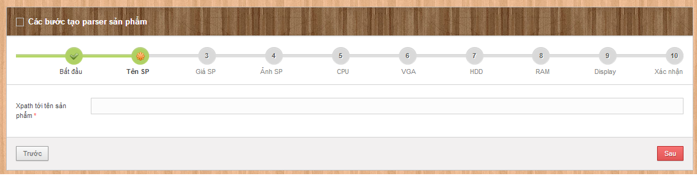

1

Figure 83: Create Parser - Step 2

**Fields**

|  |  |  |  |  |  |  |  |
| --- | --- | --- | --- | --- | --- | --- | --- |
| **No** | **Field name** | **Description** | **Read only** | **Mandatory** | **Control type** | **Data type** | **Length** |
| 1 | Name xpath | Name xpath | No | Yes | Textbox | String | N/A |

##### Step 3

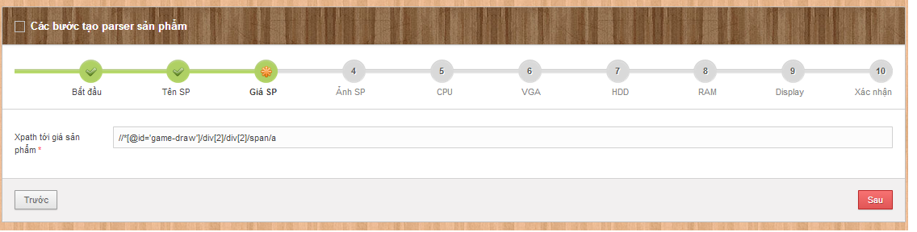

1

Figure 84: Create Parser - Step 3

**Fields**

|  |  |  |  |  |  |  |  |
| --- | --- | --- | --- | --- | --- | --- | --- |
| **No** | **Field name** | **Description** | **Read only** | **Mandatory** | **Control type** | **Data type** | **Length** |
| 1 | Price xpath | Price xpath | No | Yes | Textbox | String | N/A |

##### Step 4

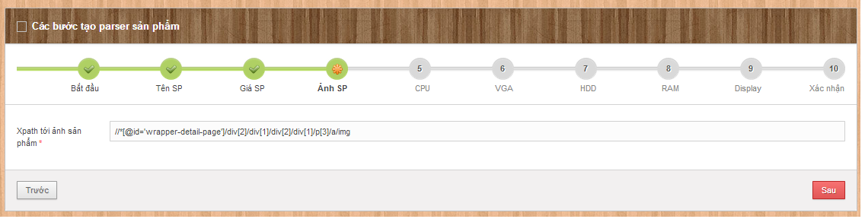

1

Figure 85: Create Parser - Step 4

**Fields**

|  |  |  |  |  |  |  |  |
| --- | --- | --- | --- | --- | --- | --- | --- |
| **No** | **Field name** | **Description** | **Read only** | **Mandatory** | **Control type** | **Data type** | **Length** |
| 1 | Image xpath | Image xpath | No | Yes | Textbox | String | N/A |

##### Step 5

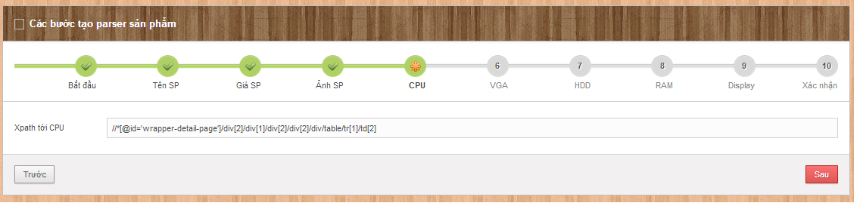

1

Figure 86: Create Parser - Step 5

**Fields**

|  |  |  |  |  |  |  |  |
| --- | --- | --- | --- | --- | --- | --- | --- |
| **No** | **Field name** | **Description** | **Read only** | **Mandatory** | **Control type** | **Data type** | **Length** |
| 1 | CPU xpath | CPU xpath | No | Yes | Textbox | String | N/A |

##### Step 6

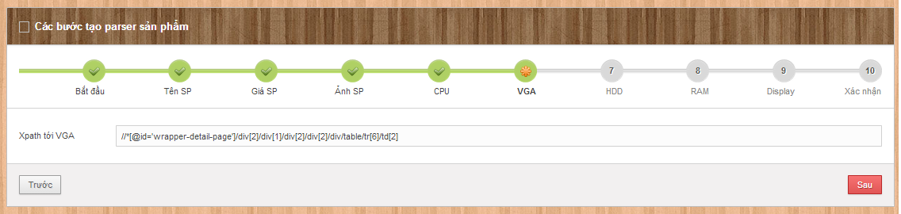

1

Figure 87: Create Parser - Step 6

**Fields**

|  |  |  |  |  |  |  |  |
| --- | --- | --- | --- | --- | --- | --- | --- |
| **No** | **Field name** | **Description** | **Read only** | **Mandatory** | **Control type** | **Data type** | **Length** |
| 1 | VGA xPath | VGA xPath | N/A | Yes | Textbox | String | N/A |

##### Step 7

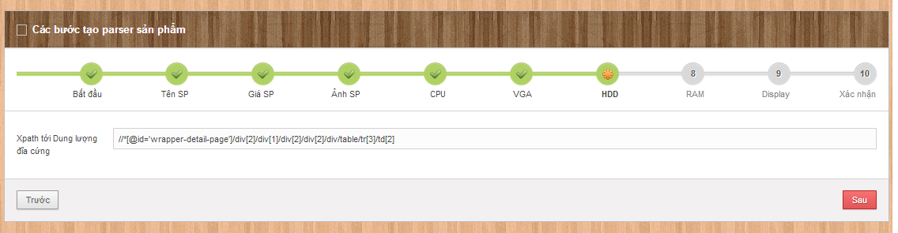

1

Figure 88: Create Parser - Step 7

|  |  |  |  |  |  |  |  |
| --- | --- | --- | --- | --- | --- | --- | --- |
| **No** | **Field name** | **Description** | **Read only** | **Mandatory** | **Control type** | **Data type** | **Length** |
| 1 | HDD xPath | HDD xPath | N/A | Yes | Textbox | String | N/A |

##### Step 8

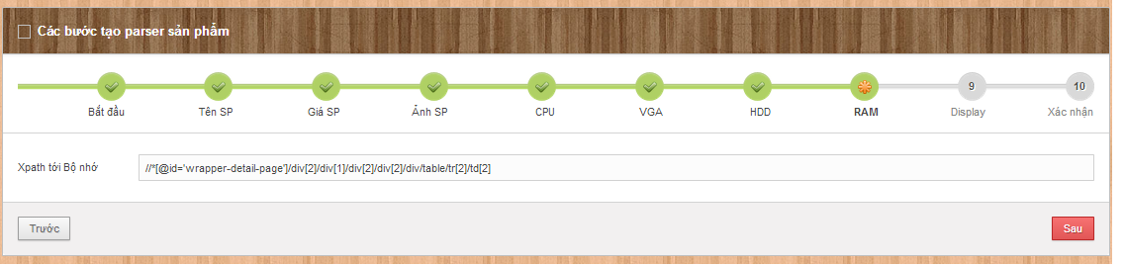

1

Figure 89: Create Parser - Step 8

|  |  |  |  |  |  |  |  |
| --- | --- | --- | --- | --- | --- | --- | --- |
| **No** | **Field name** | **Description** | **Read only** | **Mandatory** | **Control type** | **Data type** | **Length** |
| 1 | RAM xPath | RAM xPath | N/A | Yes | Textbox | String | N/A |

##### Step 9

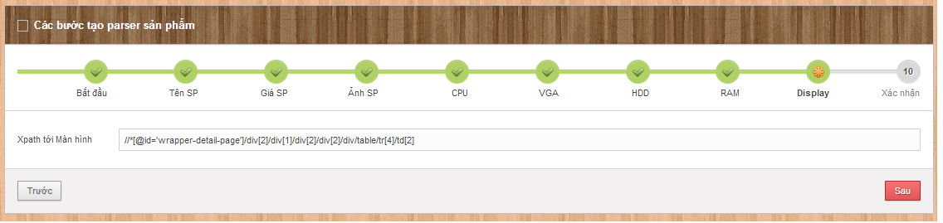

1

Figure 90: Create Parser - Step 9

|  |  |  |  |  |  |  |  |
| --- | --- | --- | --- | --- | --- | --- | --- |
| **No** | **Field name** | **Description** | **Read only** | **Mandatory** | **Control type** | **Data type** | **Length** |
| 1 | Display xPath | Display xPath | N/A | Yes | Textbox | String | N/A |

##### Step 10

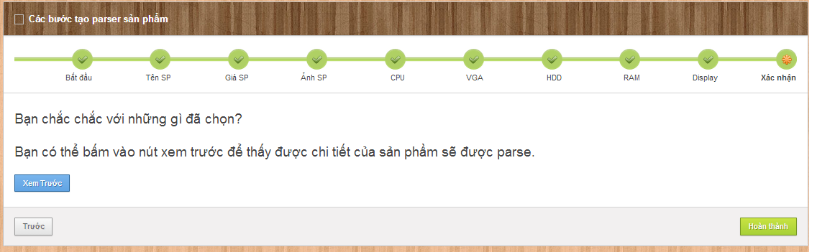

1

2

Figure 91: Create Parser - Step 10

**Button/Hyperlink**

|  |  |  |  |  |
| --- | --- | --- | --- | --- |
| **No** | **Function** | **Description** | **Validation** | **Outcome** |
| 1 | Create Parser | Click to Finish | Yes | Show message and redirect to Manage parse page |
| 2 | Preview | Click to preview data | No | Show pop-up preview |

##### Finish Step- Preview Parse Data

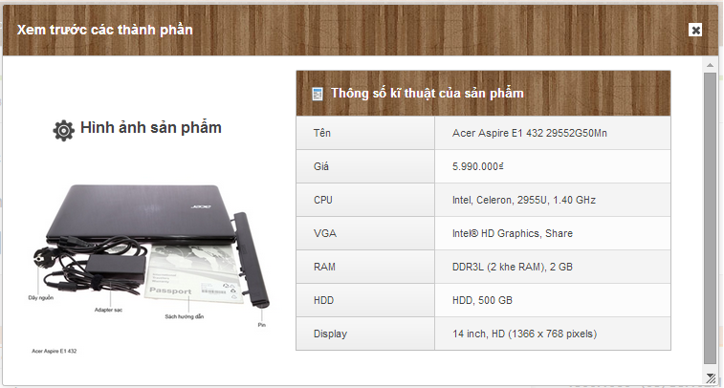

**Preview Parse Data**

|  |  |  |  |  |  |
| --- | --- | --- | --- | --- | --- |
| **Field Name** | **Description** | **Read only** | **Control Type** | **Data Type** | **Length** |
| Name | Name of product | N/A | Label | String | N/A |
| Price | Price of Product | N/A | Label | String | N/A |
| CPU | CPU of product | N/A | Label | String | N/A |
| VGA | VGA of product | N/A | Label | String | N/A |
| RAM | RAM of product | N/A | Label | String | N/A |
| HDD | HDD of product | N/A | Label | String | N/A |
| Display | Display of product | N/A | Label | String | N/A |

#### Manage Log File

1

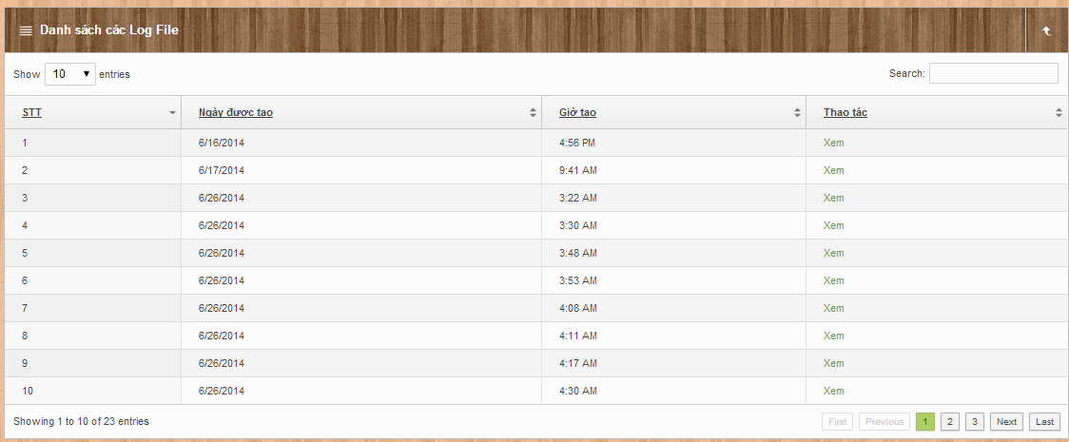

2

Figure 92: Manage Log File

**Fields**

|  |  |  |  |  |  |  |  |
| --- | --- | --- | --- | --- | --- | --- | --- |
| **No** | **Field name** | **Description** | **Read only** | **Mandatory** | **Control type** | **Data type** | **Length** |
| 1 | Log file list | Table showing | No | Yes | Table | N/A | N/A |

**Button/Hyperlink**

|  |  |  |  |  |
| --- | --- | --- | --- | --- |
| **No** | **Function** | **Description** | **Validation** | **Outcome** |
| 2 | View log file | Click to view log file | No | Transfer to log file detail |

**Table Log file List includes**

|  |  |  |  |  |  |
| --- | --- | --- | --- | --- | --- |
| **Field name** | **Description** | **Read only** | **Control type** | **Data type** | **Length** |
| No. | Number | N/A | Label | Integer | N/A |
| Date start | Date start | N/A | Label | String | N/A |
| Time start | Time start | N/A | Label | String | N/A |
| Action | Action of staff | No | Link | N/A | N/A |

#### Confirm new laptop

##### Manage New Laptop

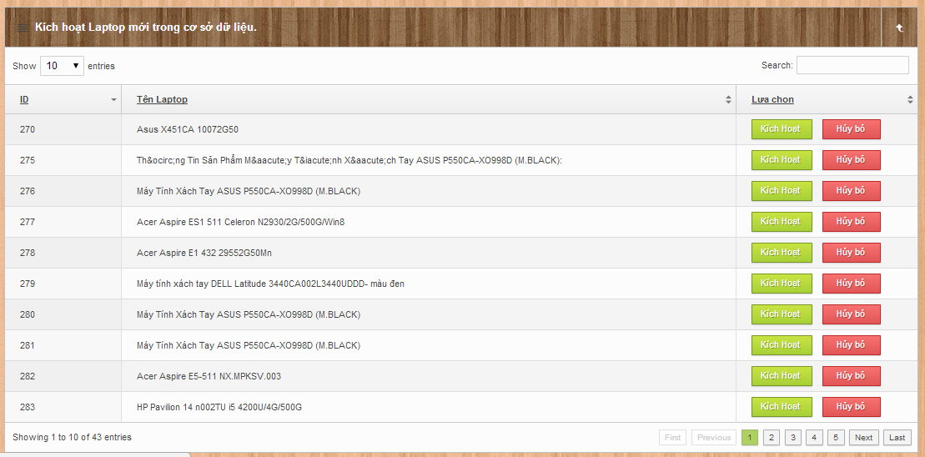

1

3

2

Figure 93: Manage new Laptop

**Fields**

|  |  |  |  |  |  |  |  |
| --- | --- | --- | --- | --- | --- | --- | --- |
| **No** | **Field name** | **Description** | **Read only** | **Mandatory** | **Control type** | **Data type** | **Length** |
| 1 | New laptop list | Table showing | No | Yes | Table | N/A | N/A |

**Button/Hyperlink**

|  |  |  |  |  |
| --- | --- | --- | --- | --- |
| **No** | **Function** | **Description** | **Validation** | **Outcome** |
| 2 | Active laptop | Click to move to active pop-up laptop | No | Transfer to active pop-up laptop |
| 3 | Deactive laptop | Click to deactive laptop | No | Update and reload table |

**New Laptop List includes**

|  |  |  |  |  |  |
| --- | --- | --- | --- | --- | --- |
| **Field name** | **Description** | **Read only** | **Control type** | **Data type** | **Length** |
| No. | Number | N/A | Label | Integer | N/A |
| Name laptop | Laptop name | N/A | Label | String | N/A |
| Action | Action of staff | No | Link | N/A | N/A |

##### Confirm new Laptop

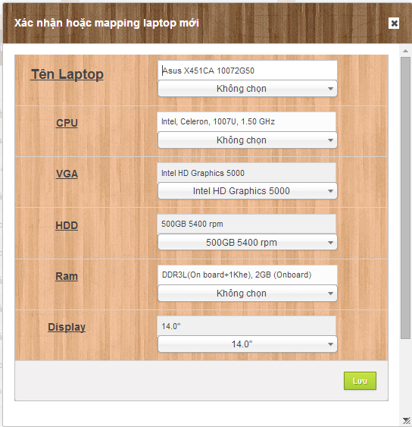

13

12

11

10

9

5

8

7

6

1

4

3

2

Figure 94: Confirm new Laptop

**Fields**

|  |  |  |  |  |  |  |  |
| --- | --- | --- | --- | --- | --- | --- | --- |
| **No** | **Field name** | **Description** | **Read only** | **Mandatory** | **Control type** | **Data type** | **Length** |
| 1 | New Laptop name | Fill new laptop name | No | Yes | Textbox | N/A | N/A |
| 2 | Maping laptop name | Chose a new name | No | No | Dropdownlist | N/A | N/A |
| 3 | New CPU name | Fill CPU | No | Yes | Textbox | N/A | N/A |
| 4 | Maping CPU name | Chose CPU | No | No | Dropdownlist | N/A | N/A |
| 5 | New VGA name | Fill VGA | No | Yes | Textbox | N/A | N/A |
| 6 | Maping VGA name | Chose VGA | No | No | Dropdownlist | N/A | N/A |
| 7 | New HDD name | Fill HDD | No | Yes | Textbox | N/A | N/A |
| 8 | Maping HDD name | Chose HDD | No | No | Dropdownlist | N/A | N/A |
| 9 | New RAM name | Fill RAM | No | Yes | Textbox | N/A | N/A |
| 10 | Maping RAM name | Chose RAM | No | No | Dropdownlist | N/A | N/A |
| 11 | New Display name | Fill Display | No | Yes | Textbox | N/A | N/A |
| 13 | Maping Display name | Chose Display | No | No | Dropdownlist | N/A | N/A |

**Button/Hyperlink**

|  |  |  |  |  |
| --- | --- | --- | --- | --- |
| **No** | **Function** | **Description** | **Validation** | **Outcome** |
| 12 | Active laptop | Click save laptop to database | No | Transfer to Manage new laptop |

#### Confirm new hardware

##### Manage new hardware

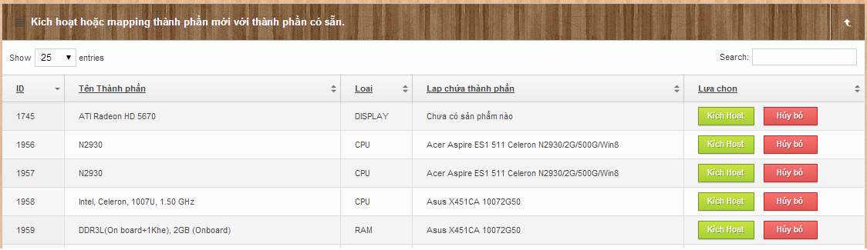

2

3

1

Figure 95: Manage new Hardware

**Fields**

|  |  |  |  |  |  |  |  |
| --- | --- | --- | --- | --- | --- | --- | --- |
| **No** | **Field name** | **Description** | **Read only** | **Mandatory** | **Control type** | **Data type** | **Length** |
| 1 | New hardware list | Table showing | No | Yes | Table | N/A | N/A |

**Button/Hyperlink**

|  |  |  |  |  |
| --- | --- | --- | --- | --- |
| **No** | **Function** | **Description** | **Validation** | **Outcome** |
| 2 | Active hardware | Click to move to active pop-up hardware | No | Transfer to active pop-up laptop |
| 3 | Deactive laptop | Click to deactive hardware | No | Update and reload table |

**New Hardware List includes**

|  |  |  |  |  |  |
| --- | --- | --- | --- | --- | --- |
| **Field name** | **Description** | **Read only** | **Control type** | **Data type** | **Length** |
| No. | Number | N/A | Label | Integer | N/A |
| Name hardware | Hardware name | N/A | Label | String | N/A |
| Kind of hardware | Kind of hardware | N/A | Label | String | N/A |
| Laptop contain | Laptop contain | N/A | Label | String | N/A |
| Action | Action of staff | No | Link | N/A | N/A |

##### Confirm new hardware

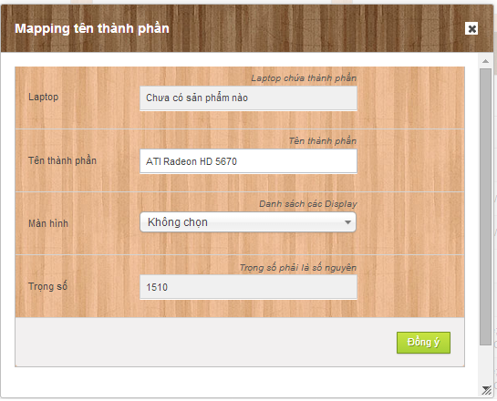

1

2

3

4

5

Figure 96: Confirm new Hardware

**Fields**

|  |  |  |  |  |  |  |  |
| --- | --- | --- | --- | --- | --- | --- | --- |
| **No** | **Field name** | **Description** | **Read only** | **Mandatory** | **Control type** | **Data type** | **Length** |
| 1 | Laptop contain name | Laptop contain name | Yes | No | Textbox | N/A | N/A |
| 2 | Hardware name | Show Hardware name | No | Yes | Textbox | N/A | N/A |
| 3 | Maping hardware | Chose maping hardware | No | No | Dropdownlist | N/A | N/A |
| 4 | Weight Criteria Point | Fill Weight  Criteria  Point | No | No | Textbox | N/A | N/A |

**Button/Hyperlink**

|  |  |  |  |  |
| --- | --- | --- | --- | --- |
| **No** | **Function** | **Description** | **Validation** | **Outcome** |
| 5 | Active Hardware | Click save hardware to database | No | Transfer to Manage new Hardware |

## Database Design

### Web Application

#### Entity Relationship Diagram

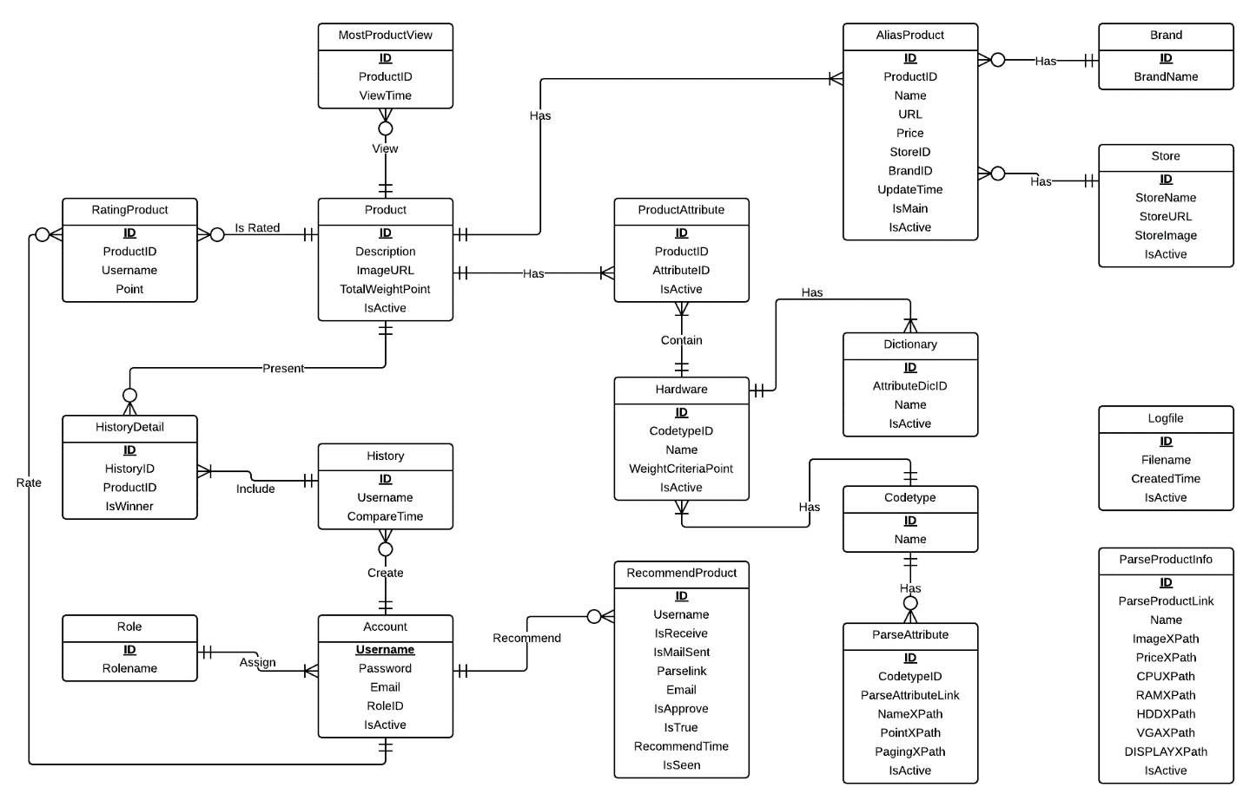

Figure 97: Entity Relationship Diagram

#### Data Dictionary

|  |  |
| --- | --- |
| **Entity Data dictionary: describe content of all entities** | |
| **Entity Name** | **Description** |
| Codetype | Describe all codetype in the system. |
| ParseInfo | Describe all data needed to parse 1 specified product |
| Hardware | Describe all hardwares of a product. |
| Product | Describe all products in the system. |
| ProductAttribute | Describe relationship between Attribute and Product. |
| AliasProdcut | Describe all alias name of product in the system. |
| Dictionary | Describe all possible hardwares names in the system. |
| Account | Describe all accounts in the system. Account includes: admin, staff, member, guest… |
| RecommendProduct | Describe the product that user recommend for system. |
| History | Describe all compare histories of user in the system. |
| HistoryDetail | Describe details of any history in the system. |
| Role | Describe all roles in the system. One user has only one role. |
| LogFile | Describe all log files of the system. |
| ParserAttribute | Describe all Xpath to parser auto hardware |
| ParserInfo | Describe all Xpath to parser auto laptop. |
| RatingProduct | Describe relationship between Attribute and Product. |
| Brand | Describe all brand that product is included. |
| Store | Describe all store that product is included. |
| MostViewProduct | Describe how much time that 1 product are viewed. |

Table 46: Entity Data Dictionary

|  |  |  |  |  |
| --- | --- | --- | --- | --- |
| **Entity name** | **Attributes** | **Description** | **Domain** | **Null** |
| Account | Username {PK} | The name chosen by user. | nvarchar(30) | No |
| Password | The password chosen by user. | nvarchar(30) | No |
| Email | The user email | nvarchar(100) | No |
| RoleID{FK} | Foreign key, role identifier. | int | No |
| IsActive | Account status. | bit | No |
| AliasProduct | ID {PK} | Unique identifier of a name, auto increment. | int | No |
| ProductID {FK} | Foreign key, product identifier. | int | No |
| Name | Name of product. | nvarchar(200) | No |
| URL | Url website get product. | nvarchar(200) | Yes |
| Price | Price of product. | float | Yes |
| StoreID | Foreign key, store identifier. | Int | Yes |
| BrandID | Foreign key, brand identifier. | bit | Yes |
| UpdateTime | Time update name | datetime | Yes |
| IsMain | Main name or alias name. | bit | Yes |
| IsActive | Status name | bit | No |
| Brand | Id {PK} | Unique identifier of a brand, auto increment. | int | No |
| Name | Brand name. | nvarchar(50) | Yes |
| Codetype | Id {PK} | Type id. | nvarchar(3) | No |
| Name | Type name. | nvarchar(50) | No |
| Dictionary | Id {PK} | Unique identifier of a hardware name, auto increment. | int | No |
| AttributeDicID {FK} | Foreign key, hardware identifier. | Int | No |
| Name | Hardware name. | nvarchar(200) | Yes |
| IsActive | Status of hardware name | bit | Yes |
| Hardware | ID {PK} | Unique identifier of hardware, auto increment. | int | No |
| CodetypeID {FK} | Foreign key, type. | nvarchar(3) | No |
| RoleId {FK} | Foreign key, role identifier. | int | No |
| Name | Hardware main name. | nvarchar(200) | No |
| WeightCriteraPoint | Score of hardware | float | No |
| IsActive | Status of hardware | bit | Yes |
| History | Id {PK} | Unique identifier a history, auto increment. | int | No |
| Username {FK} | User compare | nvarchar(30) | No |
| CompareTime | Compare time. | Datetime | No |
| HistoryDetail | ID {PK} | Unique identifier of history detail, auto increment. | Int | No |
| HistoryID {FK} | Foreign key, history identifier. | int | No |
| ProductID {FK} | Foreign key, product identifier. | int | No |
| isWinner | The winer product | bit | Yes |
| LogFile | ID {PK} | Unique identifier of logfile, auto increment. | Int | No |
| Filename | Name of logfile. | nvarchar(100) | No |
| CreatedTime | Time generate logfile. | datetime | Yes |
| IsActive | Status of logfile | bit | No |
| MostViewProduct | Id {PK } | Unique identifier of most view product, auto increment. | int | No |
| ProductID {FK} | Foreign key, product of this. | Int | No |
| ViewTime | The time view product. | datetime | No |
| ParseAttribute | Id {PK} | Unique identifier of parser hardware, auto increment. | int | No |
| CodetypeID {FK} | Foreign key, type hardware. | nvarchar(3) | No |
| ProductId {FK} | Foreign key, product identifier. | int | No |
| ParseAttributelink | Parser link. | nvarchar(200) | No |
| NameXPath | Xpath of hardware name. | nvarchar(200) | No |
| PointXPath | Xpath of hardware score | nvarchar(200) | No |
| PagingXPath | Xpath of paging | nvarchar(200) | Yes |
| IsActive |  | bit | No |
| ParseInfo | Id {PK} | Unique identifier of a parser, auto increment. | int | No |
| Parselink | Url website parser product | nvarchar(200) | No |
| Name | Xpath product name. | nvarchar(200) | No |
| PriceXPath | Xpath product price. | nvarchar(200) | Yes |
| ImageXpath | Xpath product image. | nvarchar(200) | Yes |
| CPUXPath | Xpath product cpu. | nvarchar(200) | No |
| RAMXPath | Xpath product Ram. | nvarchar(200) | No |
| VGAXPath | Xpath product vga. | nvarchar(200) | No |
| HDDXPath | Xpath product hdd. | nvarchar(200) | No |
| DisplayXPath | Xpath product display. | nvarchar(200) | No |
| IsActive | Status of parser. | bit | No |
| Product | Id {PK} | Unique identifier of product, auto increment. | int | No |
| Description | Descripton of product. | nchar(2000) | Yes |
| ImageURL | Product url image. | nvarchar(2000) | Yes |
| TotalWeightPoint | Score of product | Float | No |
| IsActive | Status of product | bit | Yes |
| ProductAttribute | Id {PK} | Unique identifier of productattribute  , auto increment. | int | No |
| ProductId {FK} | Foreign key, product identifier. | int | No |
| AttributeID {FK} | Foreign key, hardware identifier. | int | No |
| IsActive | Status of product attributes. | bit | Yes |
| RatingProduct | Id {PK} | Unique identifier of rating, auto increment. | int | No |
| ProductId {FK} | Foreign key, product identifier. | int | No |
| Username {FK} | Foreign key, account. | nvarchar(30) | No |
| Point | Rating point. | Float | No |
| RecommendProduct | Id {PK} | Unique identifier of recommend, auto increment. | int | No |
| Username {FK} | Foreign key, account. | nvarchar(30) | No |
| IsReceive | Status send notify. | bit | No |
| IsMailSent | Status sends email. | bit | No |
| Parselink | Link recommends. | nvarchar(200) | Yes |
| Email | Email to send. | nvarchar(200) | No |
| IsApprove | Status approves recommend. | bit | Yes |
| IsTrue | Status of recommend. | Bit | Yes |
| RecommendTime | Time of recommend. | Datetime | Yes |
| IsSeen | Status seen notify. | bit | No |
| Role | Id {PK} | Unique identifier of role, auto increment. | int | No |
| Rolename | Role name. | nvarchar(50) | No |
| Store | Id {PK} | Unique identifier of store, auto increment. | int | No |
| StoreName | Store name. | nvarchar(200) | Yes |
| StoreUrl | Store url website. | nvarchar(200) | Yes |
| LogoImage | Store url image. | nvarchar(200) | Yes |
| IsActive | Status of store. | bit | Yes |

Table 47: Attribute Data Dictionary

## Algorithms

### Calculating Product’s Score

#### Reduce hardware’s score on the scale from 1 to 100

* Define:
  + x : The highest hardware’s score in the database.
  + y : The hardware’s score in the database.
  + z : The hardware’s scor on the scale from 1 to 100 after reduced.
* We have a reduce formular:
$$z=\frac{100}{x}×y$$

* Example: Reduce the CPU’s score on the scale from 1 to 100.
  + Given the highest CPU’s score in the database: ***x*** = 13200.
  + Given the CPU’s score which we will reduce: ***y*** = 8000.
  + And ***z*** is the CPU’s score on the scale form 1 to 100.
  + Apply the reduce formular:

$$z=\frac{100}{13200}×8000$$

$z= 60.61$ (on the scale from 1 to 100).

#### Calculate product’s score and reduce on the scale from 1 to 100

* After calculated all the score of CPU, VGA, RAM, HDD and Display on the scale from 1 to 100, we can calculate the product score.
* Given:
  + c: CPU’s score.
  + v: VGA’s score.
  + r : RAM’s score.
  + h : HDD’s score.
  + d : Display’s score.
  + P : Product’s score.
  + H : The highest product’s score in the database.
  + P’ : Product’s score on the scale from 1 to 100.
* Define priority coefficient:
  + Priority hardwares: 60%

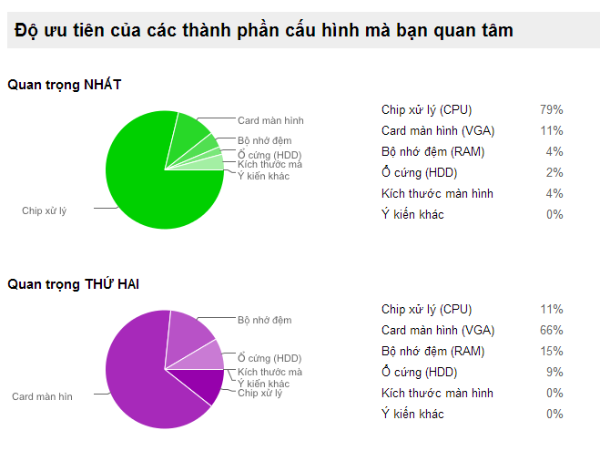

* + Normal hardwares: 40%

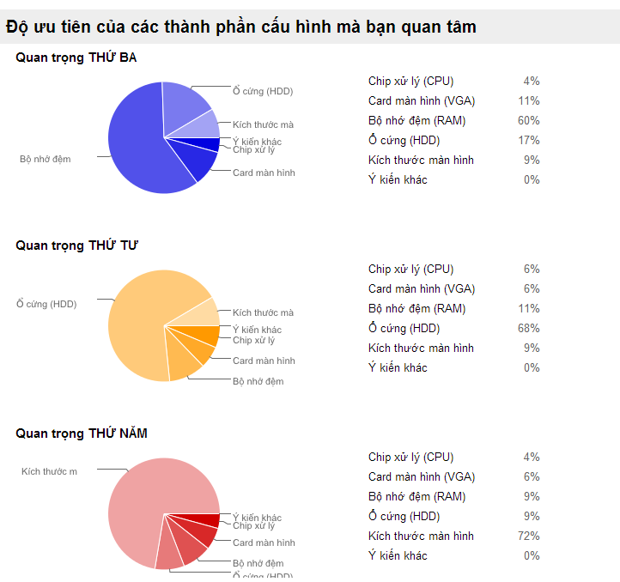

* Define the formular to calculate product’s score:
$$P=\frac{\left(c+v\right)×60\%+\left(r+h+d\right)×40\%}{5}$$

* Reduce P on the scale from 1 to 100 by the formular:
$$P'=\frac{100}{H}×P$$

* Example: Calculate the score of laptop HP Palivion 14 – R006TU with hardware configuration below
  + Given ***c*** : 14.33
  + Given ***v*** : 1.65
  + Given ***r*** : 12.5
  + Given ***h*** : 12.5
  + Given ***d*** : 80.92
  + Given ***H*** : 33.20
* So we have product’s score:
$$P=\frac{\left(14.33+1.65\right)×60\%+\left(12.5+12.5+80.92\right)×40\%}{5}$$

$$P= 10.39$$

* And reduce product’s score on the scale from 1 to 100:

$$P'=\frac{100}{33.20}×10.39$$

$$P'=31.30$$

### String Comparison

#### Define Problem

Given two strings. Calculate their matching percent.

#### Requirement

* Robustness to changes of word order: two strings which contain the same words, but in a different order, should be recognised as being similar.
* Language independence: the algorithm should work not only in English, but in many different languages.

#### Solution

* If a string contains many words, break it into a list of words.
* For each word, we find out how many adjacent character pairs are contained in it.
* Create a function *pairs(s)* which returns a list of adjacent character pairs of string *s*.
* Then, we use below formula to calculate matching percent.

$$similarity\left(s1,s2\right)=\frac{2×\left|pairs(s1)∩pairs(s2)\right|}{\left|pairs\left(s1\right)\right|+\left|pairs(s2)\right|}$$

#### Example

Calculate the matching percent of 2 strings: France and French.

* Upper case 2 strings:
  + France $→$ FRANCE.
  + French $→$ FRENCH.
* Break string into list of adjacent character pairs:
  + FRANCE $→\left\{FR,RA,AN,NC,CE\right\}$
  + FRENCH $→\left\{FR,RE,EN,NC,CH\right\}$
* Calculate its matching percent.

$$similarity\left(FRANCE,FRENCH\right)=\frac{2×\left|\left\{FR,NC\right\}\right|}{\left|\left\{FR,RA,AN,NC,CE\right\}\right|+\left|\left\{FR,RE,EN,NC,CH\right\}\right|}$$

$$=\frac{2×2}{5+5}=\frac{4}{10}=0.4$$

# System Implementation & Test

## Introduction

### System Overview

This section provides in detail all necessary information about test plans, test cases, test result, test environments, pass/fail criteria and risks estimations as well as a checklist to cover all possible cases of CPS.

### Test Approach

- Goal: To test the whole system based on the core workflow.

- Method: System Testing, Black-box Testing.

## Database Relationship Diagram

### Diagram

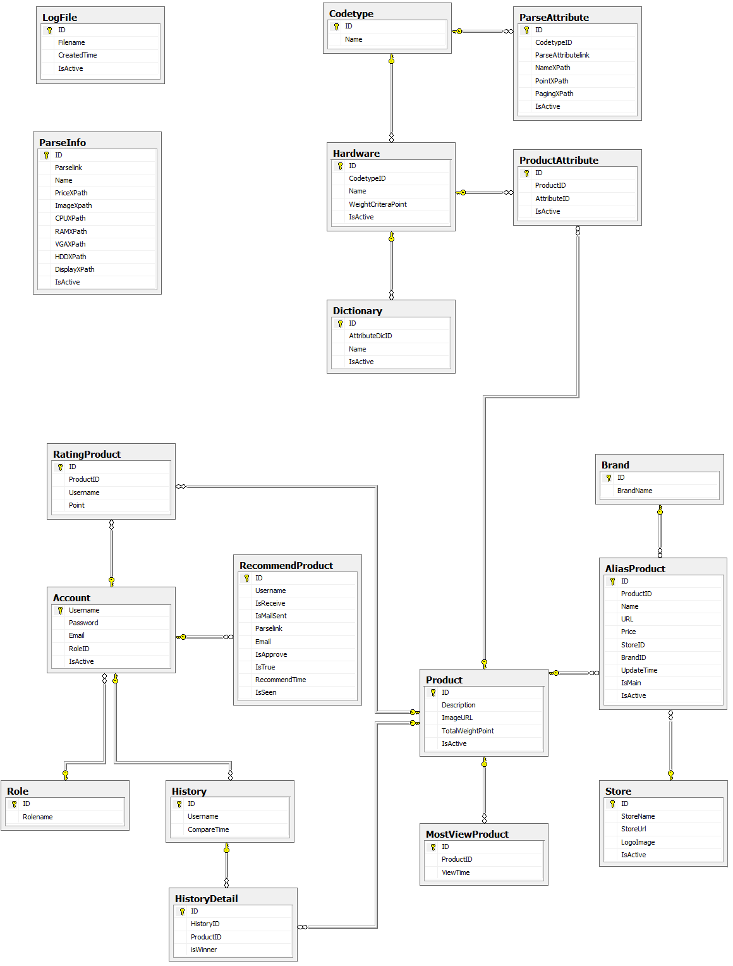

Figure 98: Database Relationship Diagram

### Data Dictionary

|  |  |
| --- | --- |
| **Entity Data dictionary: describe content of all entities** | |
| Entity Name | Description |
| Account | Describe all accounts in the system. Account includes: admin, staff, member, guest… |
| AliasProduct | Describe product the main name and alias name. |
| Brand | Describe brand of product in the system. |
| Codetype | Describe type of hardware. |
| Dictionary | Describe hardware the main name and alias name. |
| Hardware | Describe all accounts in the system. |
| History | Describe time compare of user. |
| HistoryDetail | Describe detail compare of user. |
| LogFile | Describe all log files of the system. Log file is generated after parsers finish running. |
| MostViewProduct | Describe product view time. |
| ParseAttribute | Describe all Xpath to auto parser hardware |
| ParseInfo | Describe all Xpath to auto parser laptop. |
| Product | Describe all products. |
| ProductAttribute | Describe hardware of each product. |
| RatingProduct | Describe rating point of product and user rating. |
| RecommendProduct | Describe all info product guests and user recommend for system. |
| Role | Describe all roles in the system. |
| Store | Describe all store of product in the system. |

Table 48: Data Dictionary

|  |  |  |  |  |
| --- | --- | --- | --- | --- |
| **Entity name** | **Attributes** | **Description** | **Domain** | **Null** |
| Account | Username {PK} | The name chosen by user. | nvarchar(30) | No |
| Password | The password chosen by user. | nvarchar(30) | No |
| Email | The user email | nvarchar(100) | No |
| RoleID{FK} | Foreign key, role identifier. | int | No |
| IsActive | Account status. | bit | No |
| AliasProduct | ID {PK} | Unique identifier of a name, auto increment. | int | No |
| ProductID {FK} | Foreign key, product identifier. | int | No |
| Name | Name of product. | nvarchar(200) | No |
| URL | Url website get product. | nvarchar(200) | Yes |
| Price | Price of product. | float | Yes |
| StoreID | Foreign key, store identifier. | Int | Yes |
| BrandID | Foreign key, brand identifier. | bit | Yes |
| UpdateTime | Time update name | datetime | Yes |
| IsMain | Main name or alias name. | bit | Yes |
| IsActive | Status name | bit | No |
| Brand | Id {PK} | Unique identifier of a brand, auto increment. | int | No |
| Name | Brand name. | nvarchar(50) | Yes |
| Codetype | Id {PK} | Type id. | nvarchar(3) | No |
| Name | Type name. | nvarchar(50) | No |
| Dictionary | Id {PK} | Unique identifier of a hardware name, auto increment. | int | No |
| AttributeDicID {FK} | Foreign key, hardware identifier. | Int | No |
| Name | Hardware name. | nvarchar(200) | Yes |
| IsActive | Status of hardware name | bit | Yes |
| Hardware | ID {PK} | Unique identifier of hardware, auto increment. | int | No |
| CodetypeID {FK} | Foreign key, type. | nvarchar(3) | No |
| Name | Hardware main name. | nvarchar(200) | No |
| WeightCriteraPoint | Score of hardware | float | No |
| IsActive | Status of hardware | bit | Yes |
| History | Id {PK} | Unique identifier a history, auto increment. | int | No |
| Username {FK} | User compare | nvarchar(30) | No |
| CompareTime | Compare time. | Datetime | No |
| HistoryDetail | ID {PK} | Unique identifier of history detail, auto increment. | Int | No |
| HistoryID {FK} | Foreign key, history identifier. | int | No |
| ProductID {FK} | Foreign key, product identifier. | int | No |
| isWinner | The winer product | bit | Yes |
| LogFile | ID {PK} | Unique identifier of logfile, auto increment. | Int | No |
| Filename | Name of logfile. | nvarchar(100) | No |
| CreatedTime | Time generate logfile. | datetime | Yes |
| IsActive | Status of logfile | bit | No |
| MostViewProduct | Id {PK } | Unique identifier of most view product, auto increment. | int | No |
| ProductID {FK} | Foreign key, product of this. | Int | No |
| ViewTime | The time view product. | datetime | No |
| ParseAttribute | Id {PK} | Unique identifier of parser hardware, auto increment. | int | No |
| CodetypeID {FK} | Foreign key, type hardware. | nvarchar(3) | No |
| ParseAttributelink | Parser link. | nvarchar(200) | No |
| NameXPath | Xpath of hardware name. | nvarchar(200) | No |
| PointXPath | Xpath of hardware score | nvarchar(200) | No |
| PagingXPath | Xpath of paging | nvarchar(200) | Yes |
| IsActive |  | bit | No |
| ParseInfo | Id {PK} | Unique identifier of a parser, auto increment. | int | No |
| Parselink | Url website parser product | nvarchar(200) | No |
| Name | Xpath product name. | nvarchar(200) | No |
| PriceXPath | Xpath product price. | nvarchar(200) | Yes |
| ImageXpath | Xpath product image. | nvarchar(200) | Yes |
| CPUXPath | Xpath product cpu. | nvarchar(200) | No |
| RAMXPath | Xpath product Ram. | nvarchar(200) | No |
| VGAXPath | Xpath product vga. | nvarchar(200) | No |
| HDDXPath | Xpath product hdd. | nvarchar(200) | No |
| DisplayXPath | Xpath product display. | nvarchar(200) | No |
| IsActive | Status of parser. | bit | No |
| Product | Id {PK} | Unique identifier of product, auto increment. | int | No |
| Description | Descripton of product. | nchar(2000) | Yes |
| ImageURL | Product url image. | nvarchar(2000) | Yes |
| TotalWeightPoint | Score of product | Float | No |
| IsActive | Status of product | bit | Yes |
| ProductAttribute | Id {PK} | Unique identifier of productattribute  , auto increment. | int | No |
| ProductId {FK} | Foreign key, product identifier. | int | No |
| AttributeID {FK} | Foreign key, hardware identifier. | int | No |
| IsActive | Status of product attributes. | bit | Yes |
| RatingProduct | Id {PK} | Unique identifier of rating, auto increment. | int | No |
| ProductId {FK} | Foreign key, product identifier. | int | No |
| Username {FK} | Foreign key, account. | nvarchar(30) | No |
| Point | Rating point. | Float | No |
| RecommendProduct | Id {PK} | Unique identifier of recommend, auto increment. | int | No |
| Username {FK} | Foreign key, account. | nvarchar(30) | No |
| IsReceive | Status send notify. | bit | No |
| IsMailSent | Status sends email. | bit | No |
| Parselink | Link recommends. | nvarchar(200) | Yes |
| Email | Email to send. | nvarchar(200) | No |
| IsApprove | Status approves recommend. | bit | Yes |
| IsTrue | Status of recommend. | Bit | Yes |
| RecommendTime | Time of recommend. | Datetime | Yes |
| IsSeen | Status seen notify. | bit | No |
| Role | Id {PK} | Unique identifier of role, auto increment. | int | No |
| Rolename | Role name. | nvarchar(50) | No |
| Store | Id {PK} | Unique identifier of store, auto increment. | int | No |
| StoreName | Store name. | nvarchar(200) | Yes |
| StoreUrl | Store url website. | nvarchar(200) | Yes |
| LogoImage | Store url image. | nvarchar(200) | Yes |
| IsActive | Status of store. | bit | Yes |

Table 49: Attribute Data Dictionary

## Performance Measures

### Parser Performance

* Parsing speed is 5ms per product.

### Suggestion Algorithm Performance

* The speed of suggestion algorithm is less than 2 seconds.

## Test Plan

The purpose of this section is to verify and ensure that CPS meets its design specification and other requirements from user. The following part will describe which features to be tested and which will not.

### Features to be tested

We will test the entire system based on the following core workflow (Reference: **Figure 99, 100, 101: Core Workflow**).

Based on the workflow, all following features will be tested, which can include one or more functions. These features will be focused and tested thoroughly during the test phase.

* Guest: search product, add to cart, and view compare.
* Member: recommend, view compare details, ask for suggestion, and save product history.
* System: run parsers.
* Staff: create parser, run parser, train system, and import excel.

### Features not to be tested

* Login, Logout.
* Change Password.
* Manage hardware.
* Manage product.
* Manage user.
* Configure System.

## System Testing Test Case

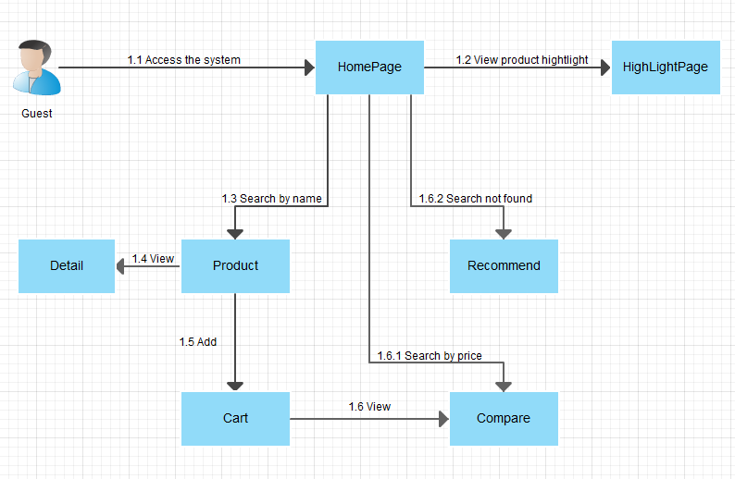

Figure 99: Guest Core Flow

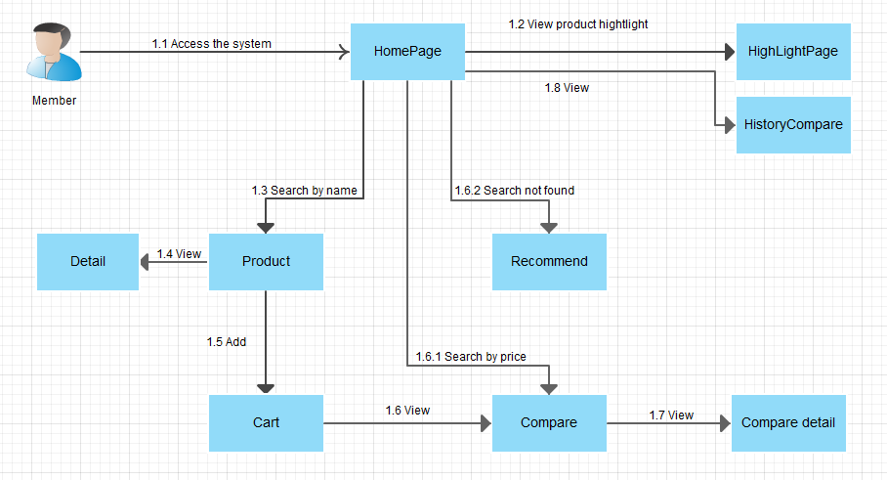

Figure 100: Member core flow

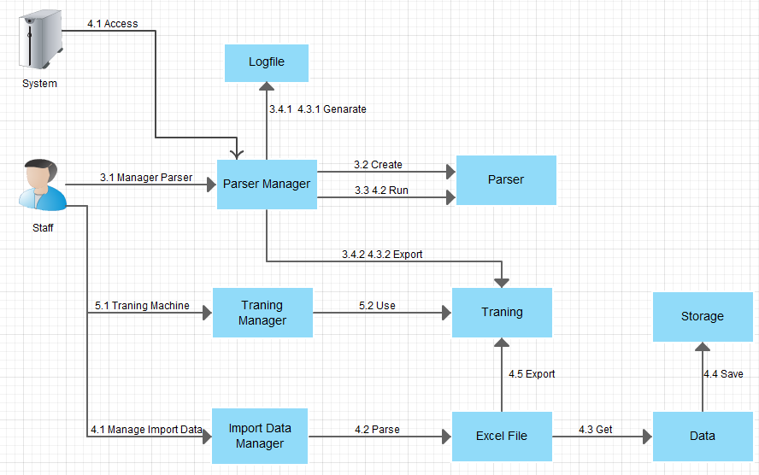

Figure 101: Staff, System Core Flow

### Guest Test Case

#### Search Product by name

|  |  |  |  |  |  |  |  |
| --- | --- | --- | --- | --- | --- | --- | --- |
| **ID** | **Test Case Description** | **Test Case Procedure** | **Expected output** | **Inter-test Case Dependence** | **Result** | **Test Date** | **Note** |
| SPN01 | Guest searches product by name. | 1 – On the home page, click on “**Tìm kiếm**” on menu bar.  2 – Input name of product on search textbox.  3 – Click “**Search**” button or press enter key. | - After step 1, go to search page  - After step 3, show search result with product name, alias name. |  | Passed | 13/08/2014 |  |
| SPN02 | Member searches product by name. | 1 – On the home page, click on “**Tìm kiếm**” on menu bar.  2 – Input name of product on search textbox.  3 – Click “**Search**” button or press enter key. | - After step 1, go to search page  - After step 3, show search result with product name, alias name. |  | Passed | 13/08/2014 |  |

Table 50: Search Product by name Test Case

#### Search Product by price

|  |  |  |  |  |  |  |  |
| --- | --- | --- | --- | --- | --- | --- | --- |
| **ID** | **Test Case Description** | **Test Case Procedure** | **Expected output** | **Inter-test Case Dependence** | **Result** | **Test Date** | **Note** |
| SPP01 | Guest searches product by price. | 1 – On the home page, click on “**Tìm kiếm**” on menu bar.  2 – Choose brand on dropdown list, choose price on dropdown list.  3 – Click “**Search**” button | - After step 1, go to search page  - After step 3, go to compare page. |  | Passed | 13/08/2014 |  |
| SPP02 | Member searches product by price. | 1 – On the home page, click on “**Tìm kiếm**” on menu bar.  2 – Choose brand on dropdown list, choose price on dropdown list.  3 – Click “**Search**” button | - After step 1, go to search page  - After step 3, go to compare page. |  | Passed | 13/08/2014 |  |

Table 51: Search Product by price Test Case

#### View Detail

|  |  |  |  |  |  |  |  |
| --- | --- | --- | --- | --- | --- | --- | --- |
| **ID** | **Test Case Description** | **Test Case Procedure** | **Expected output** | **Inter-test Case Dependence** | **Result** | **Test Date** | **Note** |
| VD01 | Guest view detail. | 1 – On the home page, click on product name result in “**SearchPage**”. | - After step 1, go to detail page. |  | Passed | 13/08/2014 |  |
| VD02 | Member view detail. | 1 – On the home page, click on product name result in “**SearchPage**”. | - After step 1, go to detail page. |  | Passed | 13/08/2014 |  |

Table 52: View Detail Test Case

#### Add To Cart

|  |  |  |  |  |  |  |  |
| --- | --- | --- | --- | --- | --- | --- | --- |
| **ID** | **Test Case Description** | **Test Case Procedure** | **Expected output** | **Inter-test Case Dependence** | **Result** | **Test Date** | **Note** |
| AC01 | Guest adds product to cart. | 1 – On the search page, click on “**+ So Sánh**” button on search result row. | - After step 1, added product to cart. | SPN01 | Passed | 13/08/2014 |  |
| AC02 | Guest adds product to cart when the product has existed in cart. | 1 – On the search page, click on “**+ So Sánh**” button on search result row. | - After step 1, update quantity of the product in cart. | SPN01, AC01 | Passed | 13/08/2014 |  |
| AC03 | Member adds product to cart. | 1 – On the search page, click on “**+ So Sánh**” button on search result row. | - After step 1, added product to cart. | SPN02 | Passed | 13/08/2014 |  |
| AC04 | Member adds product to cart when the product has existed in cart. | 1 – On the search page, click on “**+ So Sánh**” button on search result row. | - After step 1, update quantity of the product in cart. | SPN02, AC03 | Passed | 13/08/2014 |  |
| AC05 | Guest adds product to cart when the cart has 3 items. | 1 – On the search page, click on “**+ So Sánh**” button on search result row. | - After step 1, display dialog message “**Giỏ của bạn không quá 3 sản phẩm**”. | SPP01 | Passed | 13/08/2014 |  |
| AC06 | Member adds product to cart when the cart has 3 items. | 1 – On the search page, click on “**+ So Sánh**” button on search result row. | - After step 1, display dialog message “**Giỏ của bạn không quá 3 sản phẩm**”. | SPP02 | Passed | 13/08/2014 |  |

Table 53: Add To Cart Test Case

#### View Compare

|  |  |  |  |  |  |  |  |
| --- | --- | --- | --- | --- | --- | --- | --- |
| **ID** | **Test Case Description** | **Test Case Procedure** | **Expected output** | **Inter-test Case Dependence** | **Result** | **Test Date** | **Note** |
| VC01 | Guest views compare. | 1 – On the home page, click “So sánh” button on “**Giỏ hàng**” on menu bar. | - After step 1, go to view compare page and display result compare. | AC01, AC02 | Passed | 13/08/2014 |  |
| VC02 | Member views compare. | 1 – On the home page, click “So sánh” button on “**Giỏ hàng**” on menu bar. | - After step 1, go to view compare page and display result compare. | AC03, AC04 | Passed | 13/08/2014 |  |
| VC07 | Guest delete product in cart. | 1 – On the view cart page, click on “**Xóa**” button on cart list row. | - After step 1, the row is removed entirely from the table. | VC01 | Passed | 13/08/2014 |  |
| VC08 | Guest delete product in cart. | 1 – On the view cart page, click on “**Xóa**” button on cart list row. | - After step 1, the row is removed entirely from the table. | VC02 | Passed | 13/08/2014 |  |

Table 54: View Compare Test Case

#### View product highlight

|  |  |  |  |  |  |  |  |
| --- | --- | --- | --- | --- | --- | --- | --- |
| **ID** | **Test Case Description** | **Test Case Procedure** | **Expected output** | **Inter-test Case Dependence** | **Result** | **Test Date** | **Note** |
| VR01 | Guest views product hightlight. | 1 – On the home page, click on “**HightLight**” on menu bar. | - After step 1, go to hightlight product page. |  | Passed | 13/08/2014 |  |
| VR02 | Member views product hightlight. | 1 – On the home page, click on “**HightLight**” on menu bar. | - After step 1, go to hightlight product page. |  | Passed | 13/08/2014 |  |

Table 55: View hight light product Test Case

### Member Test Case

#### Compare detail

|  |  |  |  |  |  |  |  |
| --- | --- | --- | --- | --- | --- | --- | --- |
| **ID** | **Test Case Description** | **Test Case Procedure** | **Expected output** | **Inter-test Case Dependence** | **Result** | **Test Date** | **Note** |
| VCD01 | Member compare detail | 1 – On the compare, click on “**So sánh chi tiết”** button.  2 – Drap and drop line priority. | - After step 1, go to compare details page  - After step 2, show new result compares. | VC02 | Passed | 13/08/2014 |  |

Table 56: Compare detail Test Case

#### View history compare

|  |  |  |  |  |  |  |  |
| --- | --- | --- | --- | --- | --- | --- | --- |
| **ID** | **Test Case Description** | **Test Case Procedure** | **Expected output** | **Inter-test Case Dependence** | **Result** | **Test Date** | **Note** |
| VCD01 | Member view history compares. | 1 – On the menu bar, click on “**Lịch Sử So Sánh**” link. | - After step 1, go to compare history page and show compare history. |  | Passed | 13/08/2014 |  |

Table 57: History compares Test Case

### Staff Test Case

#### Manage Parser

|  |  |  |  |  |  |  |
| --- | --- | --- | --- | --- | --- | --- |
| **ID** | **Test Case Description** | **Test Case Procedure** | **Expected output** | **Result** | **Test Date** | **Note** |
| TC01 | Staff view list parsers hardware | 1 – Login into the system using a staff account  2 – On the staff home page, click “Parser”, and then click “Parser linh kiện”. | - After step 2, parser list will be shown. | Pass | 13/08/2014 |  |
| TC02 | Staff create new parser hardware | 1 – Login into the system using a staff account  2 – On the staff home page, click “Parser”, and then click “Tạo parser linh kiện”  3 – Fill url to “Link parser” textbox and click “submit button”.  4 – Fill in parser detail :   1. “Loại parser” tab 2. “Khung thông tin” tab 3. “Tên sản phẩm” tab 4. “Điểm sản phẩm” tab 5. “Phân trang” tab   5 – Click “Hoàn thành” button. | - After step 2, go to “Create parser” page.  - After step 5, parser will be inserted into database. | Pass | 13/08/2014 |  |
| TC03 | Staff run Parser | 1 – Login into the system using a staff account  2 – On the staff home page, click “Parser”, and then click “Parser linh kiện”.  3 – Staff clicks on “Chạy Parser” button. | - After step 3, product will be inserted into database.  + Generate log file.  + Export duplicate products to text file. | Pass | 13/08/2014 |  |
| TC01 | Staff view list parsers product | 1 – Login into the system using a staff account  2 – On the staff home page, click “Parser”, and then click “Parser sản phẩm”. | - After step 2, parser list will be shown. | Pass | 13/08/2014 |  |
| TC02 | Staff create new parser | 1 – Login into the system using a staff account  2 – On the staff home page, click “Dữ Liệu”, and then click “Sản phẩm đề xuất”.  3 – Fill url to “Link parse” textbox and click “Đề xuất” button.  4 – Staff click “Câp Nhập” button.  5 – Fill in parser detail :  1.“Tên SP” tab  2.“Giá SP” tab  3.“Ảnh SP” tab  4.“CPU” tab  5.“VGA” tab  6. “HDD” tab  7. “Ram” tab  8. “Display” tab  9. “Xác nhận” tab  6 – Click “Hoàn thành” button. | - After step 3, go to “CreateRecommend” page.  - After step 6, parser will be inserted into database. | Pass | 13/08/2014 |  |
| TC03 | Staff run Parser | 1 – Login into the system using a staff account  2 – On the staff home page, click “Parser”, and then click “parser sản phẩm”.  3 – Staff clicks on “Cập nhập” button and click “ok” button. | - After step 3, product will be inserted into database.  + Generate log file.  + Export duplicate products to text file. | Pass | 13/08/2014 |  |

Table 58: Manage Parser Test Case

#### Import Data

|  |  |  |  |  |  |  |
| --- | --- | --- | --- | --- | --- | --- |
| **ID** | **Test Case Description** | **Test Case Procedure** | **Expected output** | **Result** | **Test Date** | **Note** |
| TC04 | Staff import list product in excel file. | 1 – Login into the system using a staff account  2 – On the staff home page, click “Dữ liệu”, and then click “Nhập từ Excel”.  3 – Click “Brown” button.  4 – Select excel file.  5 – Click “Open” button.  6 – Click “Tải lên” button. | - After step 6, product list will be shown. | Pass | 13/08/2014 |  |
| TC05 | Staff edit product in error product table. | After step 6 in test case ST04  1 – On the import page, click “Danh sách sản phẩm lỗi” tab.  2 – Fill in Product detail:   1. Product Name 2. Url Image 3. CPU 4. VGA 5. HDD 6. Ram 7. Price 8. Url   3 – Click “Lưu” button. | - After step 1, error product list will be shown.  - After step 3, product will be compared with duplicate product in “Danh sách sản phẩm trùng” table and “Danh sách sản phẩm đúng” table:  + If not duplicate, product will be move to “Danh sách sản phẩm đúng” table.  + Else product will be moved to “Danh sách sản phẩm trùng” table. | Pass | 13/08/2014 |  |
| TC06 | Staff save products in excel file into database. | After step 6 in test case ST04.  1 – Click “Lưu” button.  2 – Check “Sản phẩm trùng”, “Sản phẩm lỗi” checkbox. Click “Hoàn thành” button. | - After step 1, product will be compared with database.  + If products be duplicated, products will be shown into “Danh sách sản phẩm trùng” table.  + Else, products will be saved into database.  +All products duplicate and error product export to text file. | Pass | 13/08/2014 |  |
| TC07 | Staff process duplicate product with database. | After TC6.  1 – Click “Gộp/Tách” button. | - After step 1, product will be insert new or update alias name to database.. |  |  |  |

Table 59: Import Data Test Case

#### Train Machine

|  |  |  |  |  |  |  |
| --- | --- | --- | --- | --- | --- | --- |
| **ID** | **Test Case Description** | **Test Case Procedure** | **Expected output** | **Result** | **Test Date** | **Note** |
| TC08 | Staff uses training file | 1 – Login into the system using a staff account.  2 – On the staff home page, click “Dữ liệu”, and then click “Xử lý dữ liệu trùng”. | - After step 2, product list in text file will be shown. | Pass | 13/08/2014 |  |
| TC09 | Staffs join products. | After step 2 in test case ST08.  1 – Click checkbox products be duplicated.  2 – Click “Gộp” button. | - After step 2, duplicate products will be joined and saved into database. | Pass | 13/08/2014 |  |
| TC10 | Staffs divide products. | After step 2 in test case ST08.  1 – Click checkbox products be duplicated.  2 – Click “Tách” button. | - After step 2, duplicate products will be divided and saved into database. | Pass | 13/08/2014 |  |
| TC11 | Staffs confirm and mapping new product | 1 – On the menubar click link “Xác nhận laptop mới”.  2- On the row include new laptop click “Kích hoạt” button.  3- On the “Kích Hoạt” popup maping laptop or hardware and lick “Lưu” button. | - After step 1, go to view confirm new laptop page and display list laptop wating confirm  -After step 2, show popup to active laptop.  - After step 3, the laptop is active on system. | Pass | 13/08/2014 |  |

Table 60: Train Machine Test Case

#### Fill Weight Hardware

|  |  |  |  |  |  |  |
| --- | --- | --- | --- | --- | --- | --- |
| **ID** | **Test Case Description** | **Test Case Procedure** | **Expected output** | **Result** | **Test Date** | **Note** |
| TC08 | Staff fill weight hardware | 1 – Login into the system using a staff account.  2 – On the staff home page, click “Fill Weight hardware” page, and then click “Xử lý dữ liệu trùng”.  3 – On the row has hardware change weight and click ”update” button | - After step 2 show list hardware weight equal zero to update new weight.  - After step 3 the hardware update new weight. | Pass | 13/08/2014 |  |

Table 61: Fill Weight Hardware Test Case

# Software User’s Manual

## Installation Guide

### Setting up environment at server side

The following software must be installed into the server machine:

#### Hardware requirements

Personal computers for developing with the minimum configuration:

* CPU Core 2 Duo 2.0GHz.
* 1GB of RAM.
* 30GB of hard disk.
* Wifi Internet (> 2Mbps).

#### Software requirements

* Web Server: Internet Information System – IIS 7.5.
* Microsoft Windows Server 2008: operating system.
* SQL Server 2008 R2: used to create and manage the database for web application.
* Other library:
* Microsoft Visual C++ 2010 SP1 Redistributable Package (x86)

(<http://www.microsoft.com/en-us/download/details.aspx?id=8328>)

### Deployment at server side

#### Prepare deployment package

* Extract the deployment package to a folder on the server.
* For example: E:\CPS

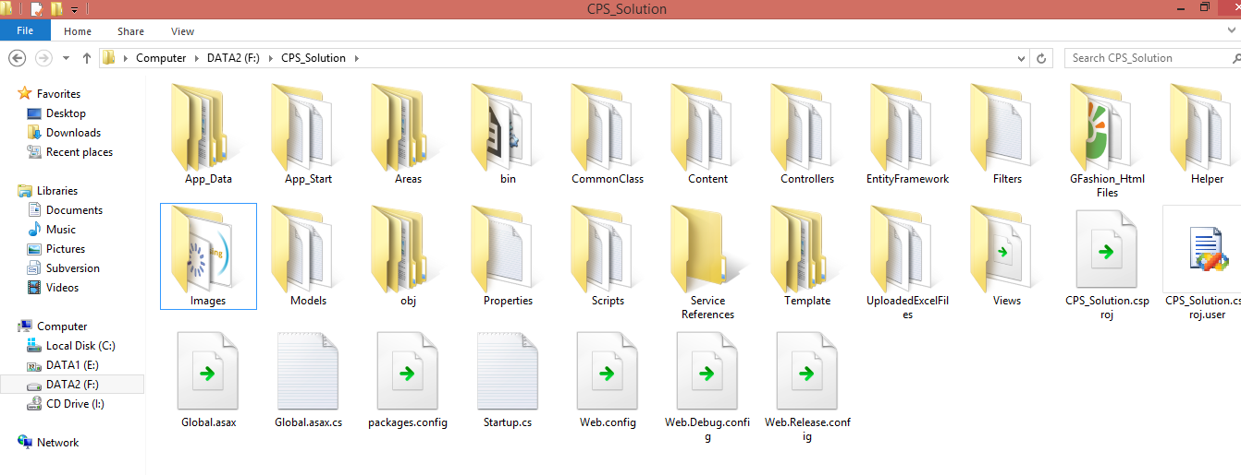

Figure 102: Prepare deployment package

#### Deploy database

* Open Microsoft SQL Server Management Studio.

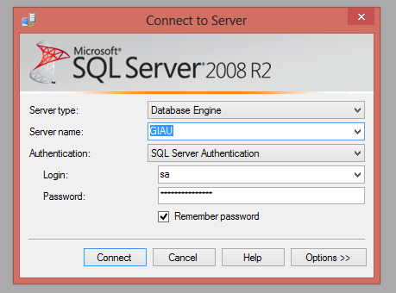

Figure 103: Deploy database – 1

* Open and excute the script.sql file

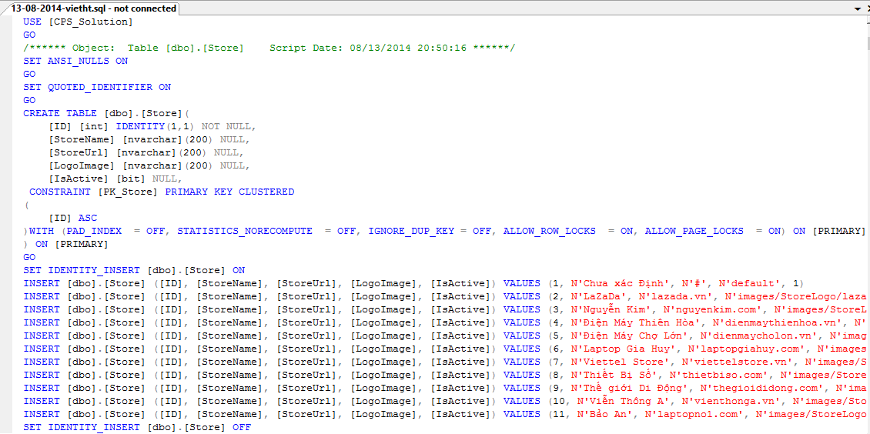

Figure 104: Deploy database - 2

#### Configure Server before deploy

* Open the Internet Information System Manager.
* Change the .NET Framework version to 4.0.

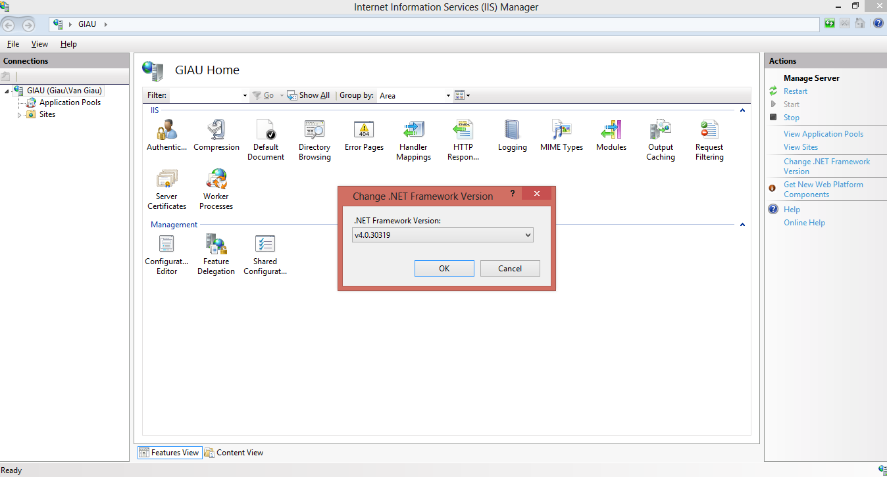

Figure 105: Configure Server before deploy – 1

#### Deploy web application on server

* Change the connection string in Web.config.

Replace the username, password, data source parts with your own data.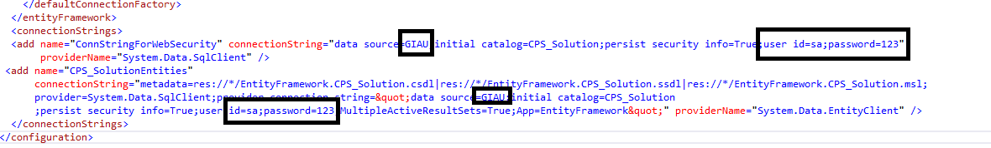

Figure 106: Deploy web application on server – 1

* Right click as Sites. Choose “Add Web Site”.

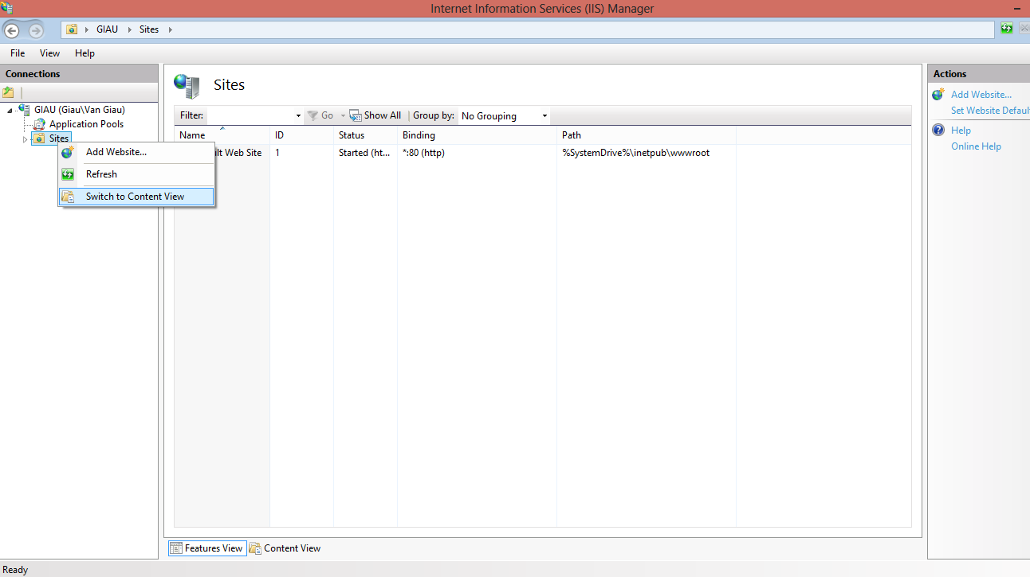

Figure 107: Deploy web application on server – 2

* Enter site name. Choose Application Pool as ASP.NET 4.0
* Select the path as the folder in step 1. Enter port other than 80.

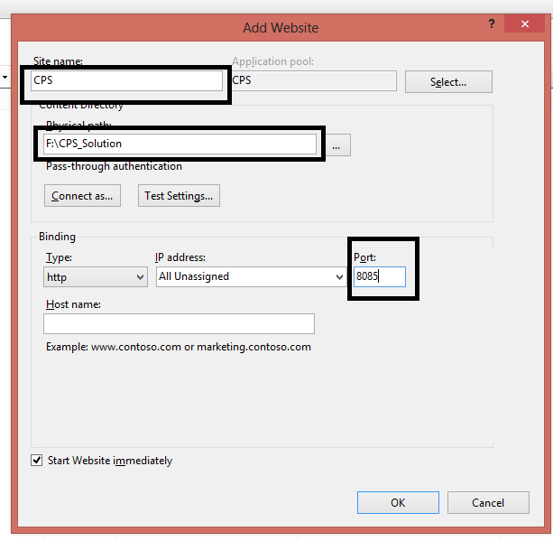

Figure 108: Deploy web application on server – 3

* Press ok to finish the process

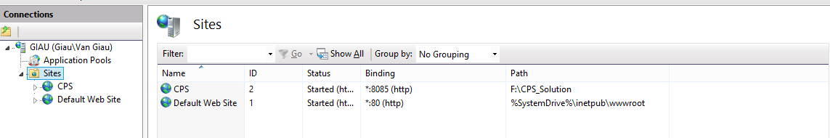

Figure 109: Deploy web application on server – 4

### Setting up the environment at client side

#### Setting up for computer

* The client devices need to have one of the following browsers to access the website:
* Google Chrome.
* Firefox.

## User Guide

The user guide is based on the normal workflow of the system

### Guest/Member Guide

#### Login



2

3

1

Figure 110: Login Page

|  |  |
| --- | --- |
| **Step** | **Description** |
| 1 | Click icon on menu bar to go to login page |
| 2 | Fill “Tên tài khoản” and “Mật khẩu” |
| 3 | Click button “Đăng nhập” |

Table 62: Login Steps

#### Search Product

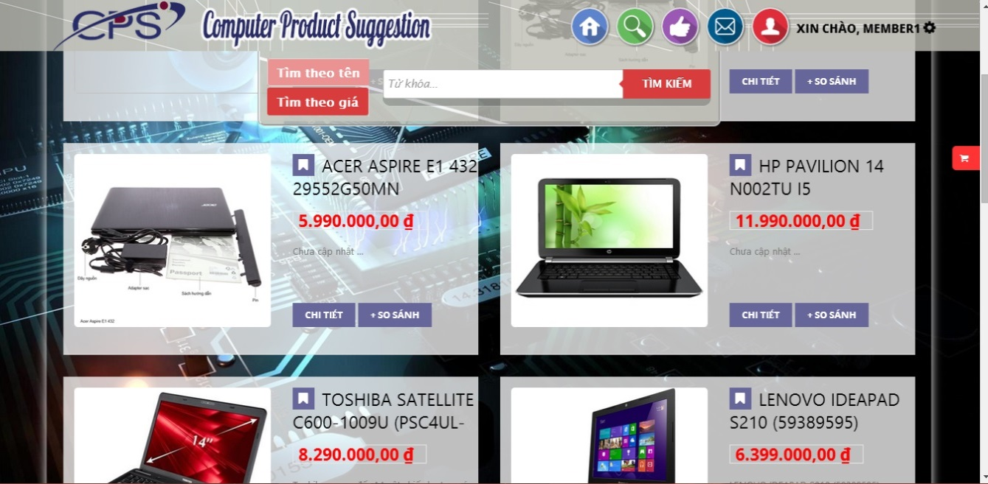

1

6

5

3

2

4

Figure 111: Search Product Page

|  |  |
| --- | --- |
| **Step** | **Description** |
| 1 | Click icon on menu bar to go to search page |
| 2 | Chose search method by name or by price |
| 3 | Fill search key |
| 4 | Clickon “Tìm kiếm” to search product |
| 5 | Click button “+ So sánh” to add product to cart |
| 6 | Click button “Chi tiết“ to view detail page |

Table 63: Search Product Steps

#### Recommend Product



1

2

4

3

Figure 112: Recommend Product

|  |  |
| --- | --- |
| **Step** | **Description** |
| 1 | Fill “Đường dẫn sản phẩm” |
| 2 | Fill “Email” |
| 3 | Check on “Nhận thong tin khi sản phẩm dc cập nhật”. |
| 4 | Click “Gửi đề xuất” button |

Table 64: Recommend Product

#### Highlight



3

2

1

Figure 113: Suggest Route Page

|  |  |
| --- | --- |
| **Step** | **Description** |
| 1 | Click icon on menu bar to go to go highlight page |
| 2 | Click on “Chi tiết ” button to go to detail page |
| 3 | Click on“+ So sánh” to add item to cart |

Table 65: Suggest Route Steps

#### View Compare

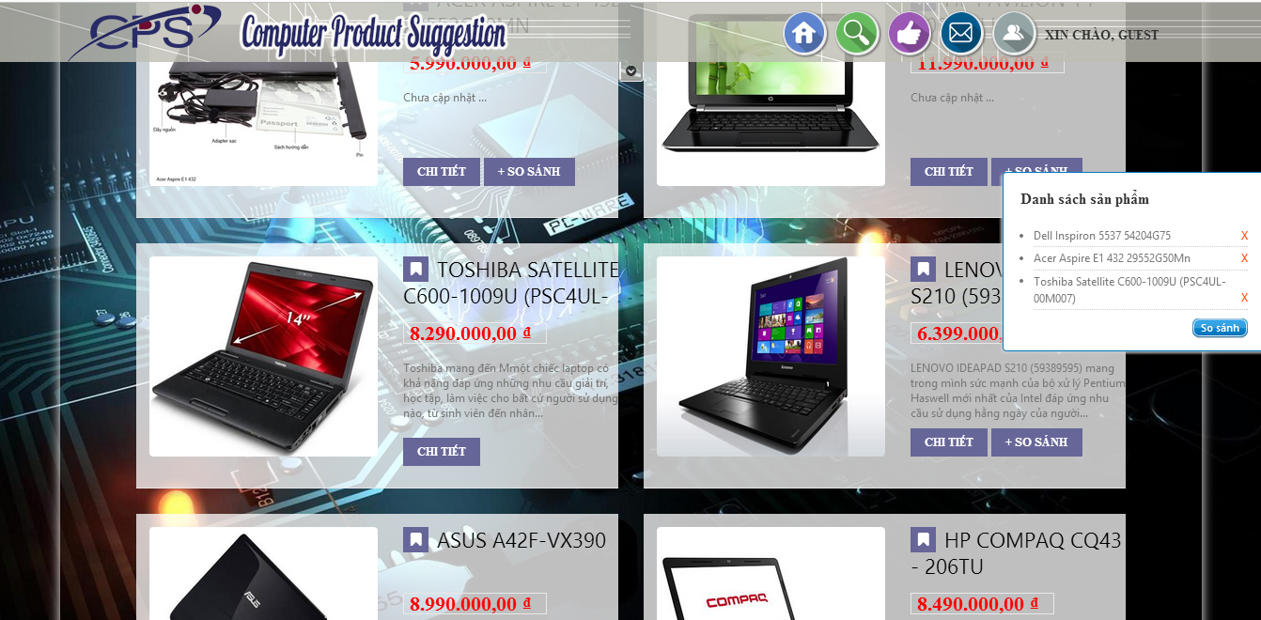

2

1

Figure 114: View Compare

|  |  |
| --- | --- |
| **Step** | **Description** |
| 1 | Click on “+ So sánh ”button to add item to cart |
| 2 | Click on “So sánh ”button in cart to view result |

Table 66: View Compare

#### View Compare Result



1

Figure 115: View compares result

|  |  |
| --- | --- |
| **Step** | **Description** |
| 1 | Click “So sánh chi tiết” button to view details |

Table 67: View History Steps

### Staff Guide

#### Login



3

1

2

4

Figure 116: Staff Login

|  |  |
| --- | --- |
| **Step** | **Description** |
| 1 | Fill in user’s name |
| 2 | Fill in user’s password |
| 3 | Click button “Remember me” to save user name and password |
| 4 | Click button “Login” to log in the system |

Table 68: Staff Login Steps

#### Import Excel

##### Save Data



4

3

2

1

Figure 117: Imported Data Page

|  |  |
| --- | --- |
| **Step** | **Description** |
| 1 | Click to select file excel. |
| 2 | Click button “Tải lên” to upload file excel. |
| 3 | Click button “Xóa” to remove product. |
| 4 | Click button “Lưu lại” to save products into database. |

Table 69: Save Imported Data Steps

##### Handle Name Conflict



4

3

2

1

Figure 118: Handle Name Conflict Page

|  |  |
| --- | --- |
| **Step** | **Description** |
| 1 | Click to select name. |
| 2 | Checkbox for pick prododuct to split or gross. |
| 3 | Click on “gộp” to gross product |
| 4 | Click on “tách” to split product |

Table 70: Handle Name Conflict Steps

#### Manage Parser

##### Create Parser



2

1

Figure 119: Create Parser Page&Step - 1

|  |  |
| --- | --- |
| **Step** | **Description** |
| 1 | Fill link to parse. |
| 2 | Click button “Cập nhật” to view website parse. |

Table 71: Create Parser Steps – 1



Figure 120: Create Parser Page – 2



Figure 121: Create Parser Page – 3



Figure 122: Create Parser Page – 4



Figure 123: Create Parser Page – 5



Figure 124: Create Parser Page – 6



Figure 125: Create Parser Page – 7



Figure 126: Create Parser Page – 8



Figure 127: Create Parser Page – 9



Figure 128: Create Parser Page – 10

|  |  |
| --- | --- |
| **Step** | **Description** |
| 1 | Beginning step |
| 2 | Click tab “Tên SP” |
| 3 | Select column product name |
| 4 | Click tab “Giá SP” |
| 5 | Select column product price |
| 6 | Click tab “Ảnh SP” |
| 7 | Select column product image |
| 8 | Click tab “CPU” |
| 9 | Select column product cpu |
| 10 | Click tab “VGA” |
| 11 | Select column product vga |
| 12 | Click tab “HDD” |
| 13 | Select column product hdd |
| 14 | Click tab “RAM” |
| 15 | Select column product Ram |
| 16 | Click tab “Display” |
| 16 | Select column product display |

Table 72: Create Parser Steps - 2

#### Preview parse data



1

Figure 129: Preview parses data

|  |  |
| --- | --- |
| **Step** | **Description** |
| 1 | Click to “Xem trước” to view preview parse data |

Figure 130: Preview parses data

#### Manage new laptop



2

1

Figure 131: Manage new laptop

|  |  |
| --- | --- |
| **Step** | **Description** |
| 1 | Click to “Kích hoạt” to active product |
| 2 | Click to “Hủy bỏ” to de-active product |

Table 73: Manage new laptop

#### Confirm new laptop



2

1

Figure 132: Confirm new laptop

|  |  |
| --- | --- |
| **Step** | **Description** |
| 1 | Fill content of new laptop |
| 2 | Click to “Lưu” to save laptop to database. |

# Appendix

1. Statictis survey: <http://www.bit.ly/cps-survey-summary>
2. String Comparison: <http://www.catalysoft.com/articles/StrikeAMatch.html>
3. Software process model : <http://www.indicthreads.com/1439/quick-introduction-to-agile-software-development/>